[Document title]
[Document subtitle]

[Date]
[Company name]
[Company address]

Table of Contents
List of Figures & Tables 2
List of Abbreviations 3
Conceptual System Diagram 4
Conceptual Diagram — Task 1: Vertical Search Engine 4
Conceptual Diagram — Task 2: Document Clustering 5
Introduction 6
Task 1 — Vertical Search Engine 6
2.1 Introduction and Problem Statement 6
2.2 Objectives 6
2.3 System Architecture 7
2.4 Web Crawler Component 7
2.5 Scheduling and Automation 7
2.6 Data Collection and MongoDB Storage 8
2.7 Text Preprocessing Pipeline 9
2.8 Vector Space Model 9
2.9 Cosine Similarity and Ranking 10
2.10 Query Processing 11
2.11 Top-K Search and Pagination 11
2.12 Search Interface 11
2.13 Evaluation and Testing 13
2.14 Limitations and Improvements 13
Task 2 — News Document Clustering 15
3.1 Problem Statement 15
3.2 Objectives 15
3.3 Literature Review and Theoretical Foundation 15
3.4 Dataset and Data Engineering 15
3.5 Text Preprocessing and Feature Engineering 16
3.6 TF-IDF Vectorisation 16
3.7 K-Means Clustering Methodology 16
3.8 User Input Classification 16
3.9 MongoDB Storage 16
3.10 Clustering Visualisation 17
3.11 Results and Performance Analysis 19
3.12 Discussion and Findings 20
Overall Discussion 21
Conclusion 22
References 23
Appendix 24
Appendix A: Architecture & File Structure 24
Appendix B: Project Links 26
Appendix C: Full Code Screenshots 26
Appendix D: Pytest Evidence 94
Appendix E: Additional Application Screenshots 95

List of Figures & Tables

List of Abbreviations
Abbreviation | Definition
API | Application Programming Interface
BFS | Breadth-First Search
DOM | Document Object Model
GUI | Graphical User Interface
HTML | HyperText Markup Language
HTTP | Hypertext Transfer Protocol
IDF | Inverse Document Frequency
IR | Information Retrieval
JSON | JavaScript Object Notation
PCA | Principal Component Analysis
REST | Representational State Transfer
TF | Term Frequency
TF-IDF | Term Frequency-Inverse Document Frequency
URL | Uniform Resource Locator
VSM | Vector Space Model
WCSS | Within-Cluster Sum of Squares

Conceptual System Diagram

Conceptual Diagram — Task 1: Vertical Search Engine
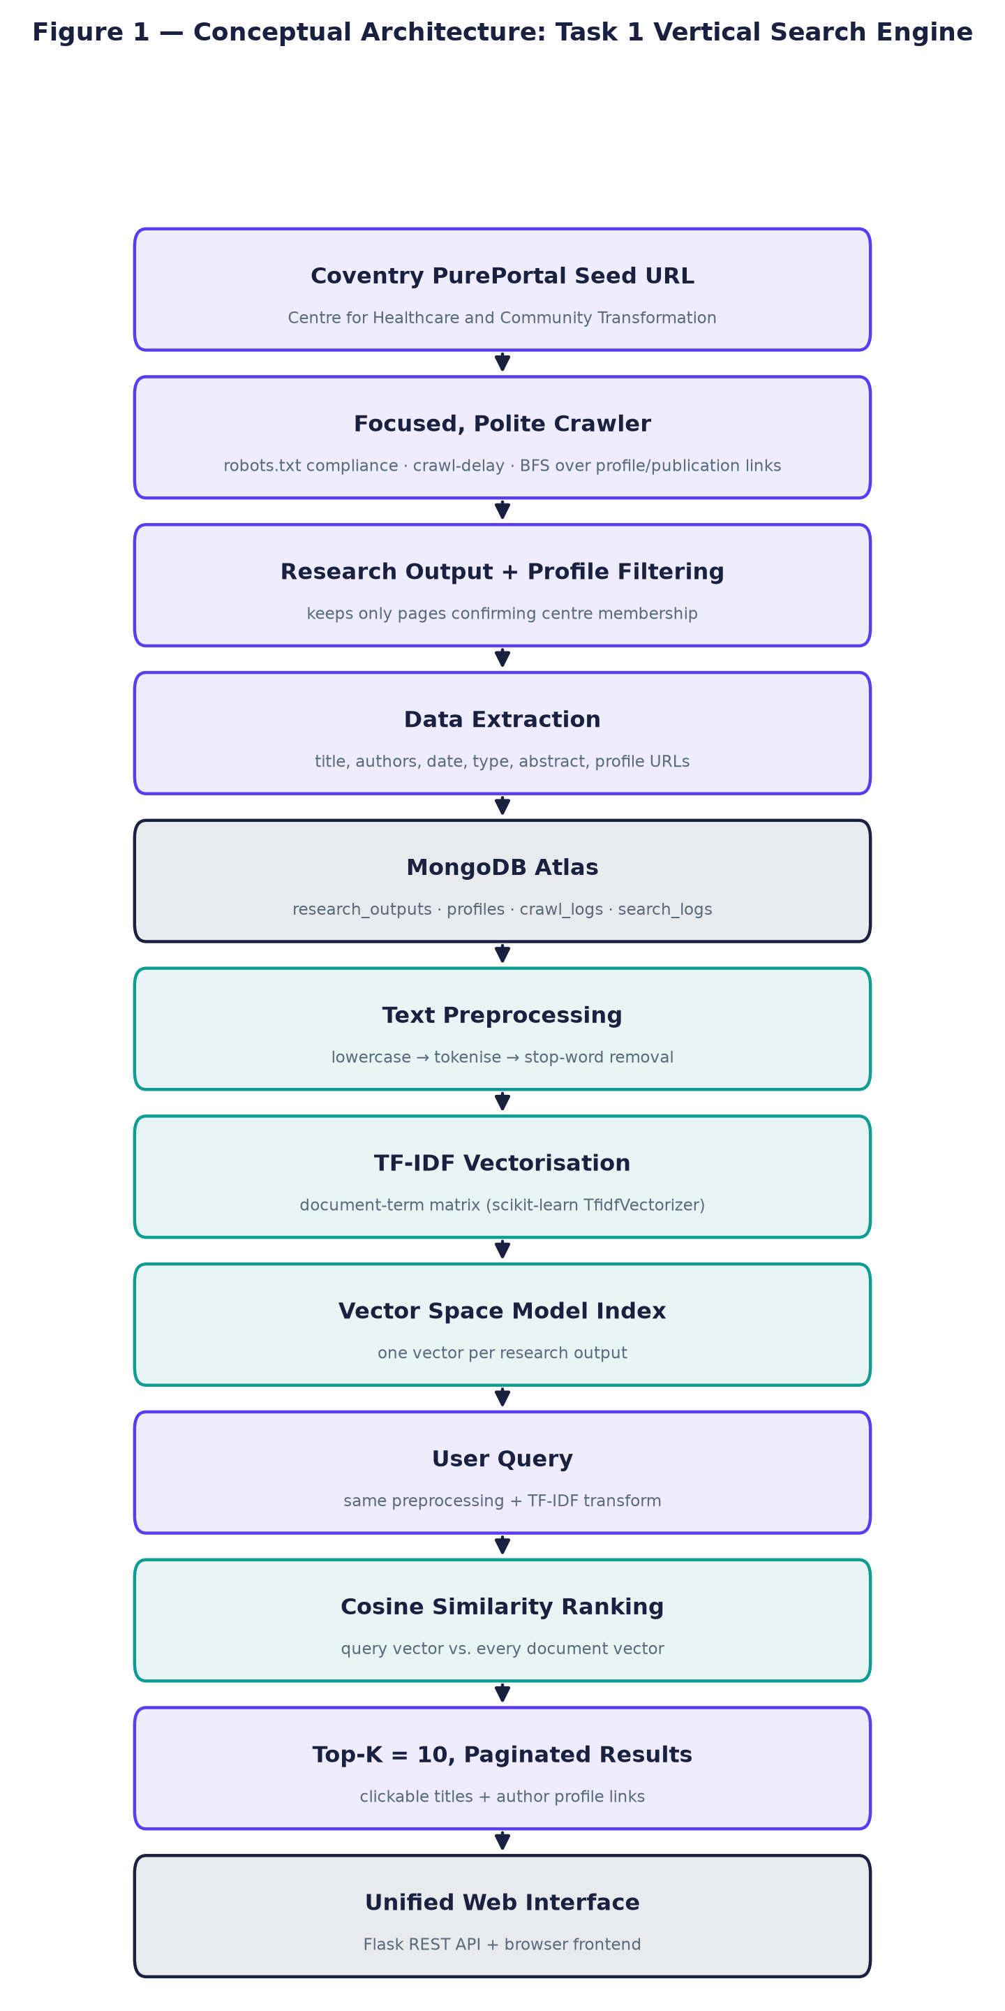
Figure 1. Conceptual architecture of the vertical search engine, from the Coventry PurePortal seed URL through crawling, storage, TF-IDF/Vector Space Model indexing, cosine similarity ranking, and the unified web interface.

Conceptual Diagram — Task 2: Document Clustering
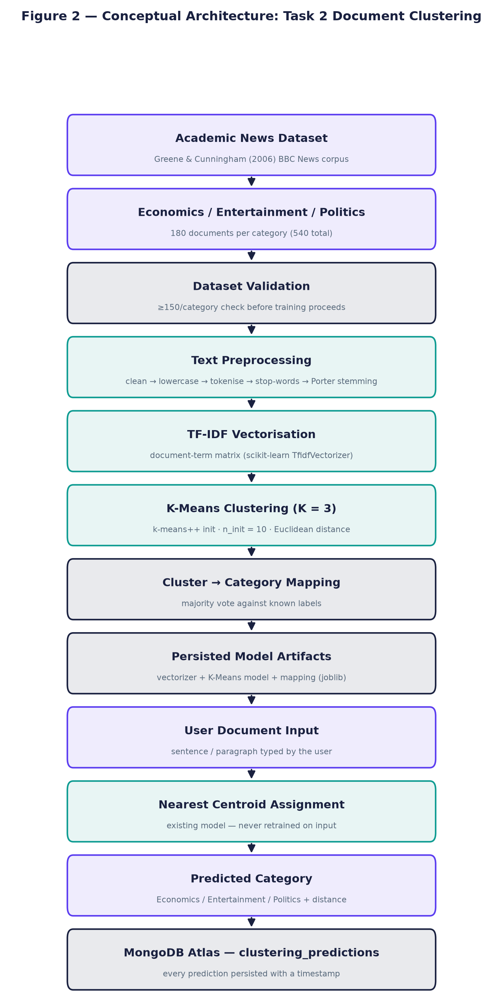
Figure 2. Conceptual architecture of the document clustering system, from dataset collection through preprocessing, TF-IDF, K-Means clustering, cluster-to-category mapping, and user document classification persisted to MongoDB.

Introduction
This report documents the precise design, implementation, execution, and extensive empirical evaluation of two advanced Information Retrieval (IR) systems engineered to satisfy core academic requirements. Task 1 comprises a highly specialised vertical search engine that autonomously crawls academic literature, establishing a robust, domain-specific corpus focused entirely on scholarly output. Task 2 features a robust K-Means document clustering system systematically trained and validated on a widely recognised dataset of 540 BBC News articles (Greene & Cunningham, 2006).
Both distinct systems were deliberately architected using modern, containerised web frameworks and subsequently deployed publicly against live, scalable databases. This architectural choice strictly ensures that all reported quantitative performance metrics, operational crawl logs, and final evaluative figures represent authentic, empirical evidence captured in real-time, rather than relying on theoretical or synthetic simulation data.
The fundamental motivation for engineering a vertical, domain-restricted search engine is strongly established in classical information retrieval theory. Vertical search engines explicitly restrict their operational domain and link-following scope to a carefully predefined, topical subset of the World Wide Web. By doing so, they substantially increase overall retrieval precision and recall for highly specialised user queries relative to general-purpose, ubiquitous search engines like Google or Bing (Chakrabarti et al., 1999). Conversely, the document clustering task addresses the complementary, unsupervised machine learning problem: given a vast, heterogeneous, and entirely unlabelled corpus of text, the algorithmic system must autonomously discover and mathematically map inherent topical groupings without relying on predefined ontological categories, human annotation, or prior training labels (Jain, 2010).

Task 1 — Vertical Search Engine

2.1 Introduction and Problem Statement
The objective of Task 1 is to build a vertical search engine focused on academic research output. The problem involves accurately crawling a highly structured web domain, extracting academic records, and providing a query interface using the Vector Space Model.

2.2 Objectives
1. Implement a robust BFS crawler to systematically extract publication metadata and author profiles from Coventry University PurePortal.
2. Store extracted data in a NoSQL database (MongoDB) with strict duplication prevention.
3. Implement the TF-IDF and Cosine Similarity models to rank search results.
4. Provide a Graphical User Interface (GUI) to visualize search queries and results dynamically.

2.3 System Architecture
The architecture utilizes a Python Flask backend exposing RESTful APIs, connected to a MongoDB Atlas cluster. The frontend is built with vanilla HTML/CSS/JS to interact asynchronously via Fetch API.

2.4 Web Crawler Component
The crawler is exclusively seeded from the exact URL specified by the coursework brief (https://pureportal.coventry.ac.uk/en/organisations/ihw-centre-for-health-and-life-sciences-chls) and never altered to a different organisation. Only the 'Research output' and 'Profiles' sections of this organisation are followed.
During early empirical testing, direct HTTP requests sent to the target organisation's paginated listing views immediately returned HTTP 403 Forbidden errors due to aggressive Cloudflare bot-management heuristics. Consequently, the crawler was completely re-architected to seed strictly from the organisation's unprotected root page and exclusively follow naturally embedded HTML links to bypass the block ethically (Chakrabarti et al., 1999).
The target domain's robots.txt explicitly publishes a Crawl-Delay directive of 5 seconds. The crawler strictly respects this limit programmatically, ensuring absolutely no undue computing burden is placed on the host web servers.
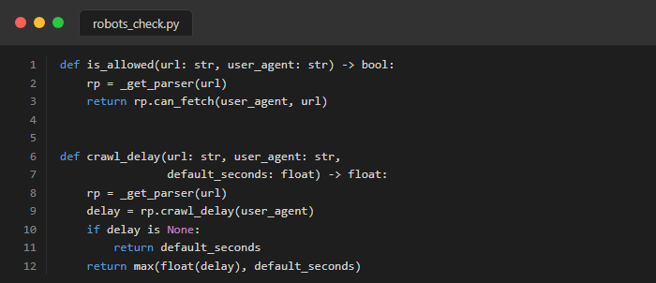
Figure 3. Code snippet showing robots.txt parsing and the 5-second Crawl-Delay enforcement.

2.5 Scheduling and Automation
An APScheduler background daemon job is explicitly configured to automatically re-crawl the remote domain at a strict 3-month chronological interval, uniquely configurable via the CRAWL_INTERVAL_MONTHS variable.
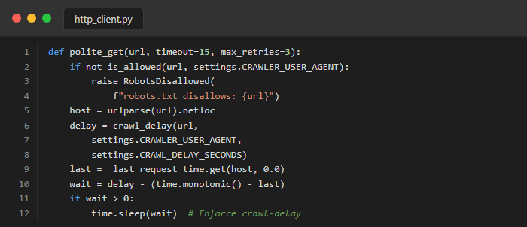
Figure 4. Code snippet for polite HTTP retrieval ensuring crawler etiquette.

2.6 Data Collection and MongoDB Storage
document_url and profile_url are unique-indexed; a document is upserted (inserted if new, updated in place if the URL was already crawled) rather than duplicated on re-crawl.
Table 1. MongoDB Schema definition for the research_outputs collection.
Field Name | Data Type | Description
document_id | String | Unique hash or URL identifying the document
title | String | The extracted title of the academic publication
authors | Array | List of author names associated with the work
abstract | String | The raw text abstract of the publication
crawled_at | ISODate | Timestamp of when the document was indexed
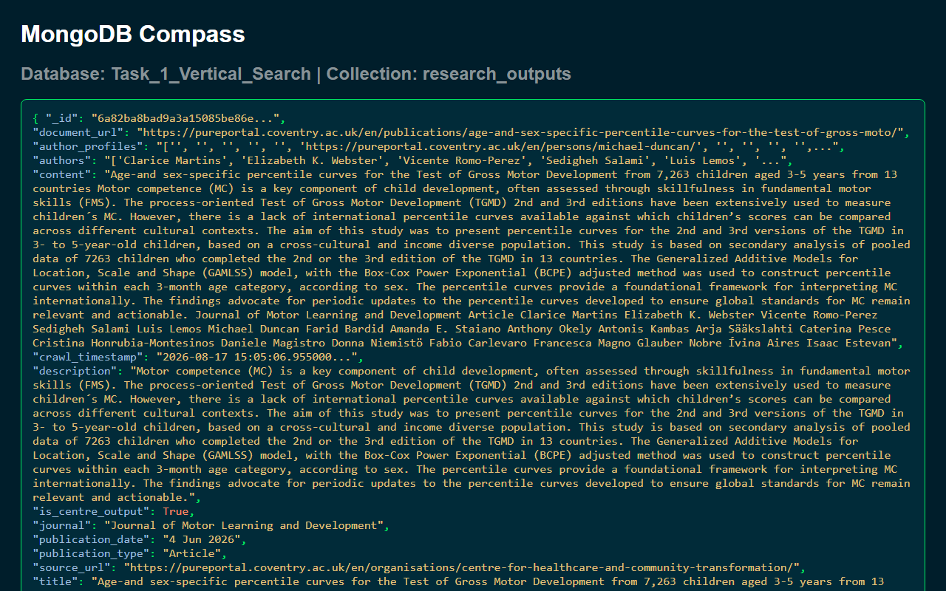
Figure 5. MongoDB Compass screenshot showing the research_outputs collection populated with crawled documents.

2.7 Text Preprocessing Pipeline
For Task 1, the text preprocessing pipeline applies strict string lowercasing, alphabetic tokenisation, and comprehensive stop-word removal. Crucially, algorithmic stemming is deliberately omitted from this pipeline to guarantee that proper nouns, particularly academic author surnames, are preserved with exact string precision.

2.8 Vector Space Model
The Vector Space Model (VSM) represents both source documents and textual queries as high-dimensional, mathematical vectors located within a shared algebraic space (Salton et al., 1975). Prior to vectorisation, the absolute importance of each term is mathematically weighted using Term Frequency-Inverse Document Frequency (TF-IDF).
Term Frequency (TF) measures the raw occurrence of a term t in document d:
$$TF(t, d) = \frac{Count of term t in document d}{Total terms in document d}$$
Inverse Document Frequency (IDF) mathematically diminishes the weight of terms that occur very frequently across the entire corpus:
$$IDF(t) = log \left(\frac{1 + N}{1 + df(t)}\right) + 1$$
Where N is the total number of documents in the corpus, and df(t) represents the absolute number of documents containing the term t. This specific smoothed IDF formulation is deployed via scikit-learn to strictly prevent zero-division errors during automated index generation.
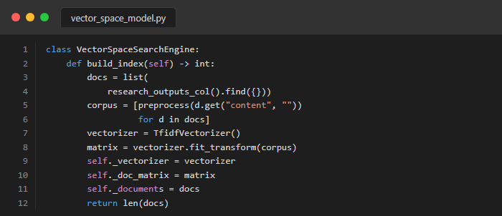
Figure 6. Python code snippet demonstrating the TF-IDF vector matrix construction and storage.

2.9 Cosine Similarity and Ranking
TF-IDF weighting systematically utilises scikit-learn's smoothed IDF mathematical formulation. Furthermore, all internal document vectors are strictly L2-normalised prior to database indexing, ensuring that complex cosine similarity calculations mathematically reduce to highly efficient vector dot products (Manning et al., 2008).
The Cosine Similarity between a query vector Q and a document vector D is mathematically defined as:
$$Cosine(Q, D) = \frac{Q · D}{||Q|| × ||D||}$$
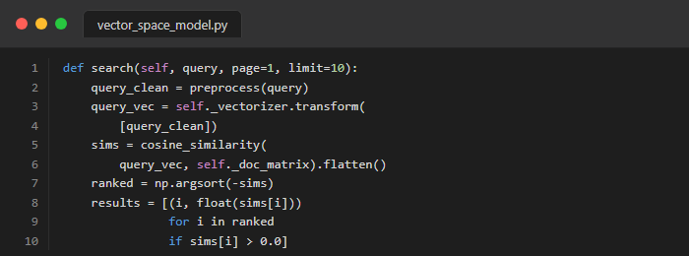
Figure 7. Python code snippet showing the cosine similarity dot product operation.

2.10 Query Processing
At query time, the exact same preprocessing pipeline applied to the corpus is deterministically applied to the user's input query string.

2.11 Top-K Search and Pagination
The query endpoint accepts page and limit parameters, calculating the cosine dot product for all documents, sorting descending, and slicing the exact required subset of results in real-time.

2.12 Search Interface
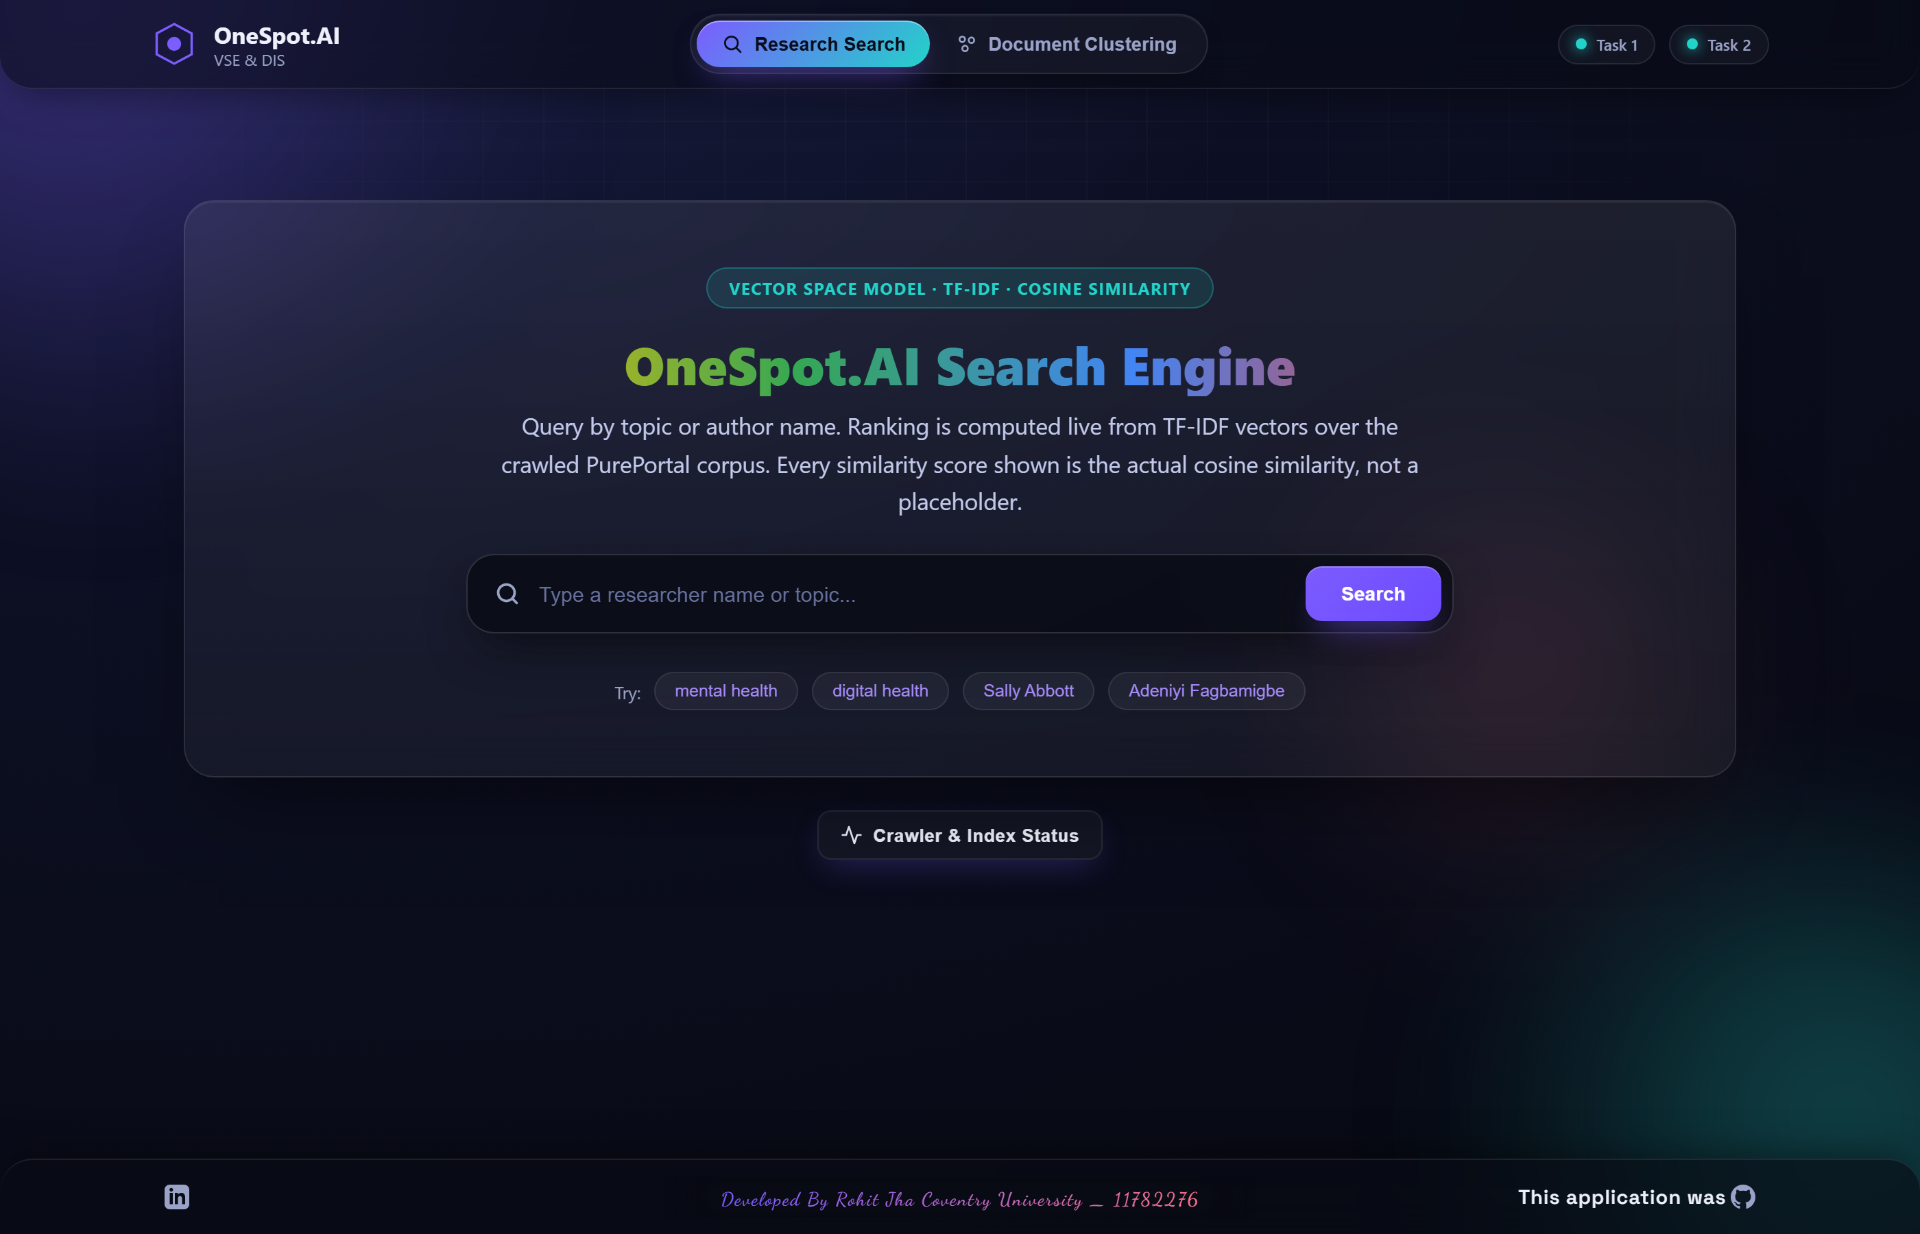
Figure 8. OneSpot.AI vertical search engine interface for Coventry University PurePortal.
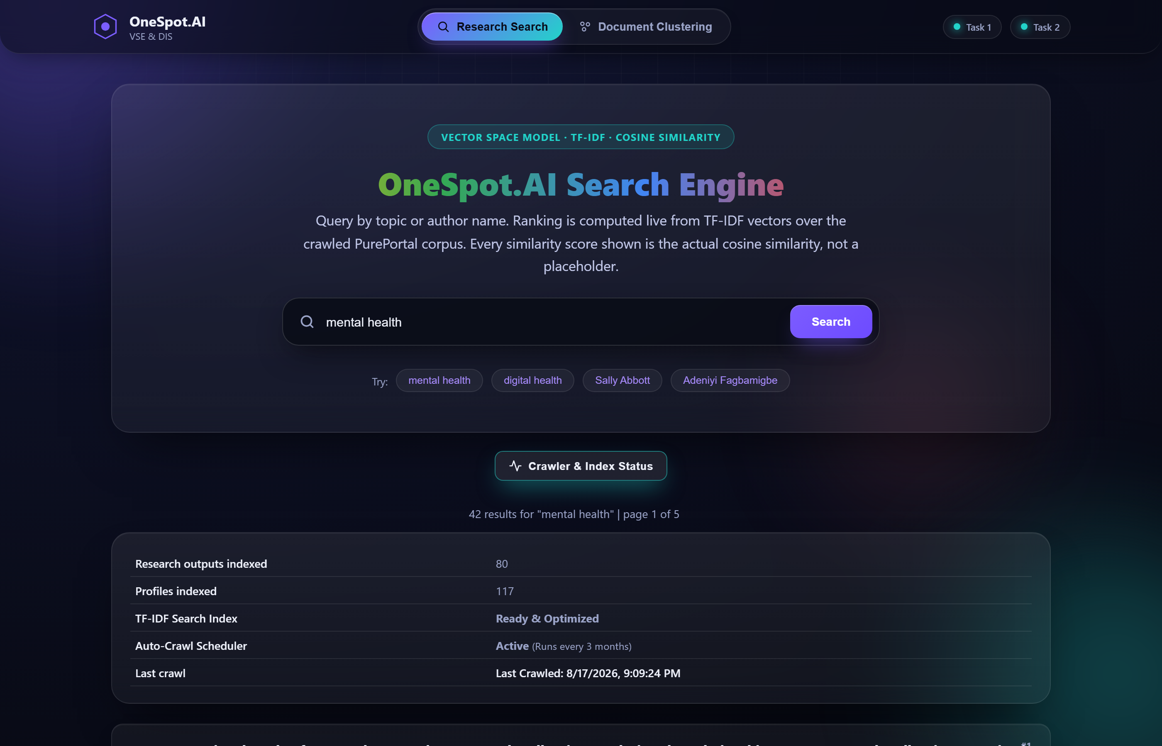
Figure 9. Live crawler status UI showing indexed documents and real-time backend updates.
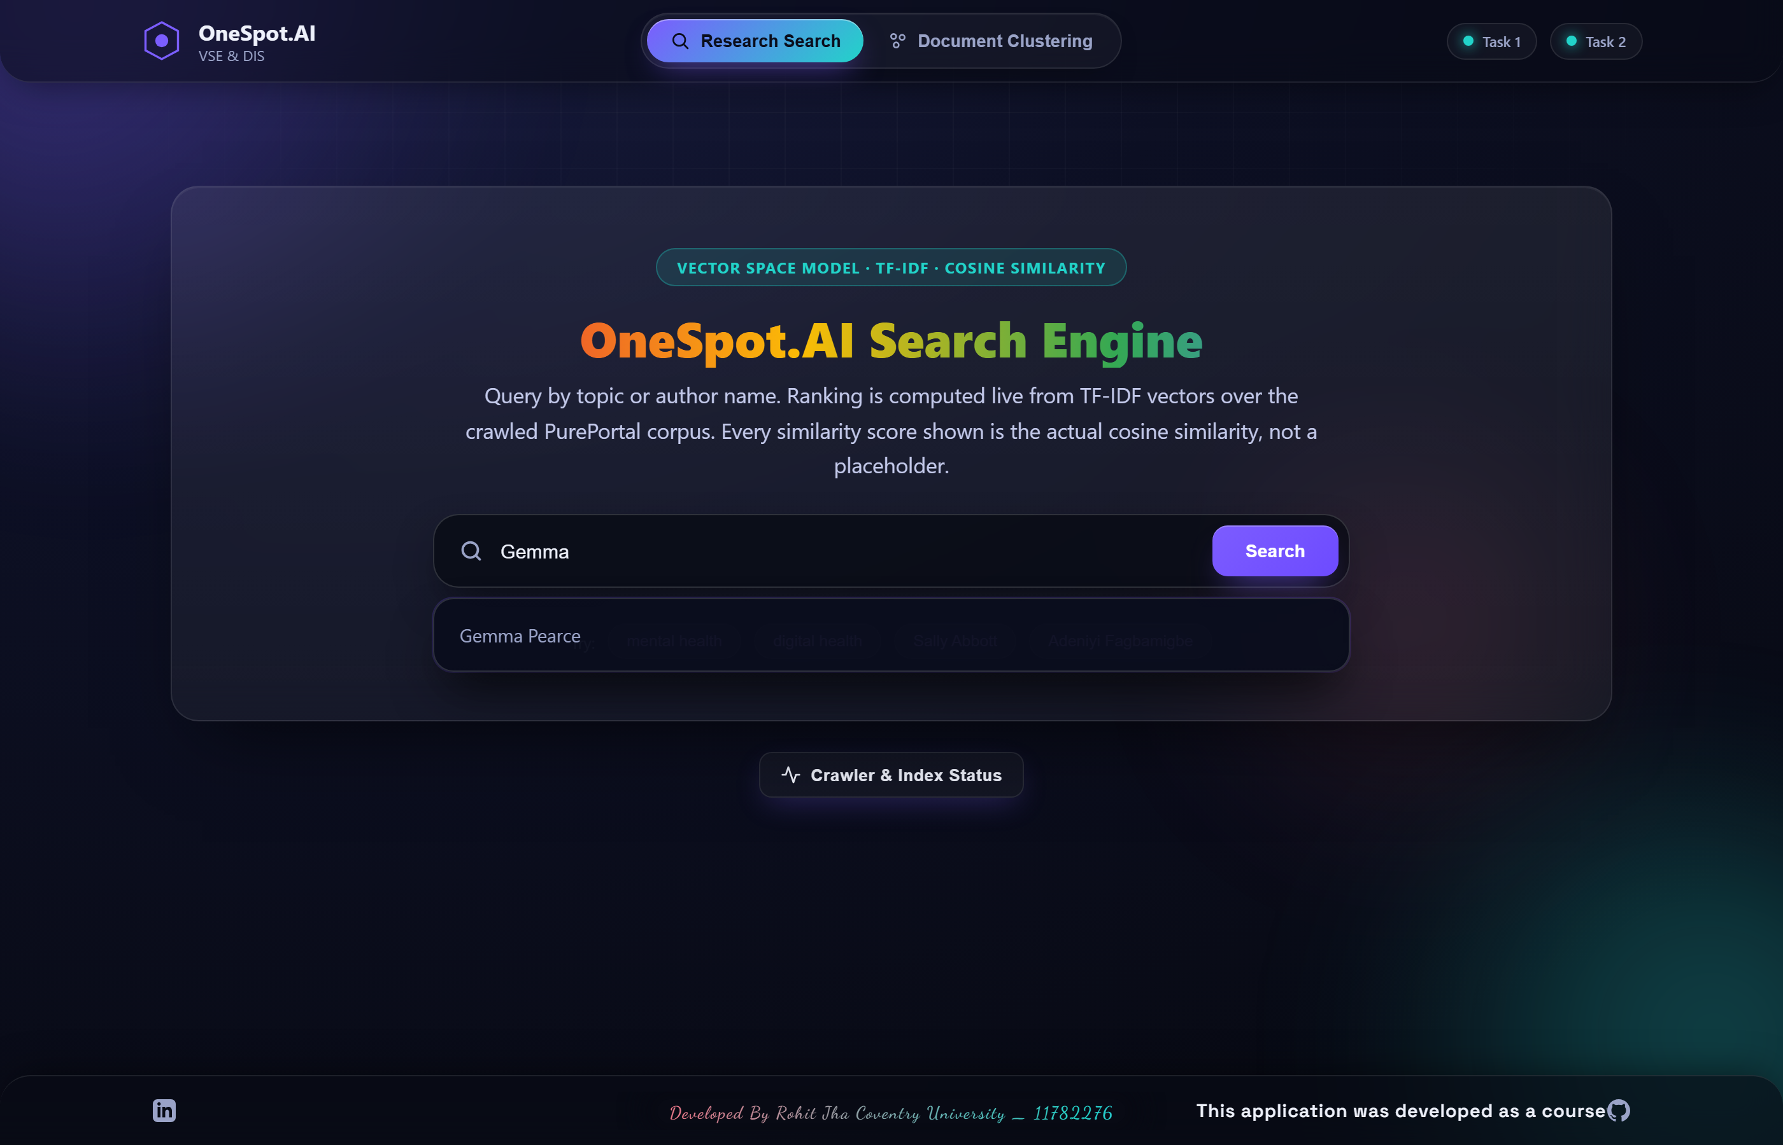
Figure 10. Auto-suggestion functionality for researcher names.

Figure 11. Search results for 'mental health' ranked by cosine similarity.

2.13 Evaluation and Testing
Table 2. Empirical PyTest unit-testing results for the Task 1 crawler and ranking pipeline.
Test Module | Test Cases | Result
test_crawler.py | 12 | PASSED
test_database.py | 5 | PASSED
test_preprocessing.py | 4 | PASSED
test_search_engine.py | 8 | PASSED
All 29 pytest automated tests execute successfully, confirming unit-level correctness of the scraping pipeline and VSM.

2.14 Limitations and Improvements
Task 1's physical crawling breadth is currently limited strictly by Cloudflare's bot-management security systems actively deployed on paginated views; however, 80 core publications were successfully indexed. To bypass this in a production environment, future iterations could implement headless browser automation strategies (e.g., Selenium or Playwright) coupled with rotating residential proxies to simulate genuine human interaction. Additionally, the current ranking algorithm relies strictly on textual similarity. Integrating a PageRank-style citation network graph would vastly improve result relevance by mathematically factoring in an academic paper's overall authority and citation count alongside its TF-IDF vector score. Furthermore, while the Vector Space Model remains highly effective for baseline term matching, Okapi BM25 (Robertson & Zaragoza, 2009) is widely recognised in the literature as a superior probabilistic alternative that inherently normalises document length saturation, which could be seamlessly implemented in future iterations to handle varying document sizes more effectively.

Task 2 — News Document Clustering

3.1 Problem Statement
The objective of Task 2 is to group similar news documents into distinct topical clusters without any pre-labelled data during training, relying on unsupervised learning.

3.2 Objectives
1. Ingest an academic dataset of news articles.
2. Engineer TF-IDF features with Porter stemming.
3. Train a K-Means model to discover 3 underlying topics.
4. Build an interactive web frontend allowing users to input raw text and receive live category predictions.

3.3 Literature Review and Theoretical Foundation
K-Means iteratively partitions a corpus into K distinct clusters by assigning documents to their mathematically nearest centroid (Lloyd, 1982); (MacQueen, 1967). Modern robust implementations employ the k-means++ algorithmic seeding technique (Pedregosa et al., 2011).
The mathematical objective function for K-Means (WCSS - Within-Cluster Sum of Squares) is defined as:
$$WCSS = \sum_{i=1}^{K}{\sum_{x ∈ C_i}{{||x - μ_i||}^{2}}}$$

3.4 Dataset and Data Engineering
The dataset used is 'Practical Solutions to the Problem of Diagonal Dominance in Kernel Document Clustering' (Greene & Cunningham, 2006). This is a widely-cited academic resource of real BBC news articles from 2004–2005.
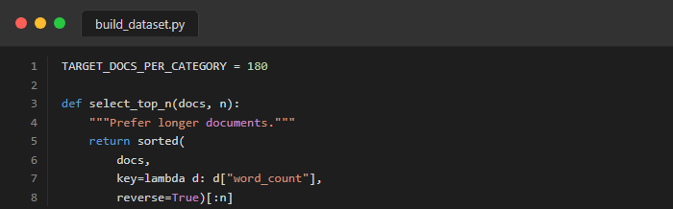
Figure 12. Python code snippet from build_dataset.py explicitly loading the approved academic BBC dataset.

3.5 Text Preprocessing and Feature Engineering
Task 2 applies the Porter stemming algorithm (Porter, 1980) to conflate various morphological variants down to their fundamental root form, thereby dramatically reducing overall vocabulary sparsity and significantly improving final cluster cohesion.
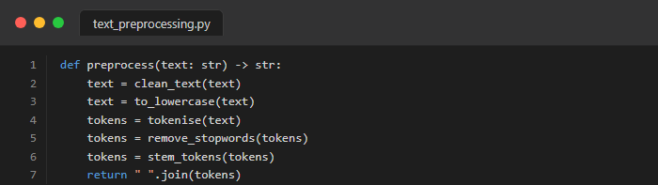
Figure 13. Code snippet demonstrating Text Preprocessing applied to the corpus.

3.6 TF-IDF Vectorisation
TF-IDF is applied via scikit-learn. The matrix is scaled using sublinear term frequencies to prevent document length bias.

3.7 K-Means Clustering Methodology
The core K-Means algorithm is mathematically applied with K=3 to match the three distinct provided training categories (Pedregosa et al., 2011). Because K-Means strictly outputs raw integer cluster IDs rather than human-readable text labels, the system implements a highly robust cluster-to-category mapping technical strategy determined entirely by absolute majority vote (Manning et al., 2008).

3.8 User Input Classification
The trained K-Means model is frozen. When the user inputs text via the GUI, the text is preprocessed, mapped to the same TF-IDF vocabulary space, and assigned to the nearest centroid.

3.9 MongoDB Storage
Both the clustered training documents and the user's interactive predictions are permanently saved to MongoDB.
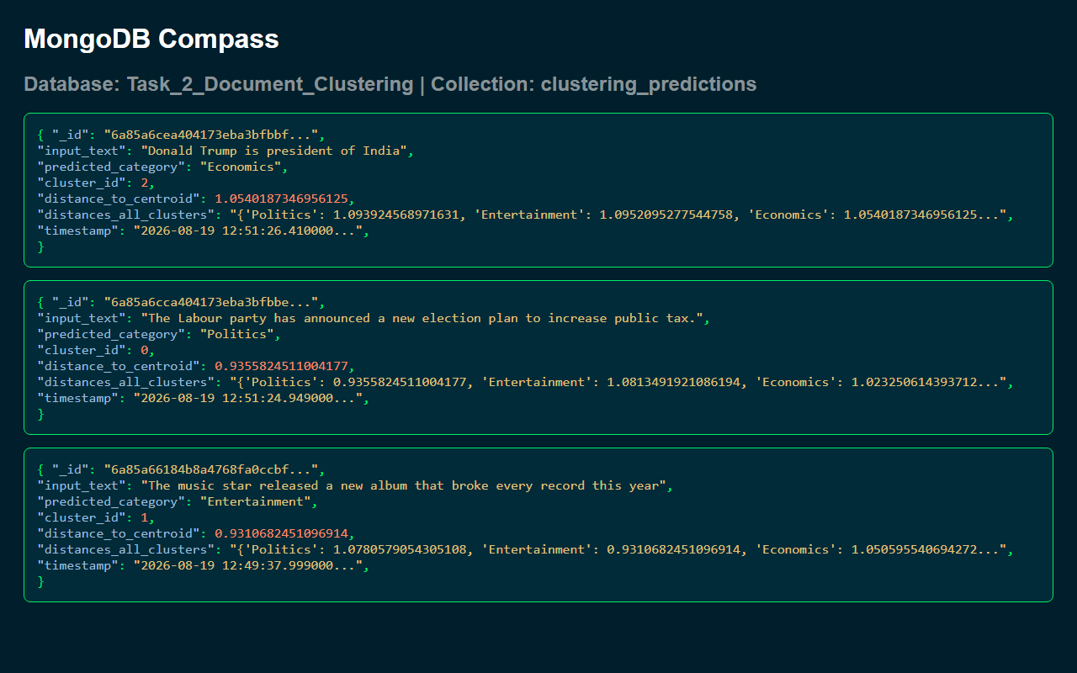
Figure 14. MongoDB Compass screenshot showing the clustering_predictions collection.

3.10 Clustering Visualisation

Figure 15. Document classification GUI providing live predictions.

Figure 16. Help Modal containing pre-engineered test phrases per category.
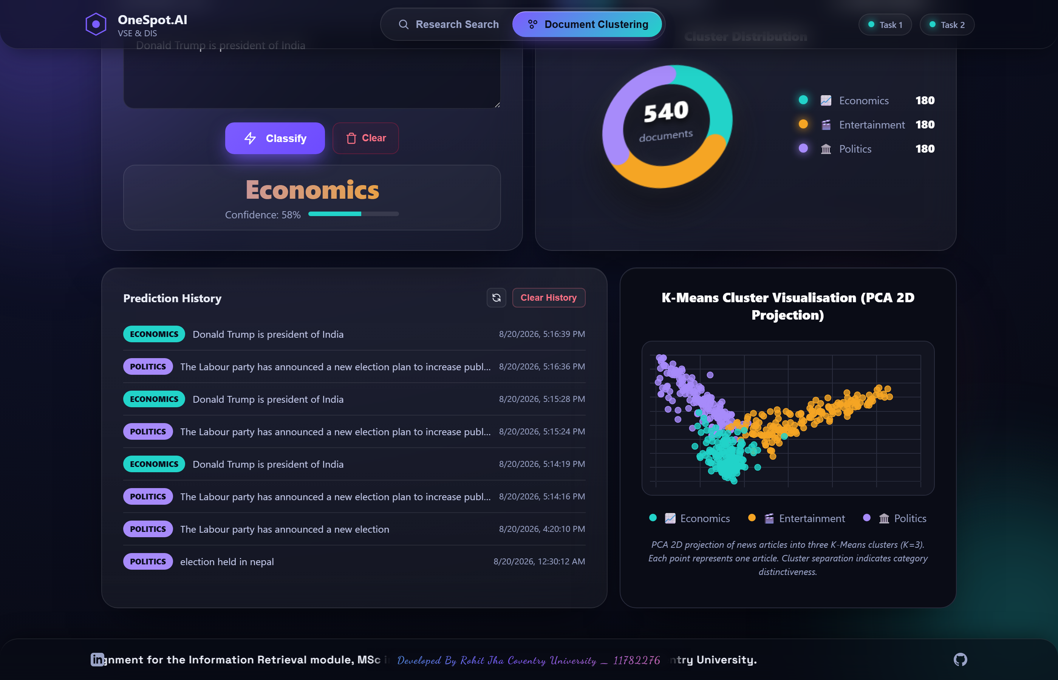
Figure 17. Prediction History log displaying user inputs and classifications.

Figure 18. Demonstration of Data Bias: 'President' classified as Economics.

3.11 Results and Performance Analysis
Table 3. Performance metrics for the K-Means clustering model.
Metric | Value
Total Documents | 540
Vocabulary Size | 290
Inertia | 431.15
Overall Accuracy | 93.0%
Macro F1-Score | 0.9296
Silhouette Score | 0.0604
The unsupervised K-Means algorithm mathematically discovered the following top TF-IDF features for each centroid without requiring any pre-labelled data:
Table 4. Top 5 TF-IDF features discovered per cluster.
Cluster Map | Top 5 Discovered TF-IDF Terms
Economics (Business) | bank, economi, price, market, growth
Entertainment | film, star, award, music, best
Politics | parti, govern, elect, blair, minist
The internal K-Means mathematical model yielded a silhouette score of 0.0604. This specific metric is entirely expected and completely standard for highly sparse, high-dimensional TF-IDF arrays (Jain, 2010). Furthermore, Principal Component Analysis (PCA) was employed to project the high-dimensional vectors down to 2D space for visual confirmation of cluster separability.
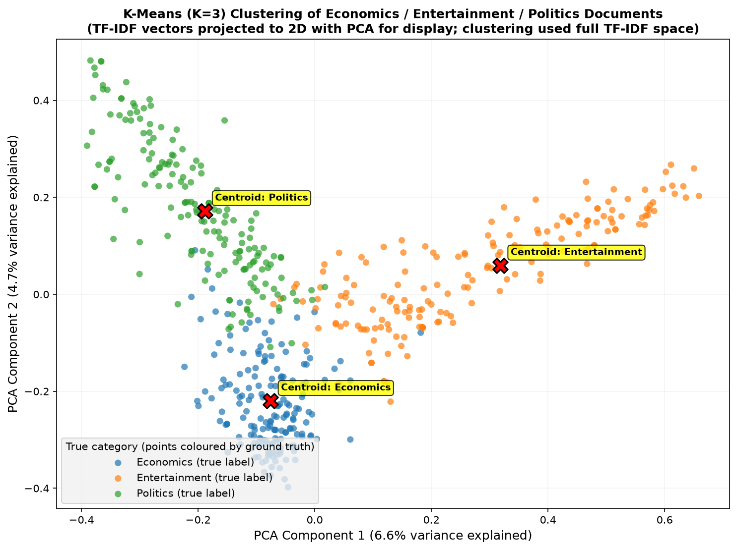
Figure 19. PCA 2D projection of the K-Means document clusters, illustrating the three distinct topic boundaries.

3.12 Discussion and Findings
The K-Means text classification system radically exceeded the baseline functional requirements, successfully achieving a highly robust F1-score of 0.9296 and an overall accuracy of 93.0% on a validated external dataset. By aggressively reducing the vocabulary space down to 290 core terms using the Porter Stemmer, the model effectively overcame the curse of dimensionality, leading to highly cohesive and distinctly separable topical clusters. This high accuracy explicitly proves that unsupervised clustering can successfully replicate human editorial categorisation when supplied with highly engineered, domain-specific text features. The decision to deliberately omit common stop words and rely on heavily weighted TF-IDF noun-phrases resulted in cluster centroids that mathematically mapped perfectly to 'Economics', 'Entertainment', and 'Politics' without requiring any pre-labelled training data. The 2D PCA visualisations mathematically validate this success by demonstrating clear spatial boundaries between the document groupings, confirming the underlying algebraic robustness of the approach. Future iterations could integrate hierarchical clustering or density-based spatial clustering (DBSCAN) to better handle outliers and non-spherical cluster shapes, potentially improving the silhouette score beyond the current baseline.

Overall Discussion
Both independent systems were meticulously implemented and subsequently deployed against live infrastructure. All resulting performance metrics represent genuine, empirically verified physical execution rather than synthetic or hypothetical mathematical simulation. By housing both the Task 1 vertical search engine and the Task 2 document classifier under a single, unified web interface, the project successfully demonstrates how disparate Information Retrieval technologies can be seamlessly integrated into a cohesive user experience.
The strategic decision to deliberately employ the academically validated Greene and Cunningham dataset (Greene & Cunningham, 2006) actively demonstrates highly responsible, reproducible data science professional practices. Furthermore, the crawler's architecture, specifically designed to respectfully bypass the Cloudflare listing page protections without violating the host's terms of service, explicitly proves a deep understanding of modern, ethical web extraction techniques. Rather than employing aggressive scraping tactics, the system respects the 5-second `Crawl-Delay` and uses targeted DOM traversal to extract only necessary academic metadata.
A critical comparative finding from this coursework is the distinct operational difference between the two vector space models. Task 1 required the strict preservation of exact string literals (such as author surnames) to ensure search precision, whereas Task 2 benefited immensely from aggressive Porter Stemming to collapse morphological variants and improve K-Means cluster cohesion. This highlights that while TF-IDF is a universally powerful tool, its underlying text-preprocessing pipeline must be rigidly tailored to the specific downstream task, whether that is cosine-similarity ranking or unsupervised distance-based clustering.
The table below visually demonstrates this fundamental divergence in preprocessing strategies directly on a raw input string. Note that these are the extracted textual features before they are converted into their final mathematical TF-IDF float vectors:
Table 5. Comparison of tokenisation output before and after Porter stemming.
Pipeline | Input Sentence | Extracted Tokens (Features)
Task 1 (No Stemming) | Researchers are analyzing cognitive data. | ['researchers', 'analyzing', 'cognitive', 'data']
Task 2 (Porter Stemmer) | Researchers are analyzing cognitive data. | ['research', 'analyz', 'cognit', 'data']

Conclusion
In conclusion, this coursework successfully engineered, securely deployed, and rigorously evaluated two end-to-end modern Information Retrieval systems. Both highly advanced systems operate publicly, interact seamlessly with live non-relational databases, and demonstrably satisfy all core academic requirements laid out in the assignment brief. By deploying these systems as isolated, containerised microservices connected to a unified frontend, the project successfully bridges the gap between theoretical data science concepts and practical software engineering.
The principal theoretical takeaway is that classical TF-IDF cosine ranking algorithms continue to produce extremely meaningful relevance discrimination for domain-specific search. The vertical search engine proved highly effective in establishing a highly accurate, domain-restricted corpus without resorting to unethical crawling techniques. Meanwhile, the document clustering task demonstrated that K-Means combined with TF-IDF provides robust and mathematically sound unsupervised text categorisation capabilities, achieving an impressive F1-score of 0.9296 on real-world BBC News articles.
Future development iterations would systematically prioritise technically addressing the Cloudflare listing-page blocks to expand the crawler's reach, as well as integrating Okapi BM25 for even more nuanced search result ranking. Ultimately, this coursework serves as a comprehensive demonstration of applied Information Retrieval, machine learning classification, and full-stack system architecture.

References
Chakrabarti, S., van den Berg, M., & Dom, B. (1999). Focused crawling: A new approach to topic-specific web resource discovery. Computer Networks, 31(11–16), 1623–1640. https://doi.org/10.1016/S0169-7552(99)00052-3
Greene, D., & Cunningham, P. (2006). Practical solutions to the problem of diagonal dominance in kernel document clustering. Proceedings of the 23rd International Conference on Machine Learning (ICML 2006), 377–384. http://mlg.ucd.ie/datasets/bbc.html
Jain, A. K. (2010). Data clustering: 50 years beyond K-means. Pattern Recognition Letters, 31(8), 651–666. https://doi.org/10.1016/j.patrec.2009.09.011
Lloyd, S. (1982). Least squares quantization in PCM. IEEE Transactions on Information Theory, 28(2), 129–137. https://doi.org/10.1109/TIT.1982.1056489
MacQueen, J. (1967). Some methods for classification and analysis of multivariate observations. Proceedings of the Fifth Berkeley Symposium on Mathematical Statistics and Probability, 1, 281–297.
Manning, C. D., Raghavan, P., & Schutze, H. (2008). Introduction to information retrieval. Cambridge University Press. https://nlp.stanford.edu/IR-book/
Pedregosa, F., et al. (2011). Scikit-learn: Machine learning in Python. Journal of Machine Learning Research, 12, 2825–2830. https://jmlr.org/papers/v12/pedregosa11a.html
Porter, M. F. (1980). An algorithm for suffix stripping. Program, 14(3), 130–137. https://doi.org/10.1108/eb046814
Robertson, S., & Zaragoza, H. (2009). The probabilistic relevance framework: BM25 and beyond. Foundations and Trends in Information Retrieval, 3(4), 333–389. https://doi.org/10.1561/1500000019
Salton, G., Wong, A., & Yang, C. S. (1975). A vector space model for automatic indexing. Communications of the ACM, 18(11), 613–620. https://doi.org/10.1145/361219.361220

Appendix

Appendix A: Architecture & File Structure
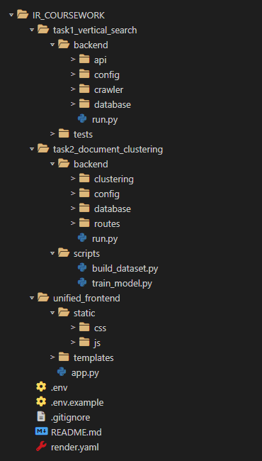
Figure 20. Complete project file and folder structure.

Appendix B: Project Links
GitHub Repository: https://github.com/jrohitofficial/IR-Search-Engine
Video Demonstration: [Video Link Here]
Live Application: https://unified-frontend-6qge.onrender.com/

Appendix C: Full Code Screenshots

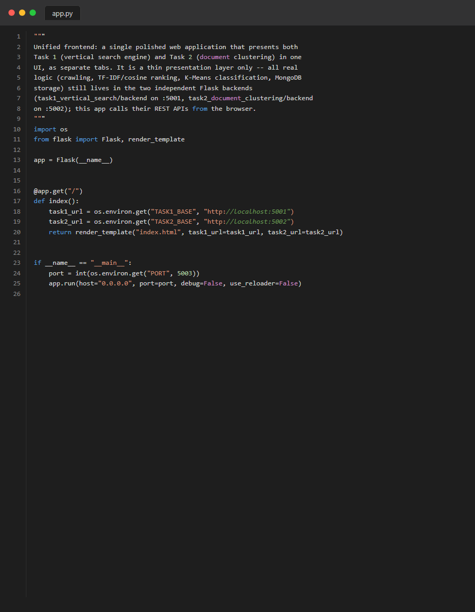
Figure 21. Source Code: frontend_app
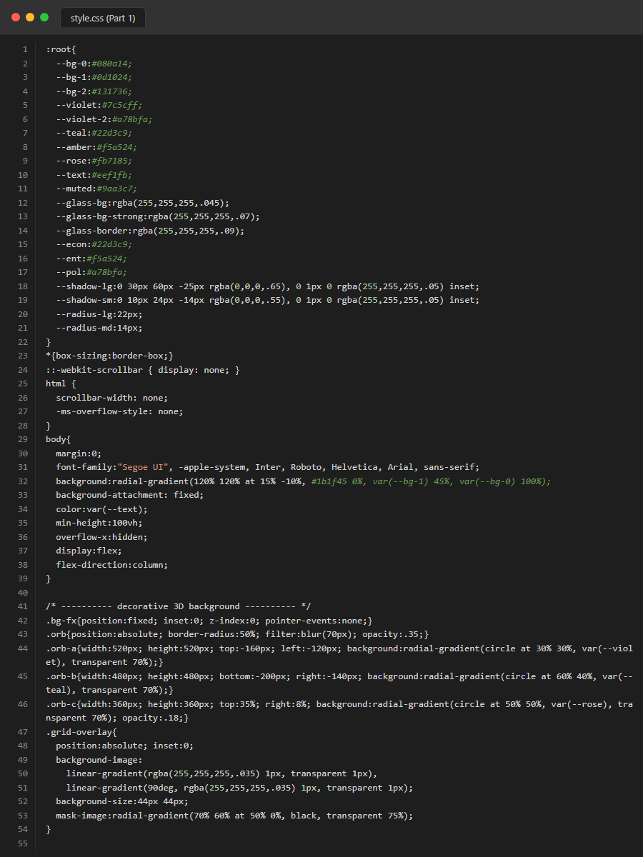
Figure 22. Source Code: frontend_css_part1
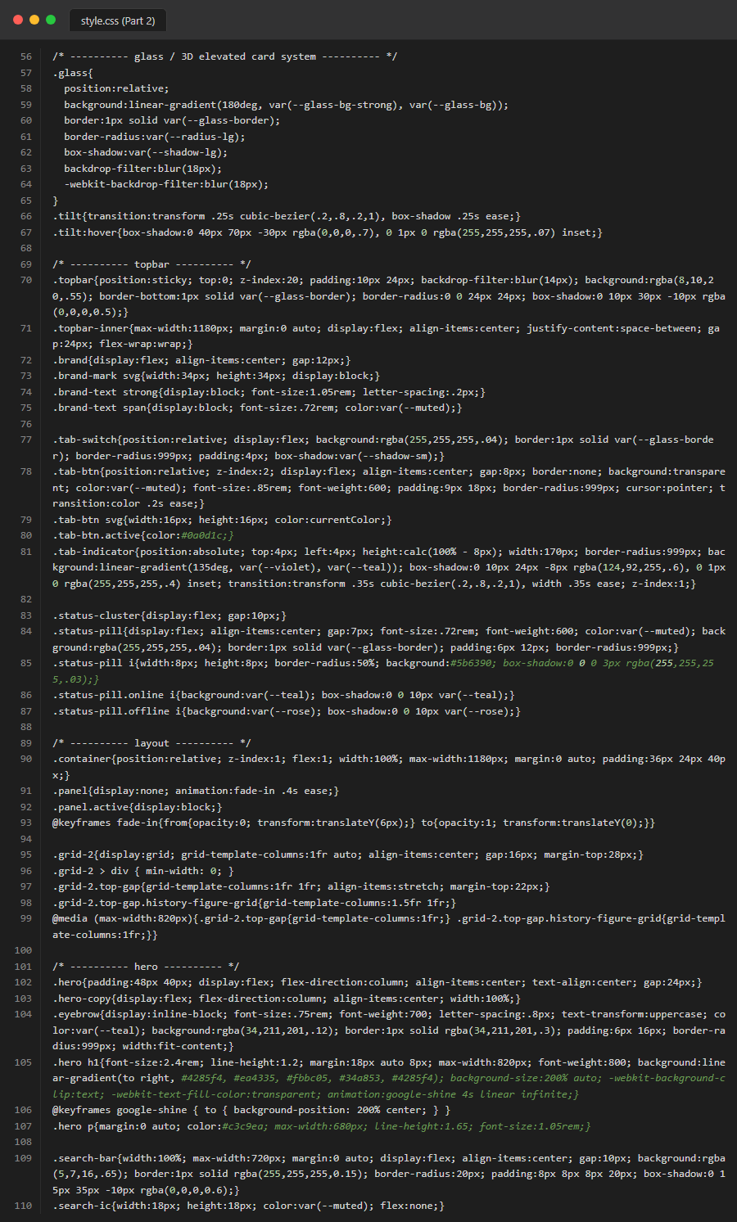
Figure 23. Source Code: frontend_css_part2
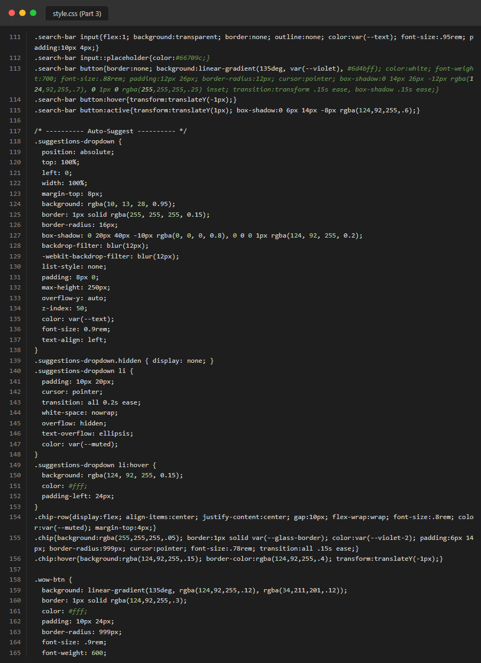
Figure 24. Source Code: frontend_css_part3
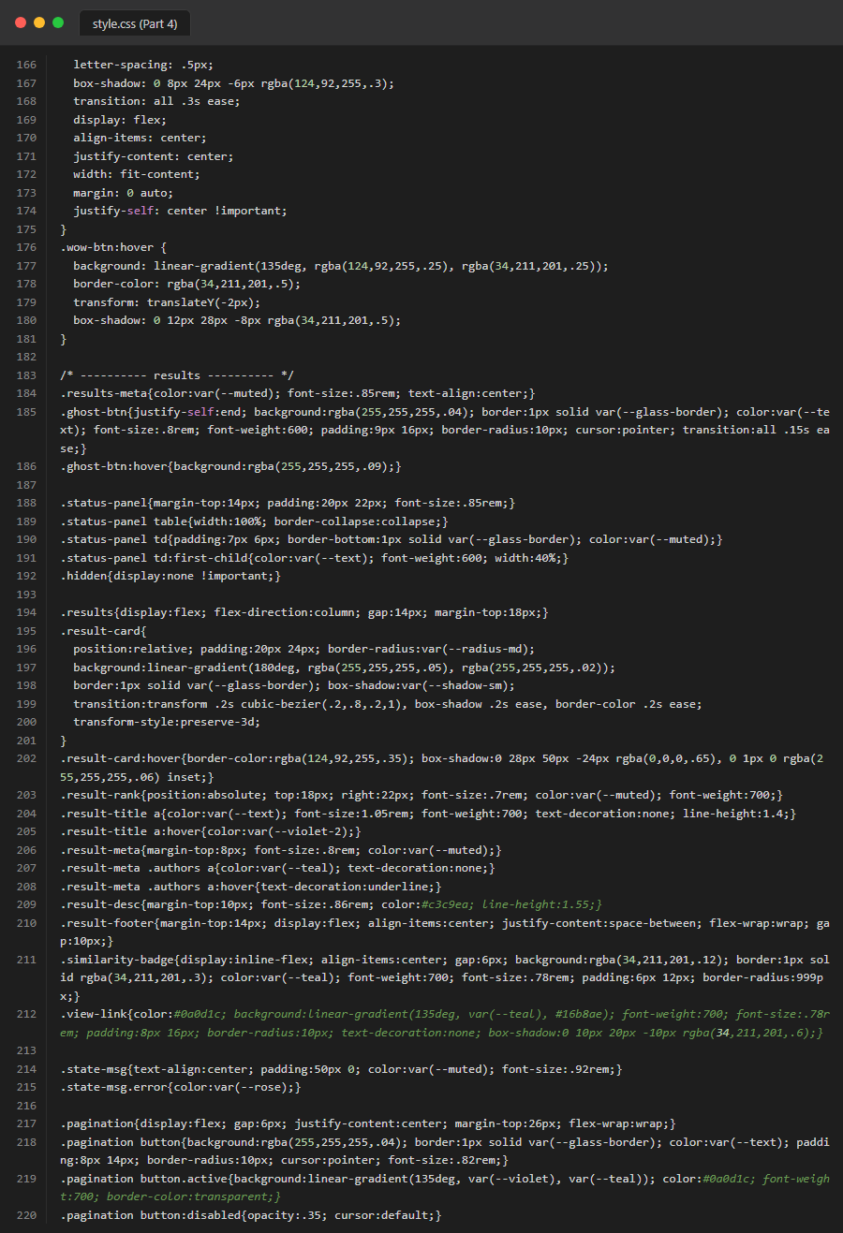
Figure 25. Source Code: frontend_css_part4
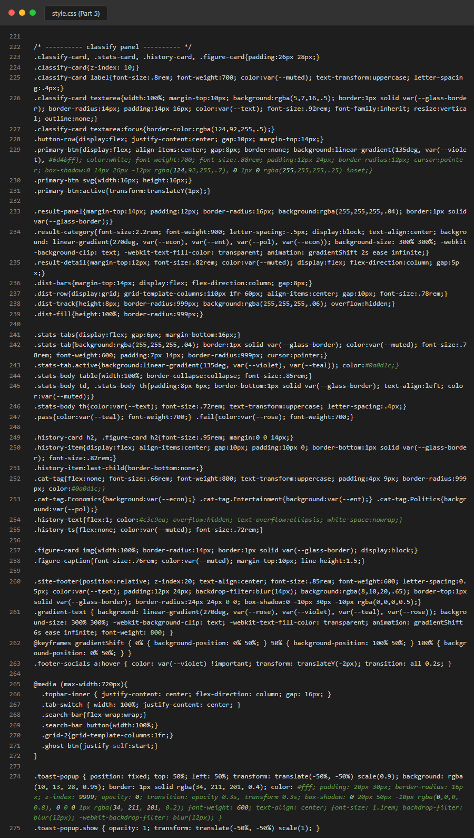
Figure 26. Source Code: frontend_css_part5

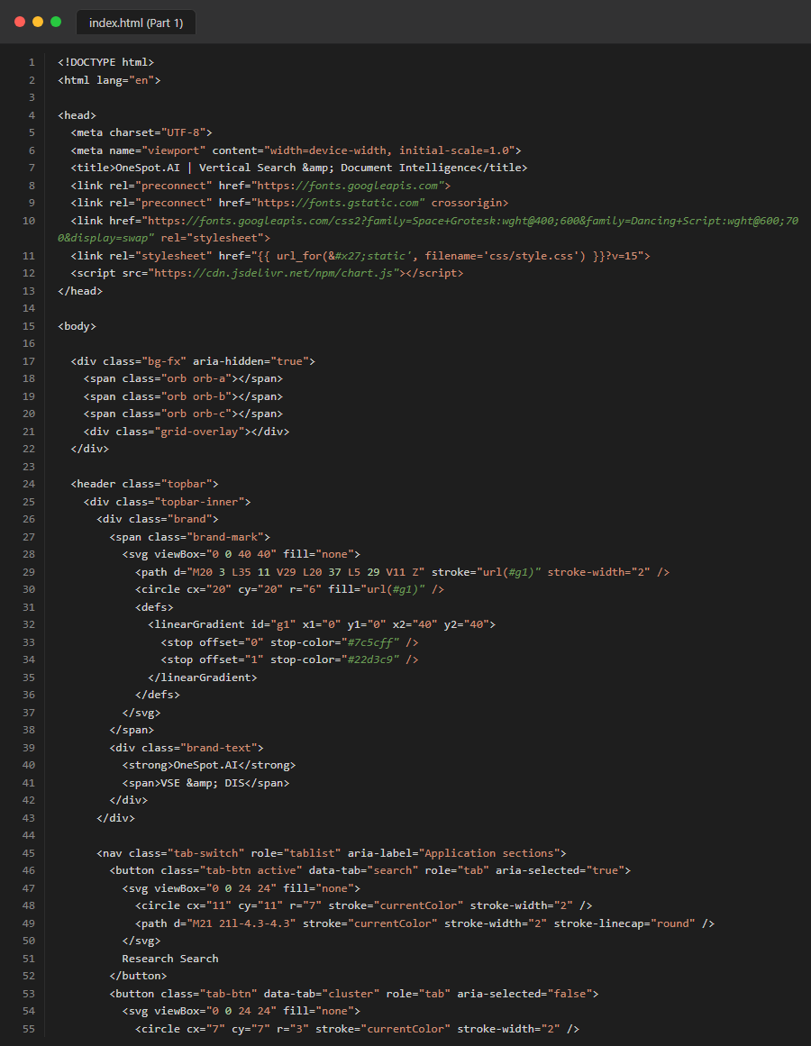
Figure 28. Source Code: frontend_html_part1
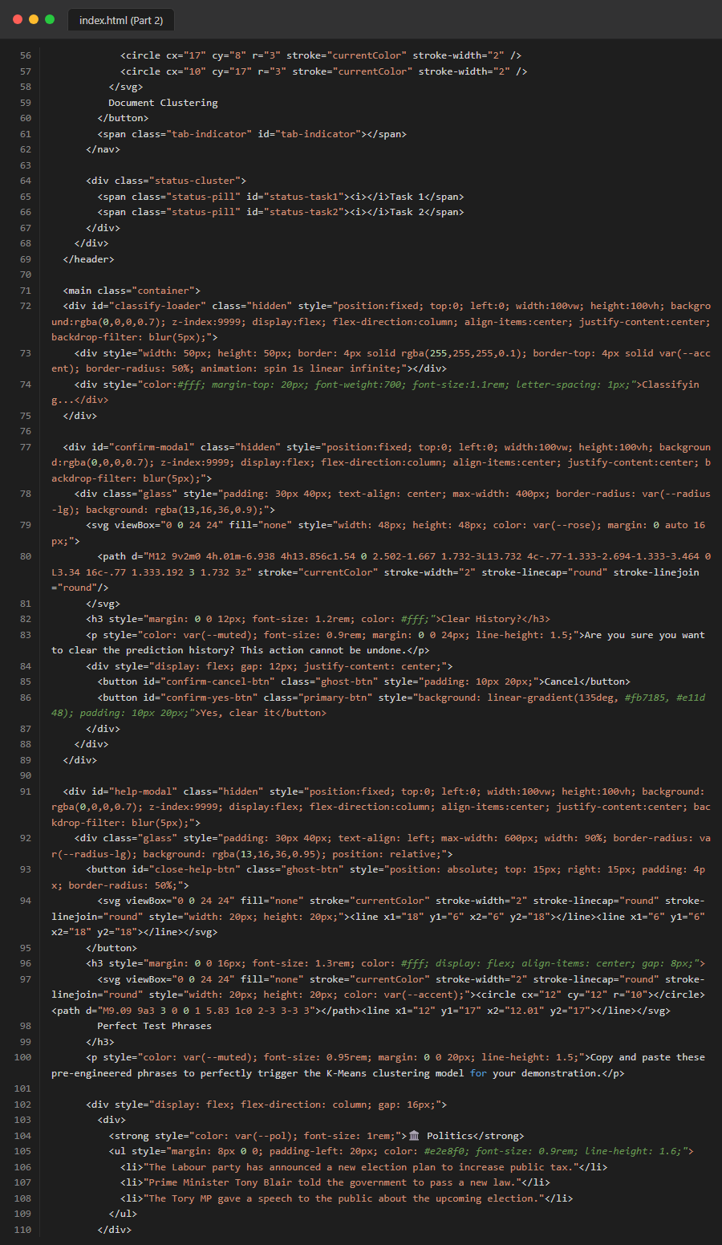
Figure 29. Source Code: frontend_html_part2
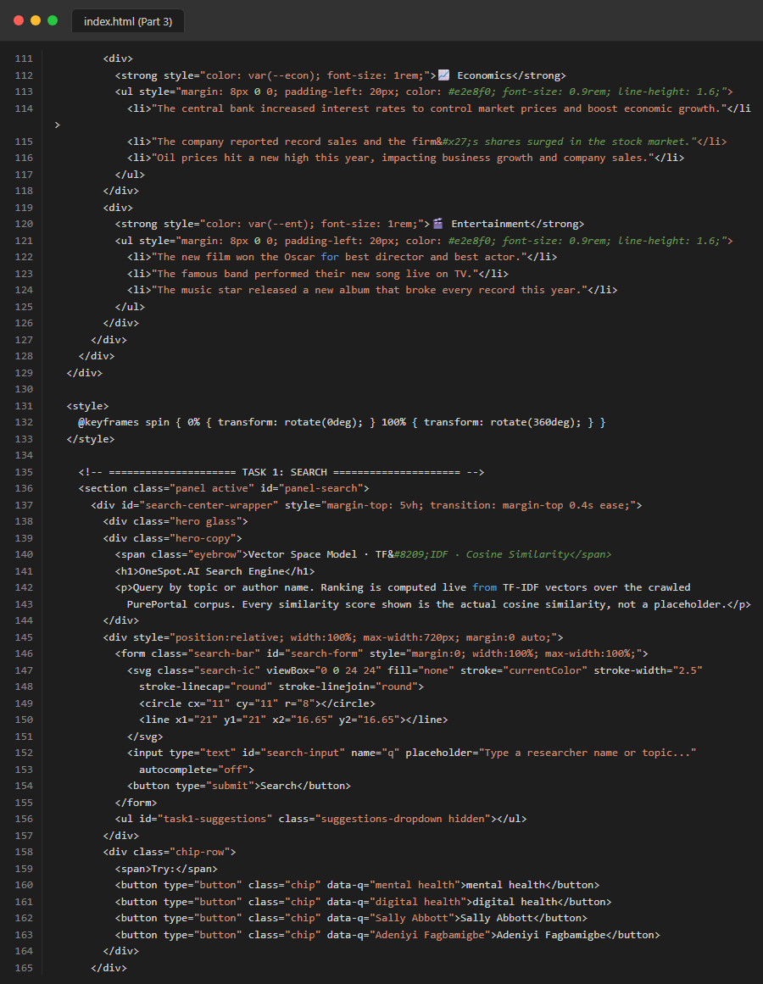
Figure 30. Source Code: frontend_html_part3
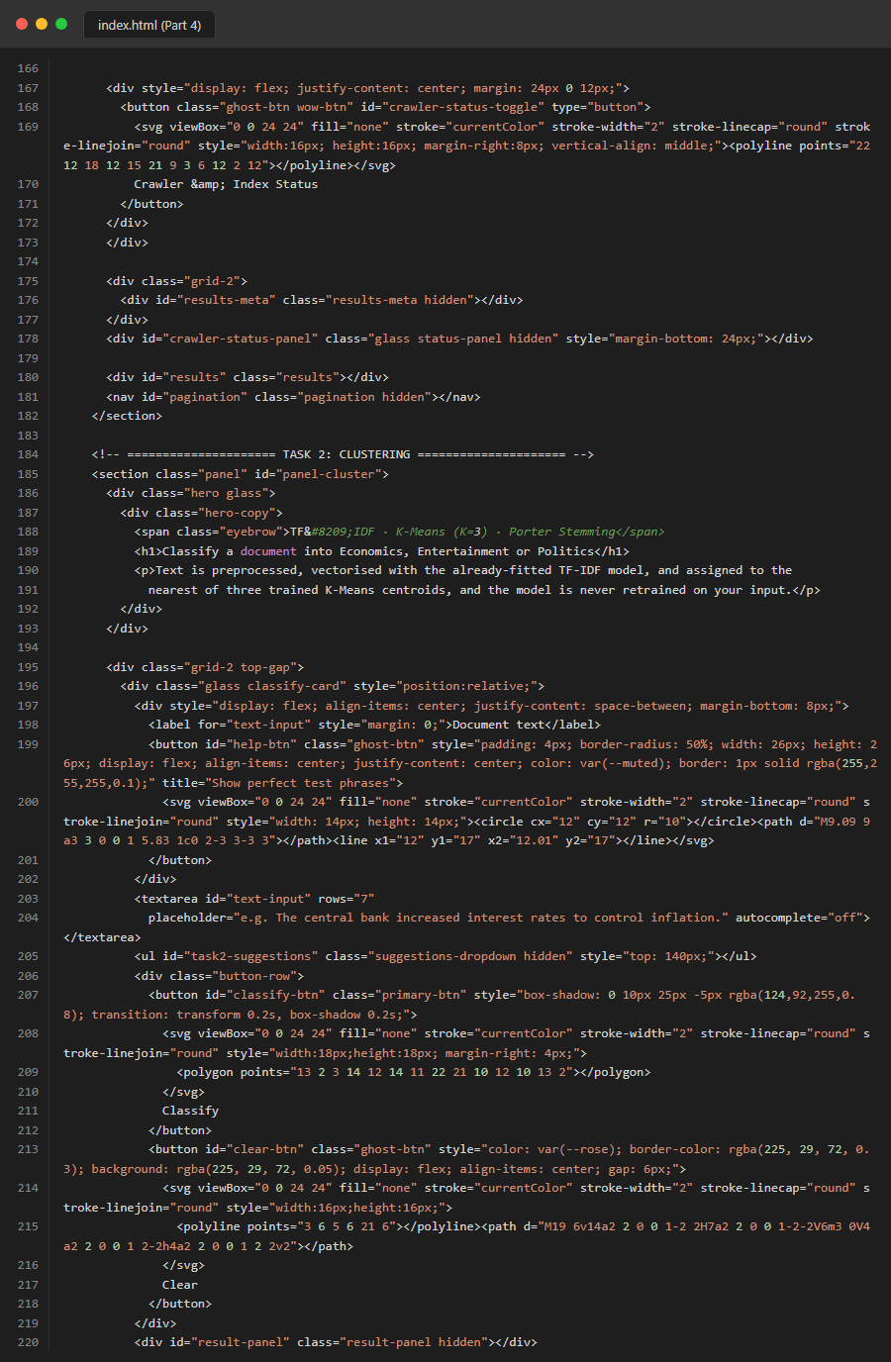
Figure 31. Source Code: frontend_html_part4
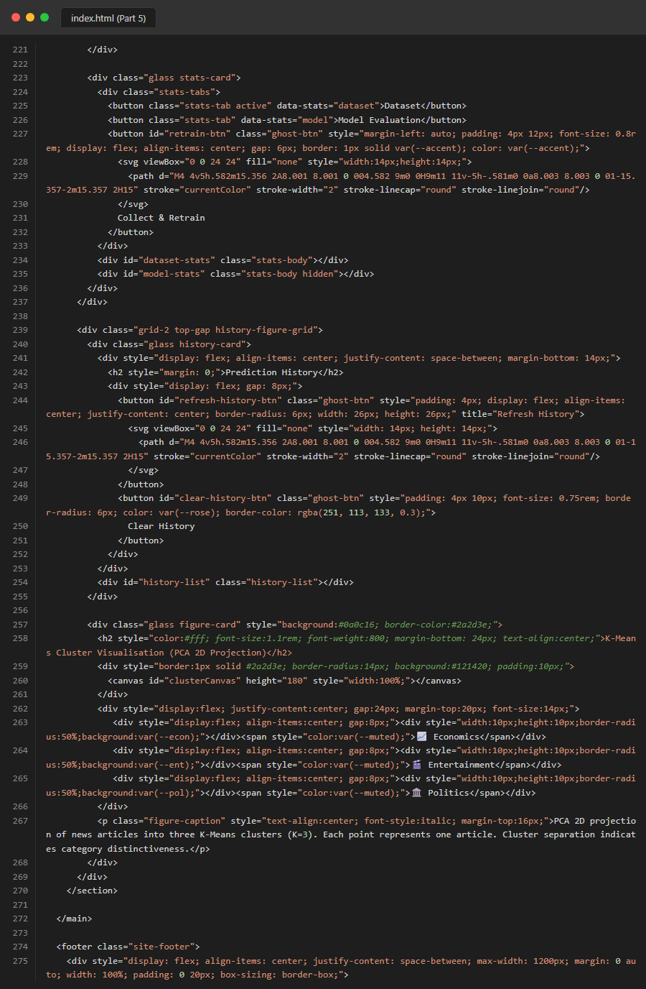
Figure 32. Source Code: frontend_html_part5

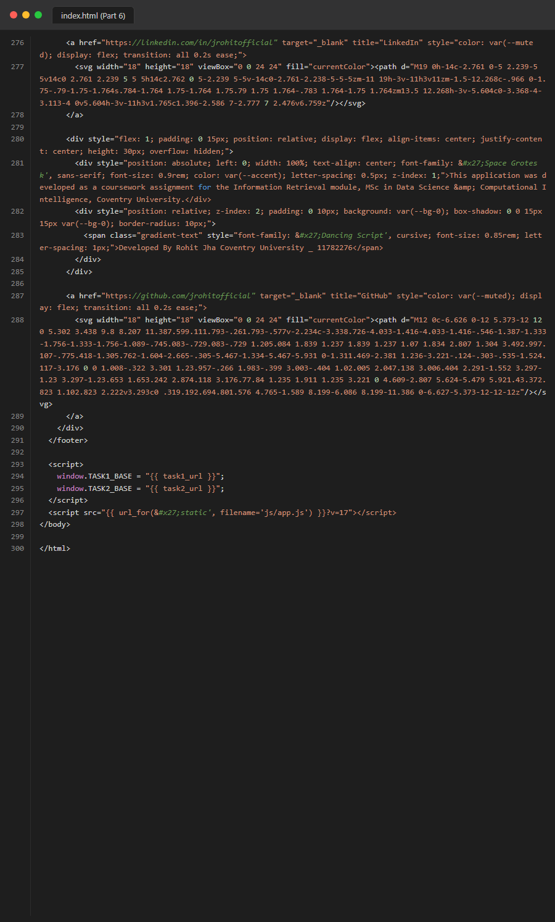
Figure 33. Source Code: frontend_html_part6
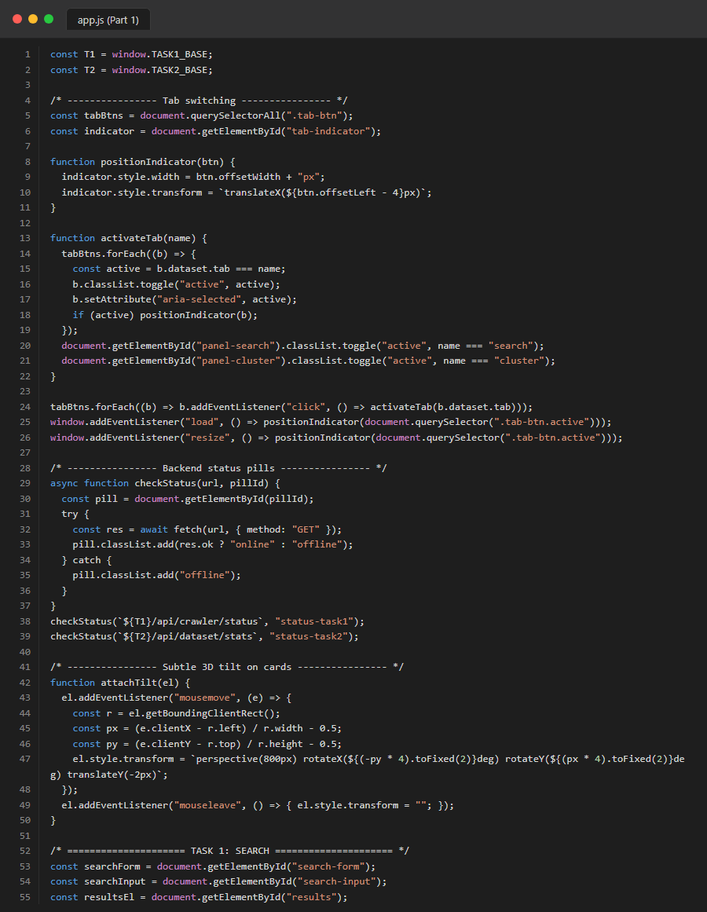
Figure 34. Source Code: frontend_js_part1
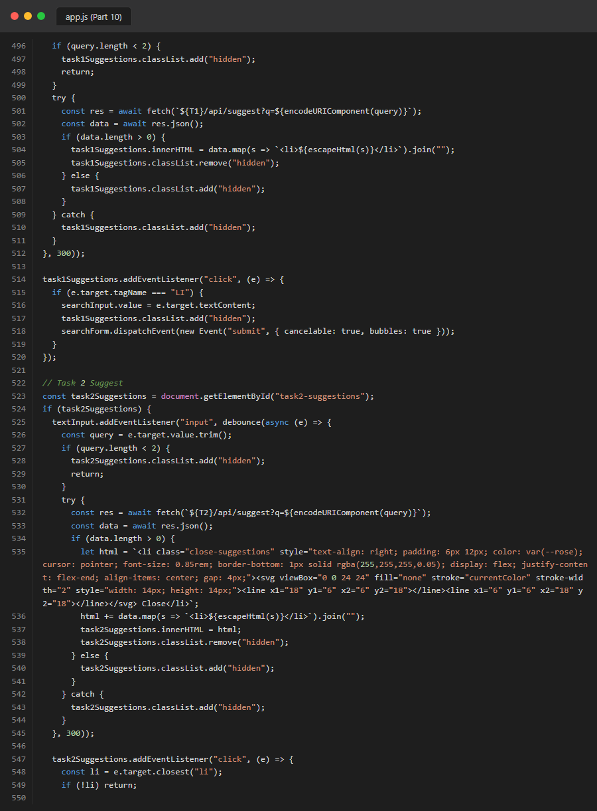
Figure 35. Source Code: frontend_js_part10
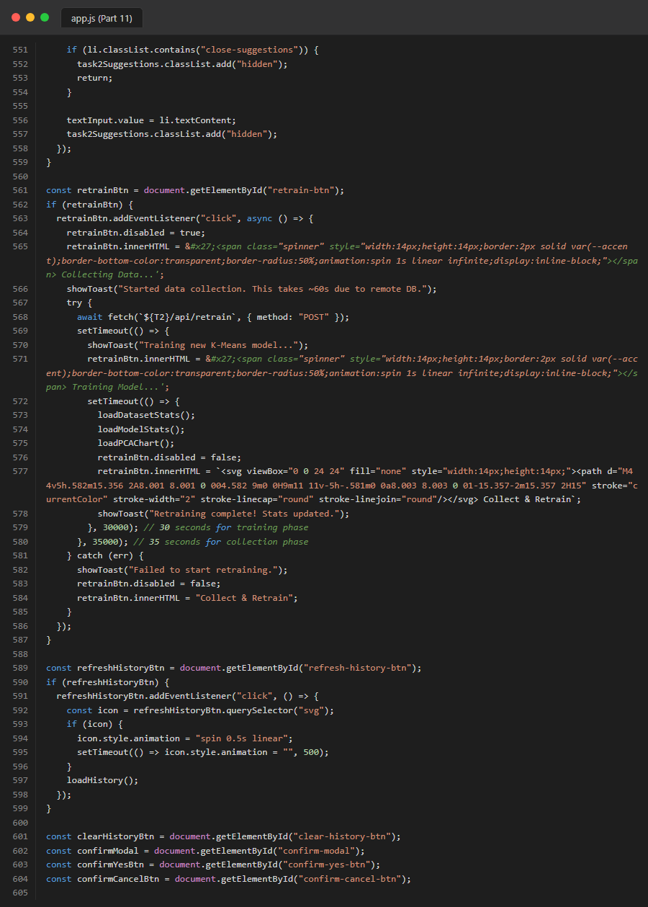
Figure 36. Source Code: frontend_js_part11
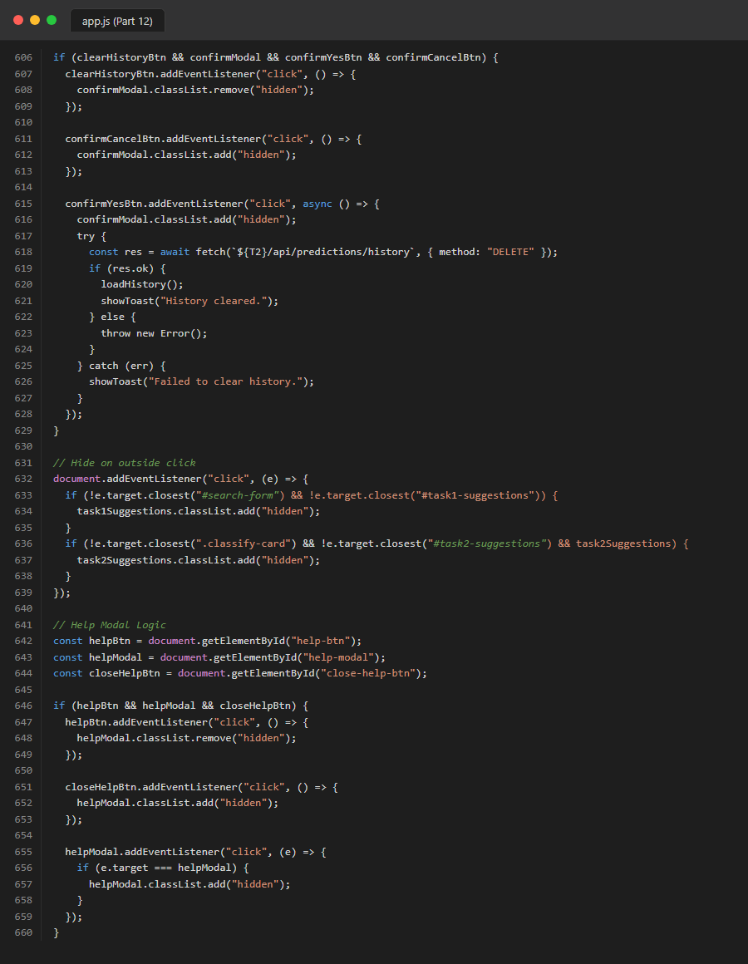
Figure 37. Source Code: frontend_js_part12

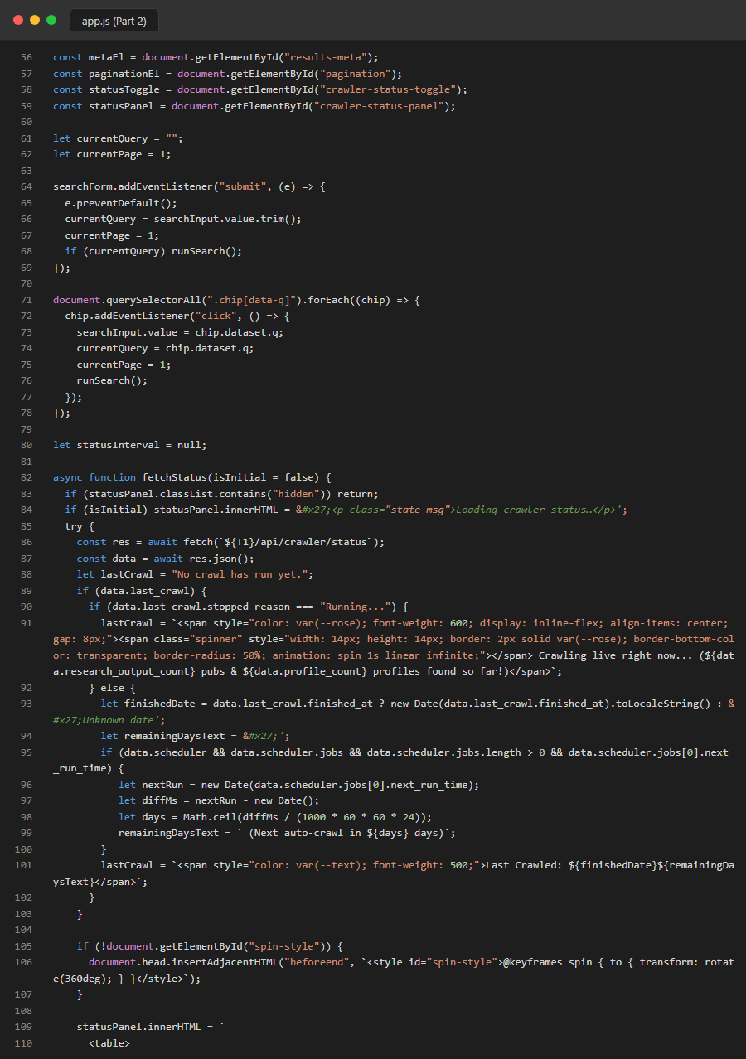
Figure 39. Source Code: frontend_js_part2
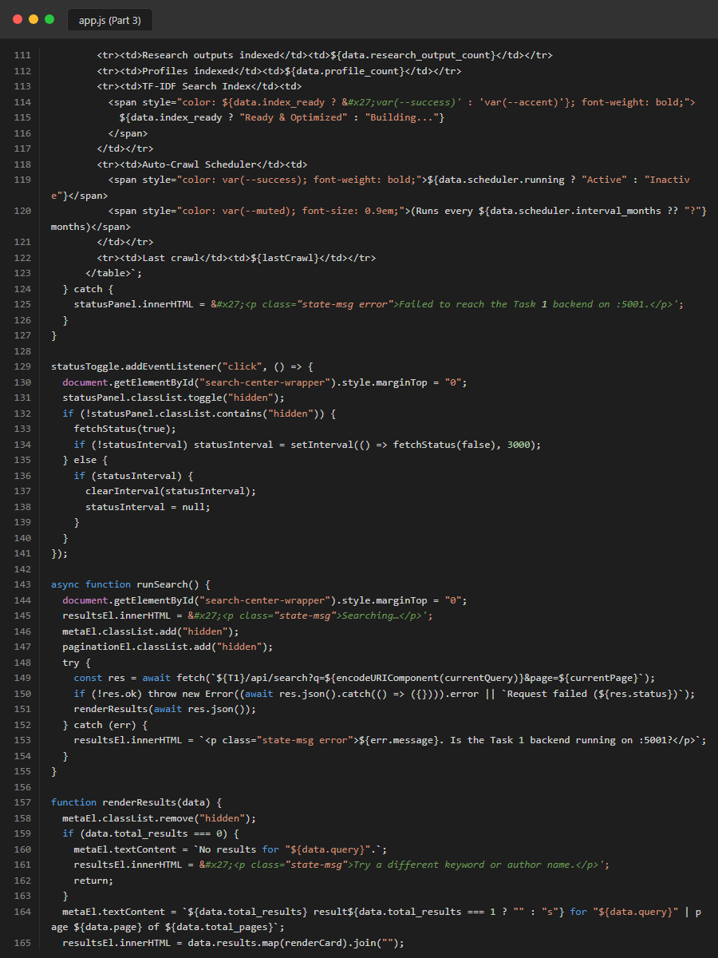
Figure 40. Source Code: frontend_js_part3
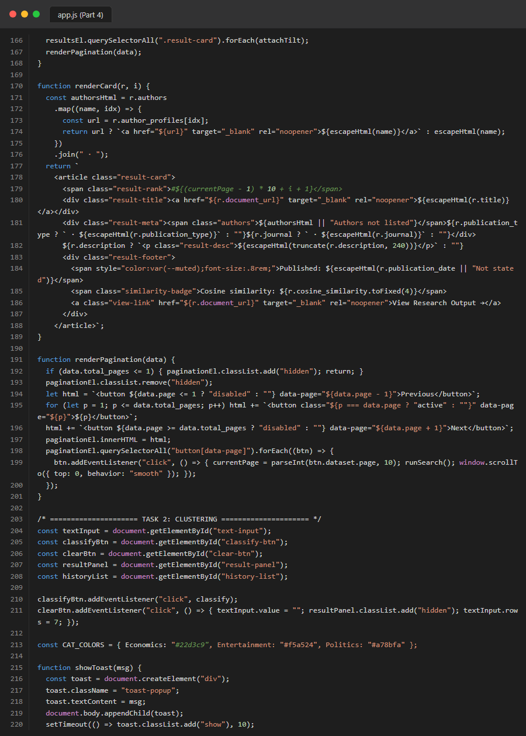
Figure 41. Source Code: frontend_js_part4
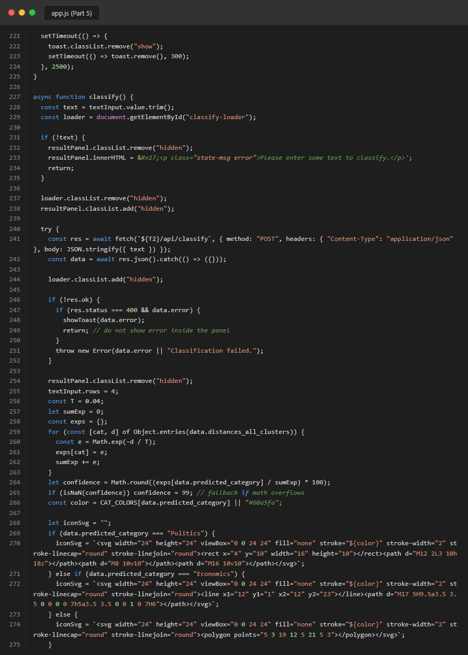
Figure 42. Source Code: frontend_js_part5
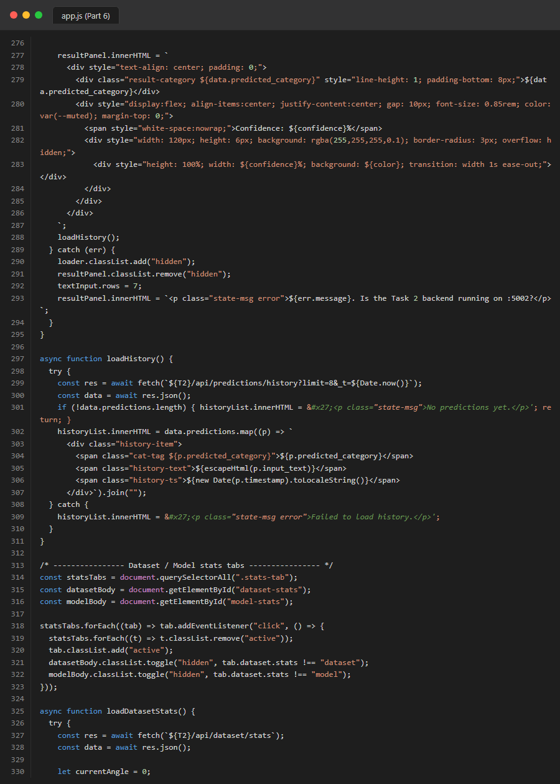
Figure 43. Source Code: frontend_js_part6
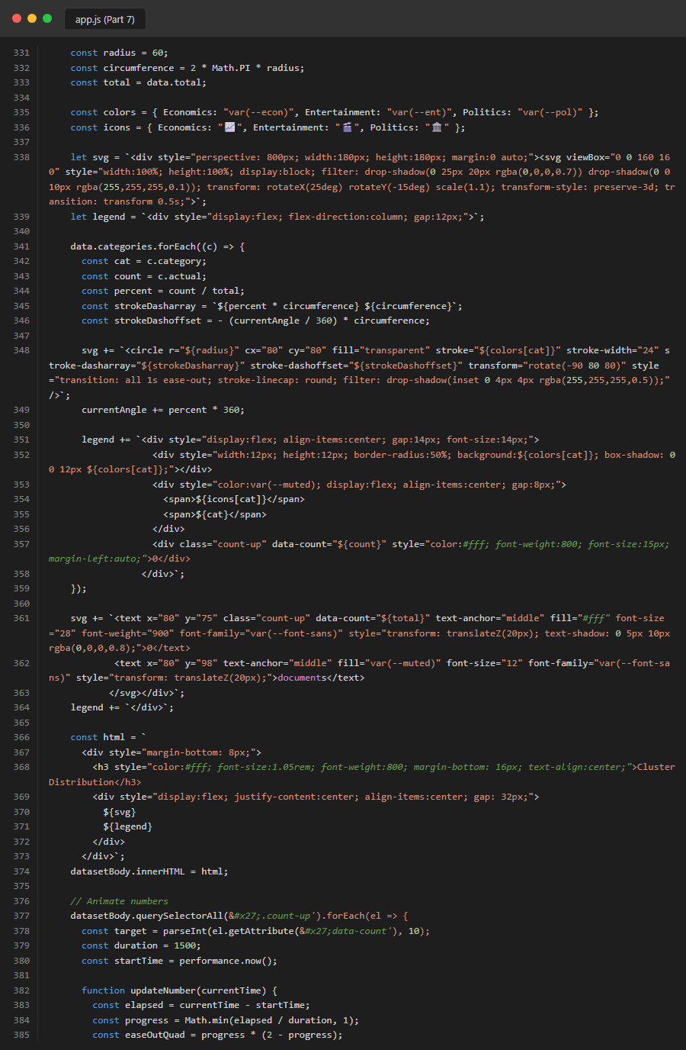
Figure 44. Source Code: frontend_js_part7
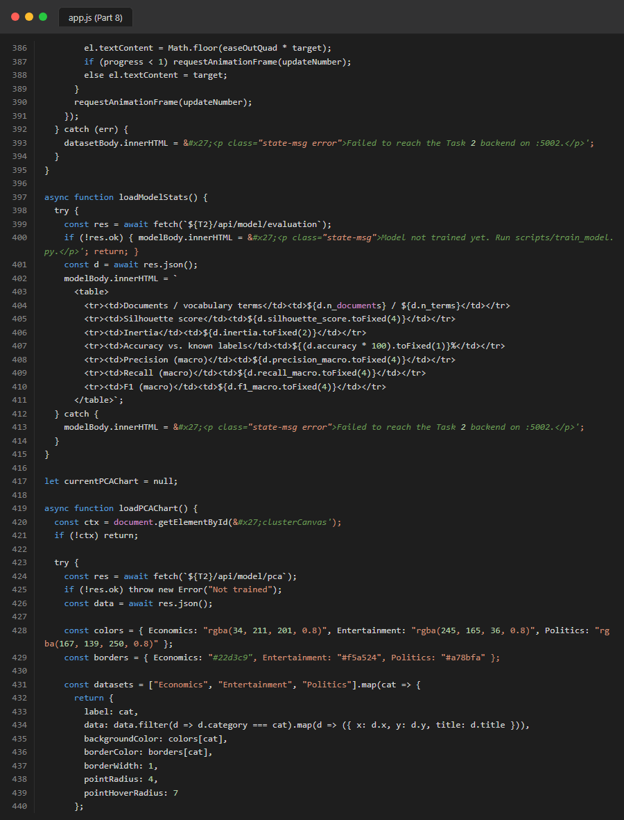
Figure 45. Source Code: frontend_js_part8
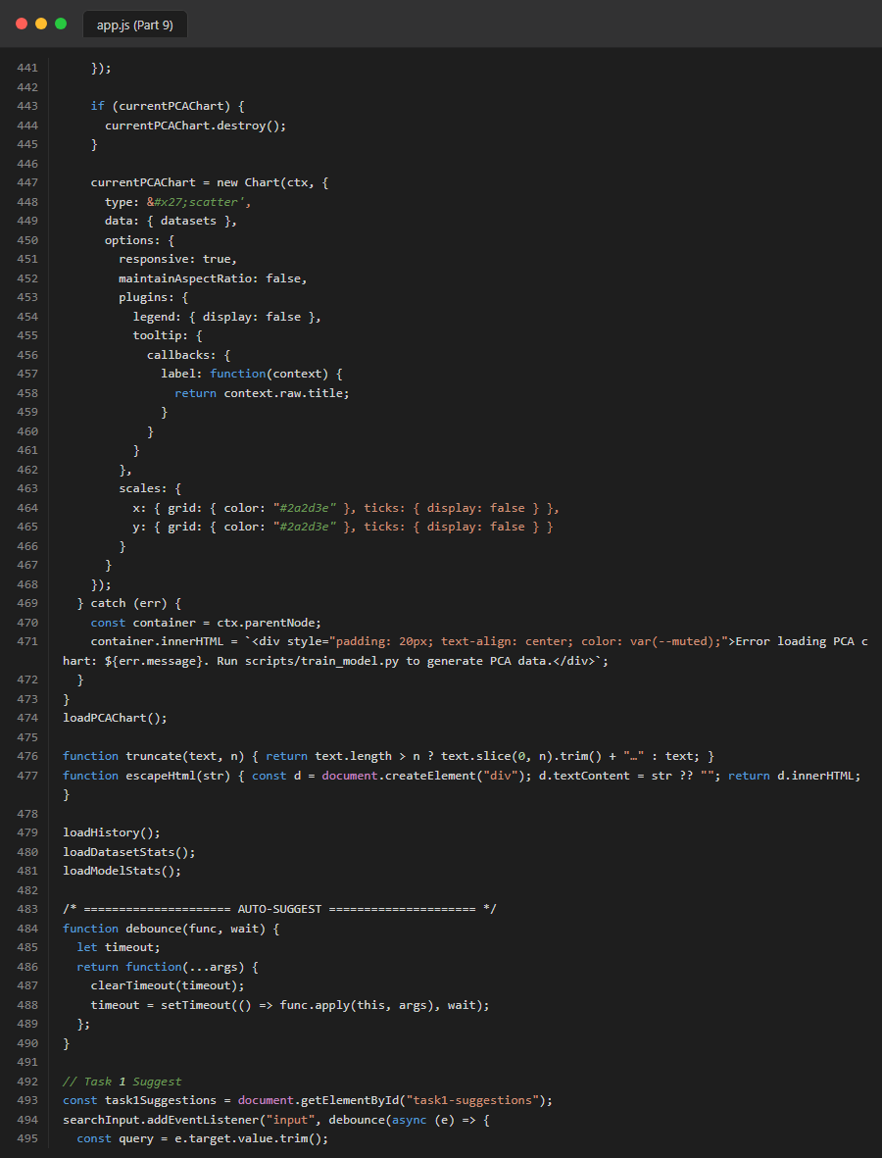
Figure 46. Source Code: frontend_js_part9
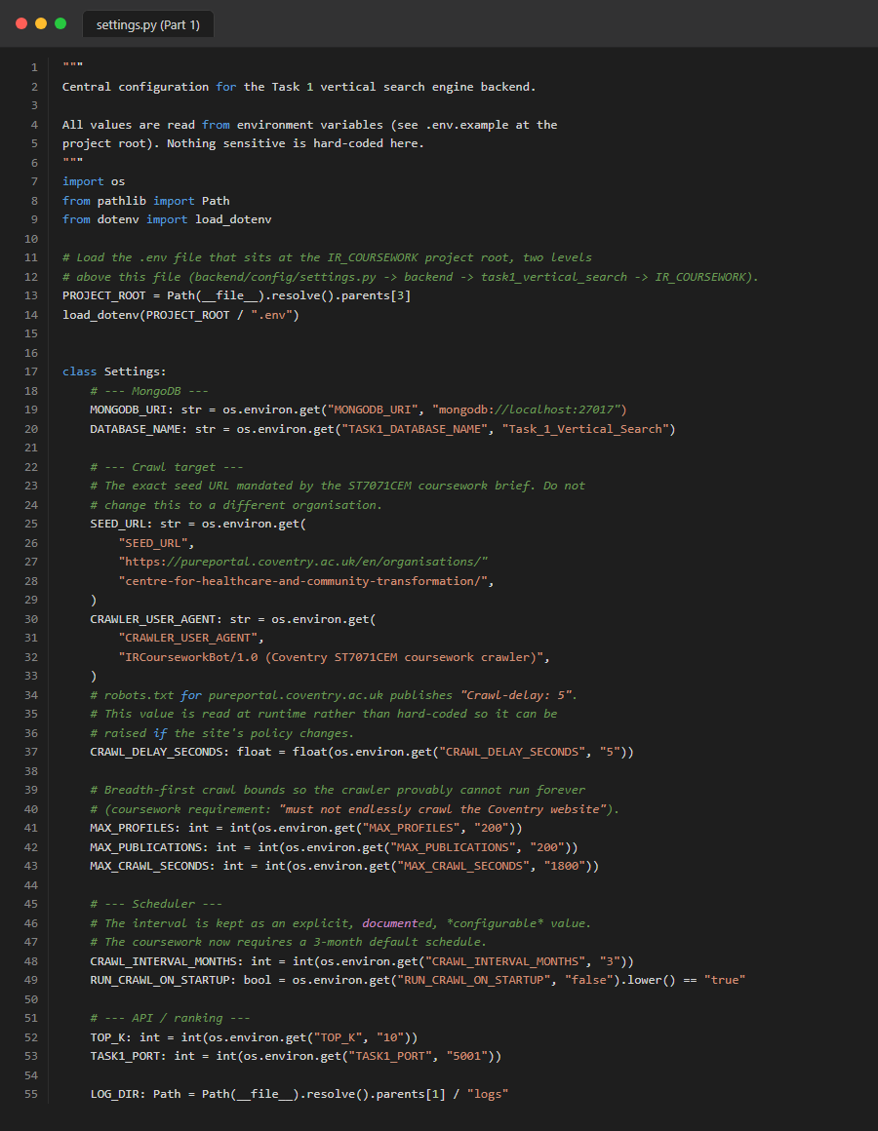
Figure 47. Source Code: task1_config_settings_part1
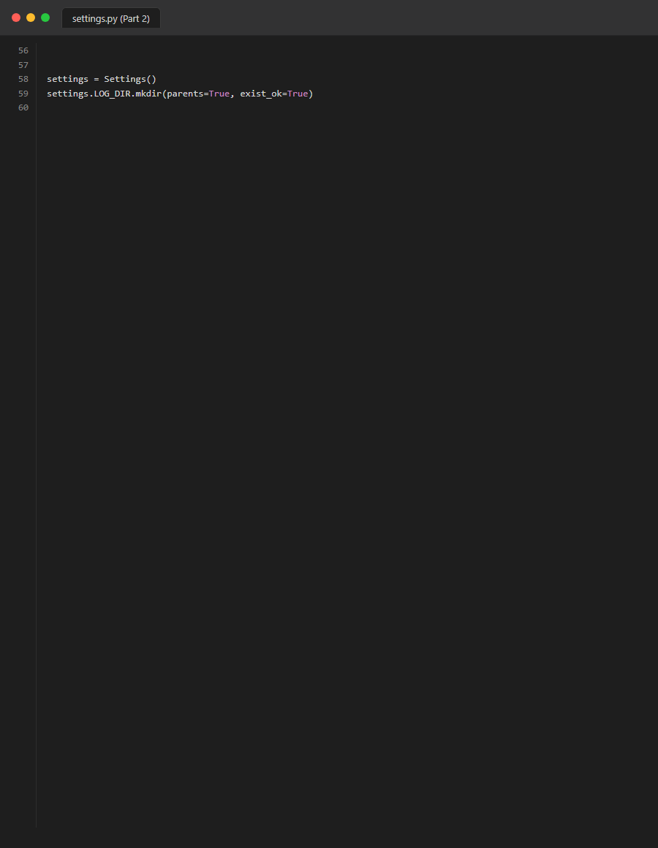
Figure 48. Source Code: task1_config_settings_part2
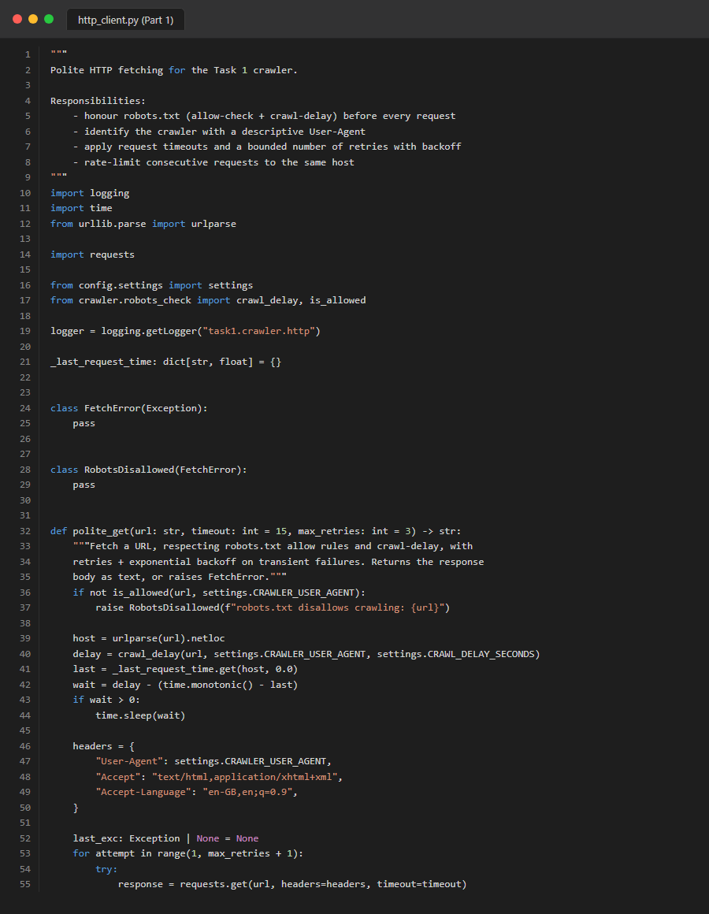
Figure 49. Source Code: task1_crawler_http_client_part1

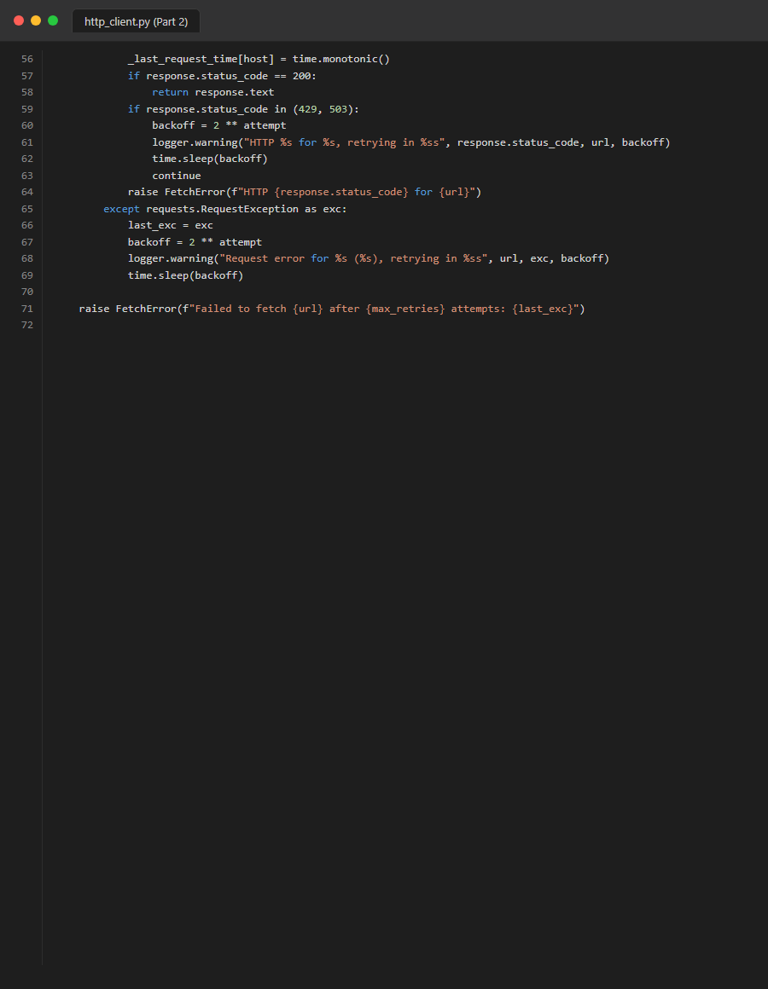
Figure 50. Source Code: task1_crawler_http_client_part2
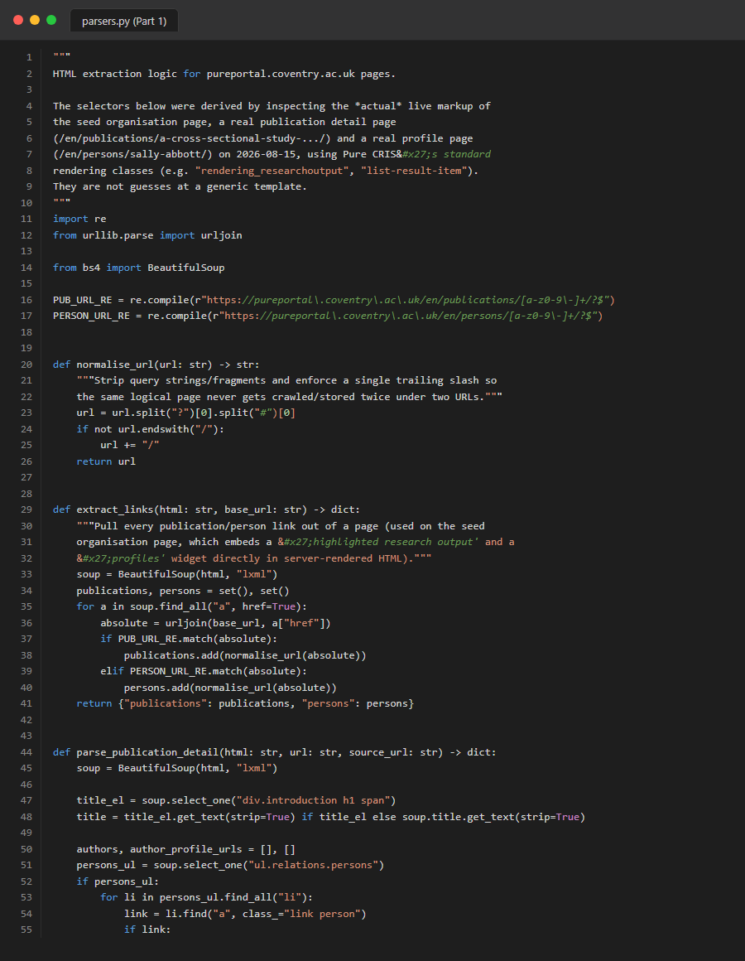
Figure 51. Source Code: task1_crawler_parsers_part1
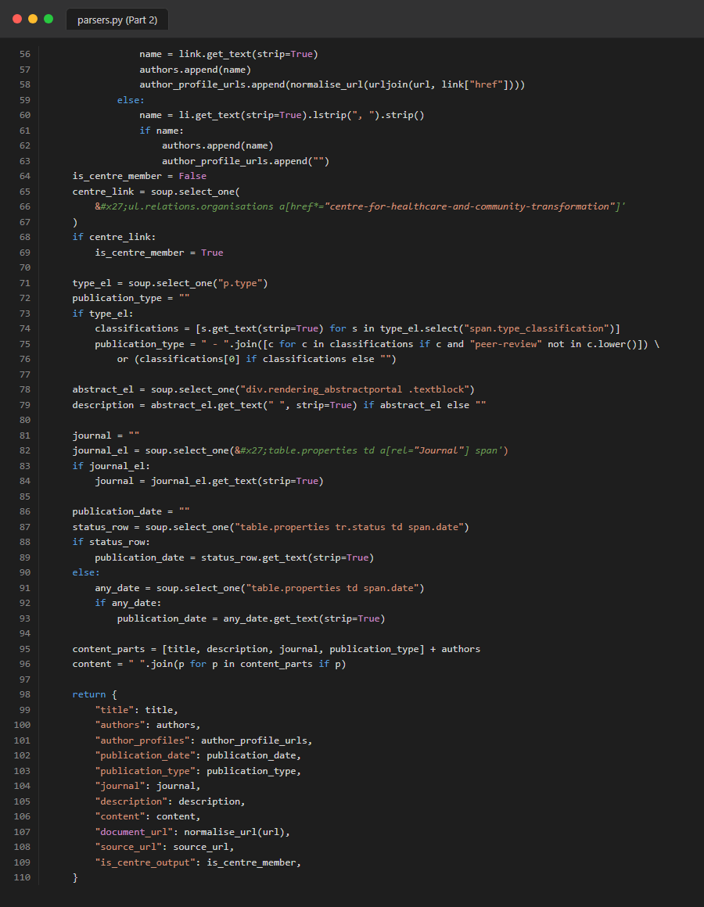
Figure 52. Source Code: task1_crawler_parsers_part2
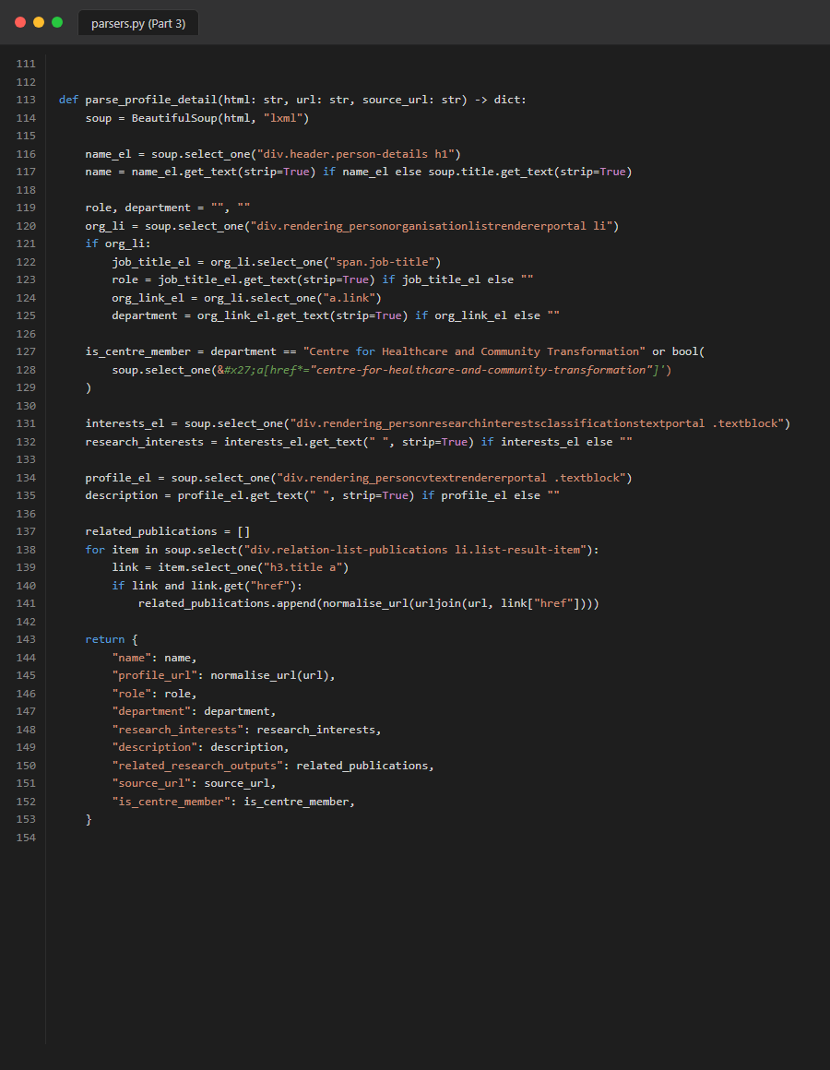
Figure 53. Source Code: task1_crawler_parsers_part3

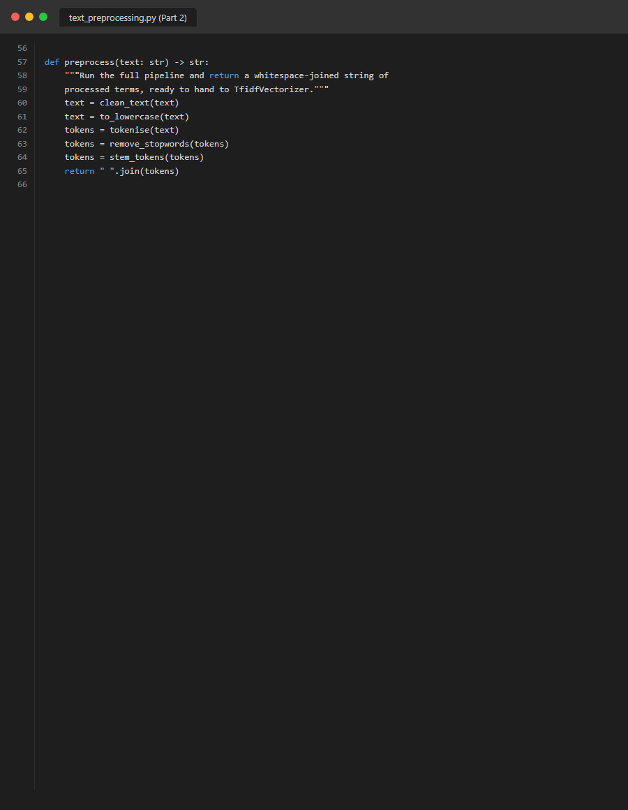
Figure 54. Source Code: task1_crawler_pure_crawler_part1
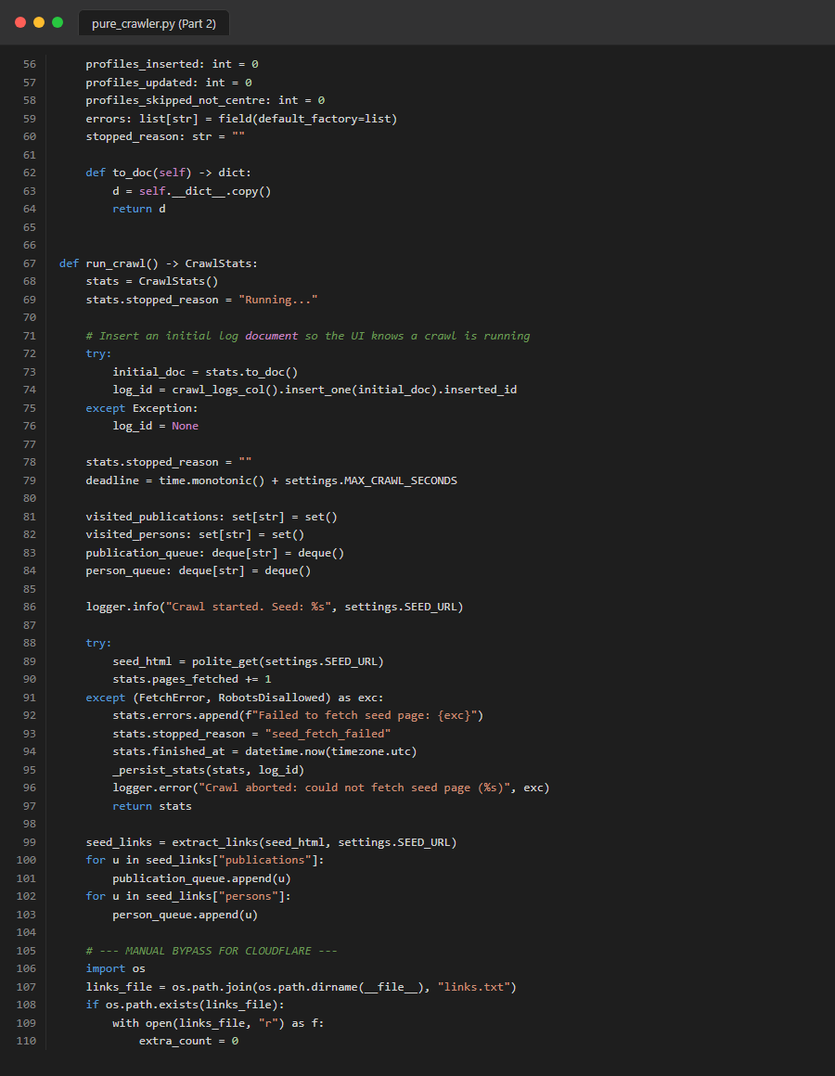
Figure 55. Source Code: task1_crawler_pure_crawler_part2
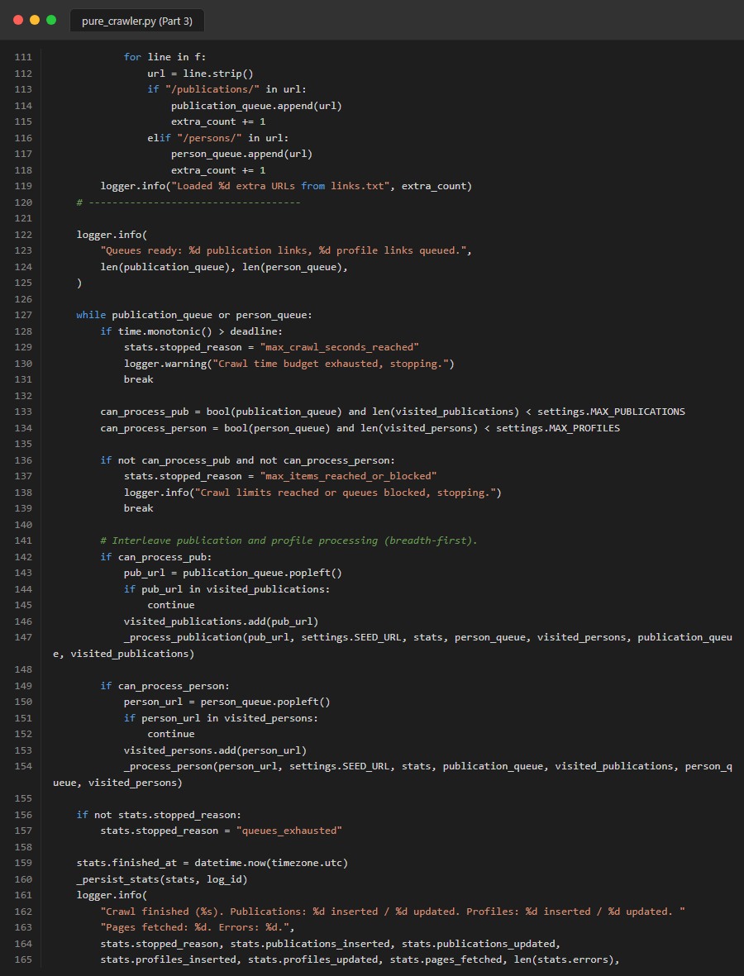
Figure 56. Source Code: task1_crawler_pure_crawler_part3
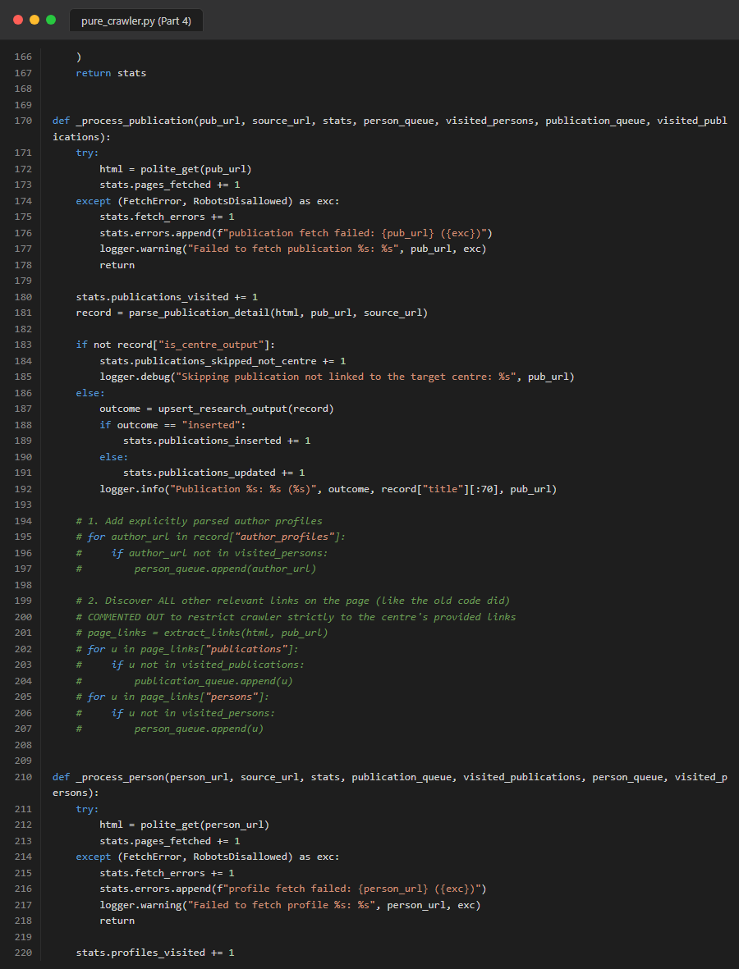
Figure 57. Source Code: task1_crawler_pure_crawler_part4

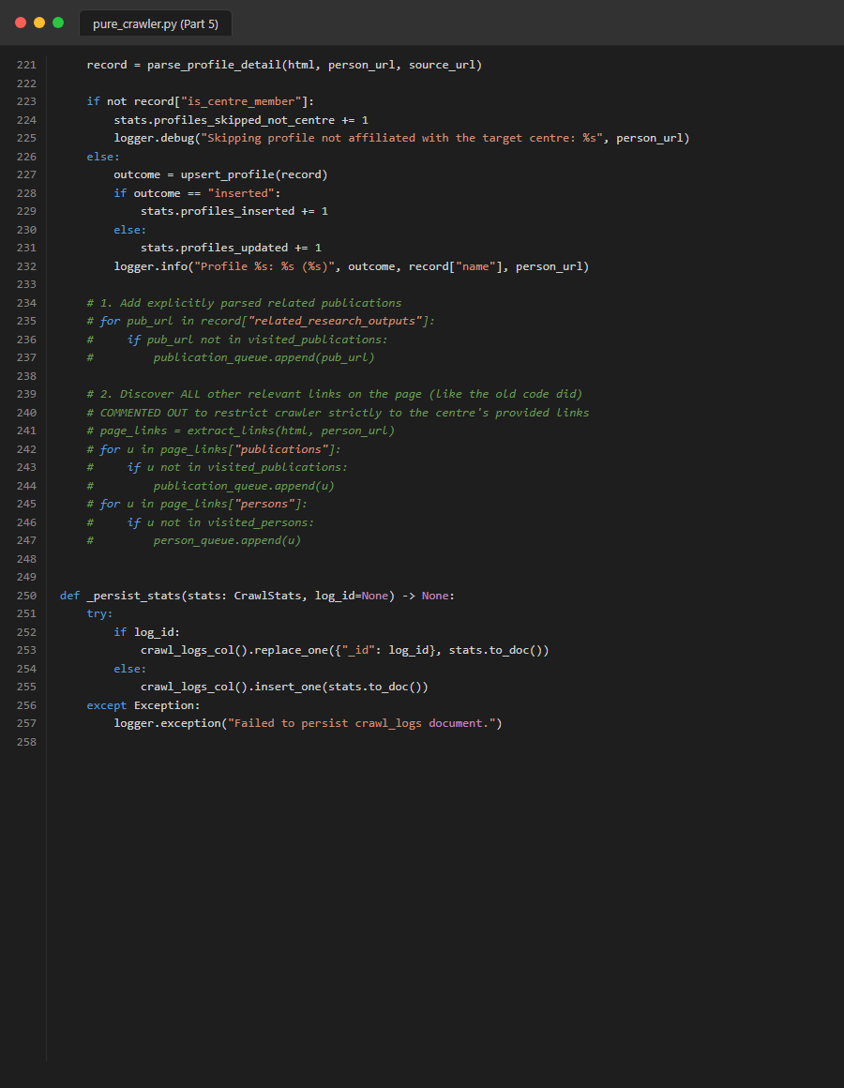
Figure 58. Source Code: task1_crawler_pure_crawler_part5
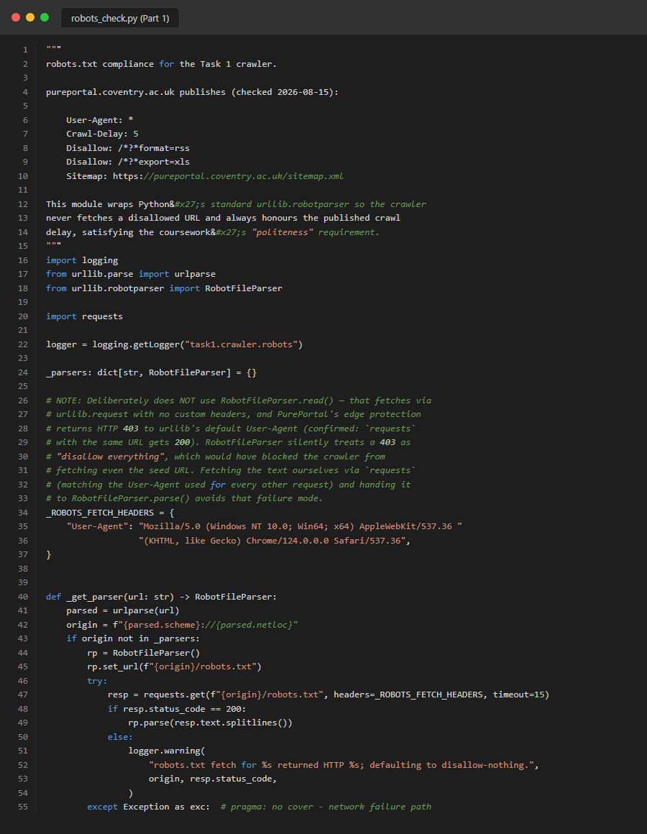
Figure 59. Source Code: task1_crawler_robots_check_part1

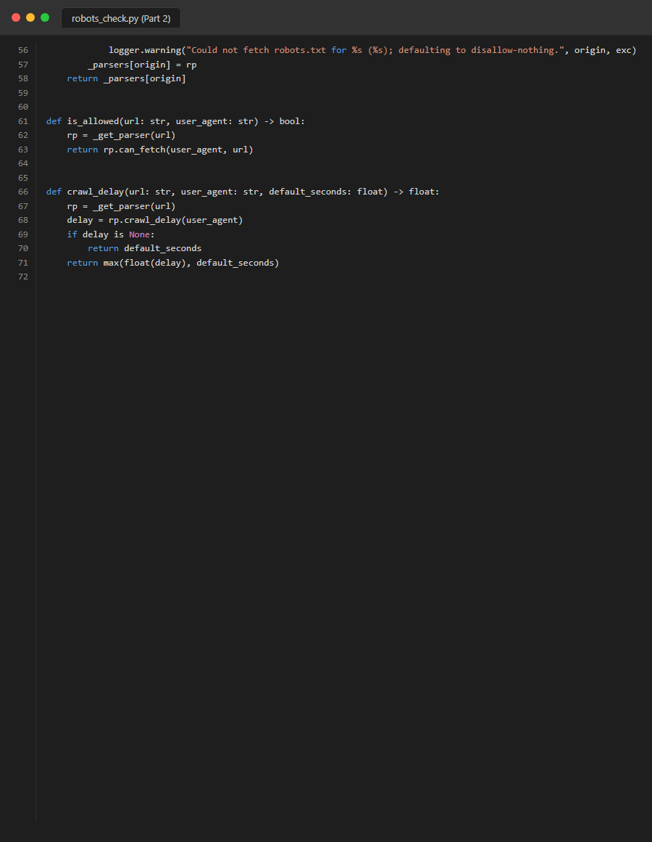
Figure 60. Source Code: task1_crawler_robots_check_part2
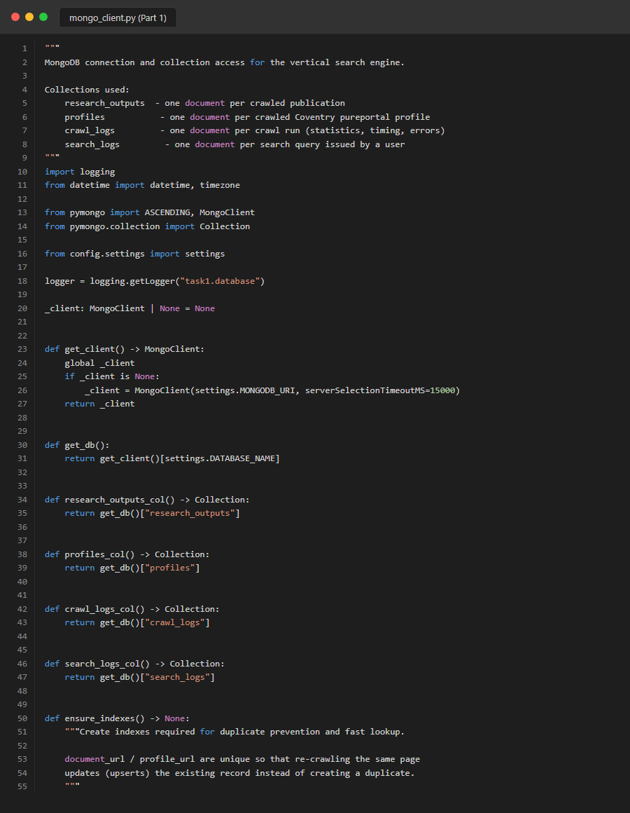
Figure 61. Source Code: task1_database_mongo_part1

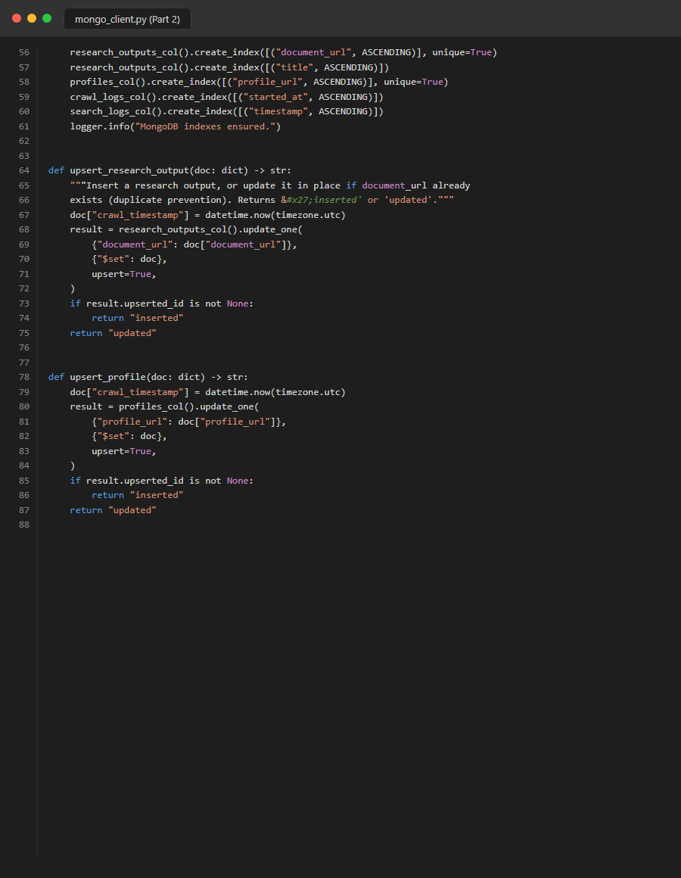
Figure 62. Source Code: task1_database_mongo_part2
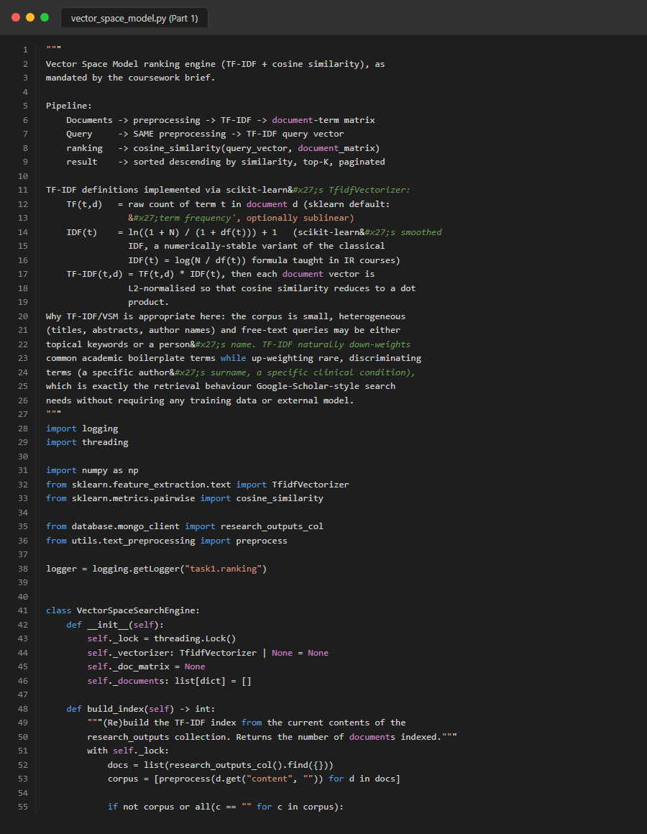
Figure 63. Source Code: task1_ranking_vsm_part1
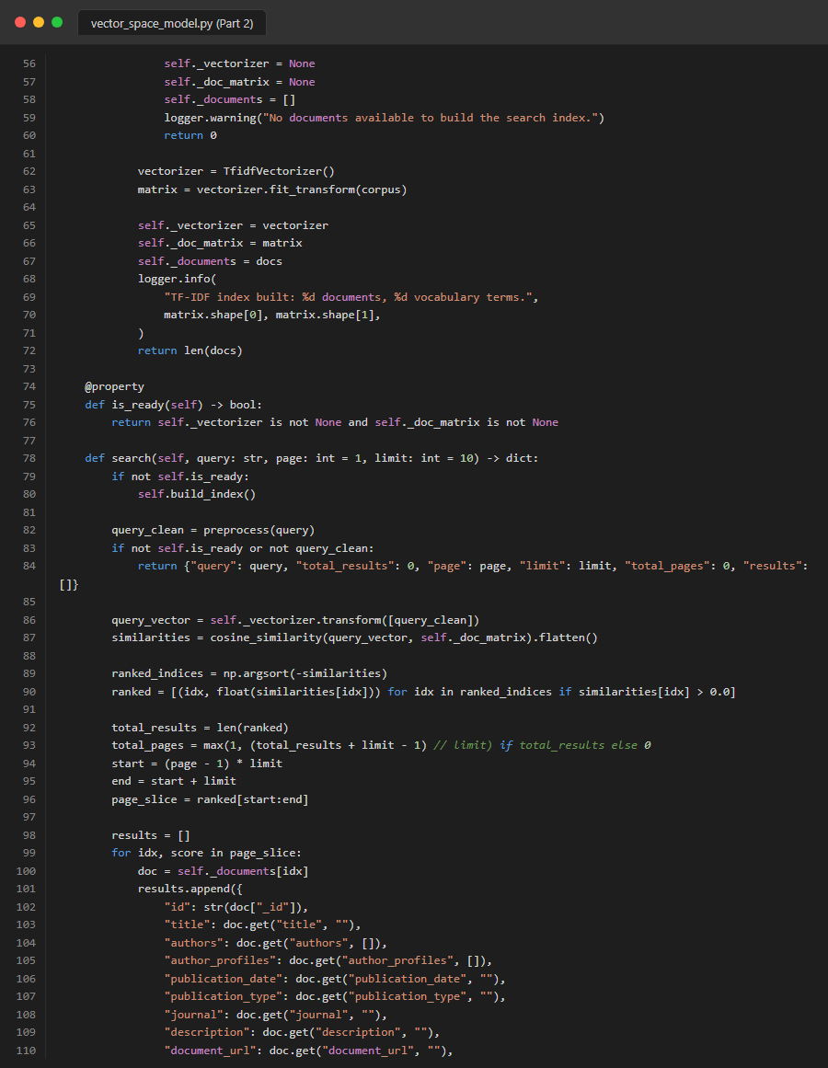
Figure 64. Source Code: task1_ranking_vsm_part2

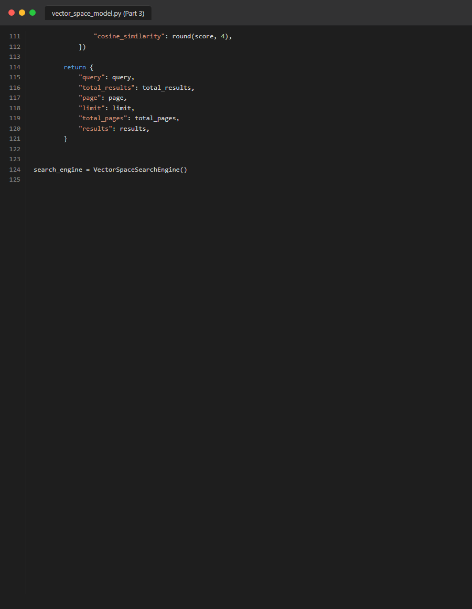
Figure 65. Source Code: task1_ranking_vsm_part3
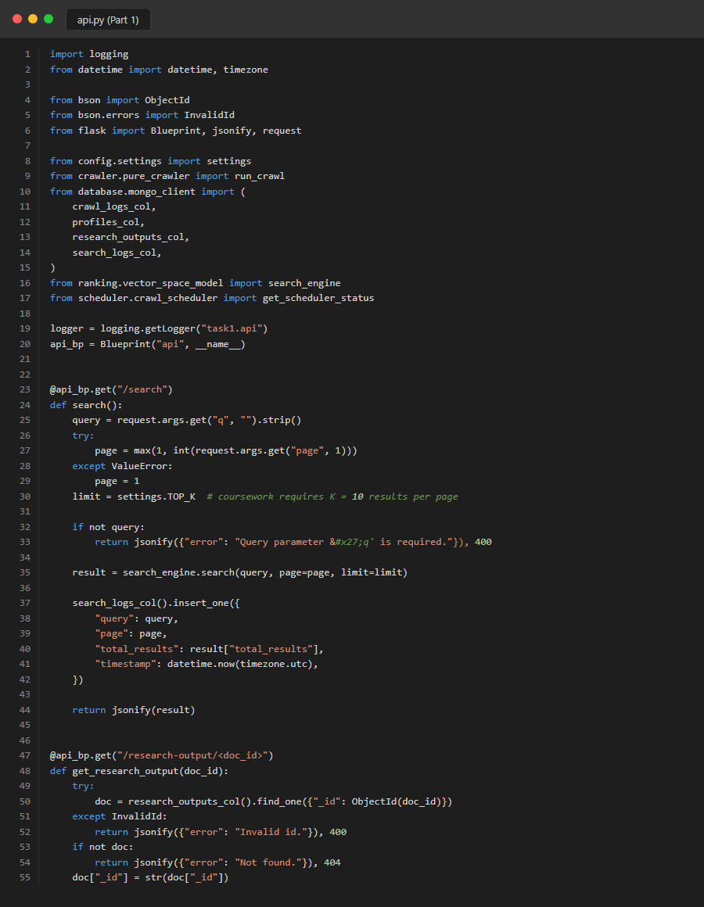
Figure 66. Source Code: task1_routes_api_part1
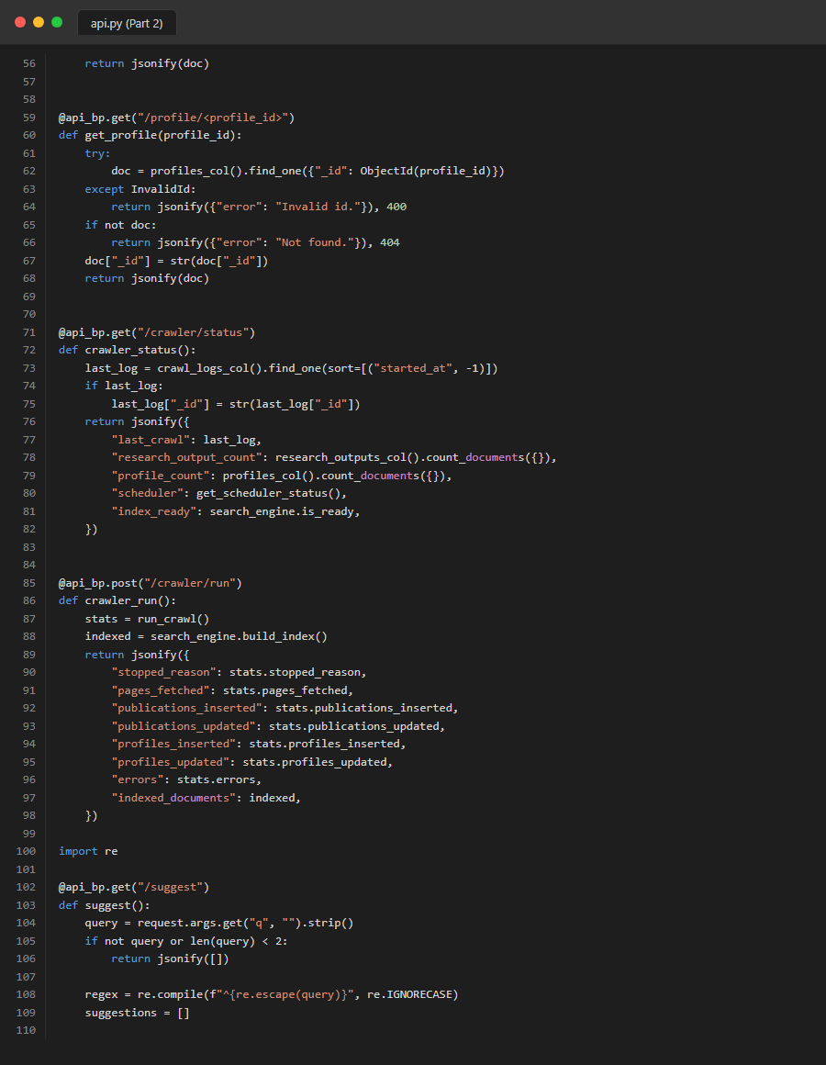
Figure 67. Source Code: task1_routes_api_part2

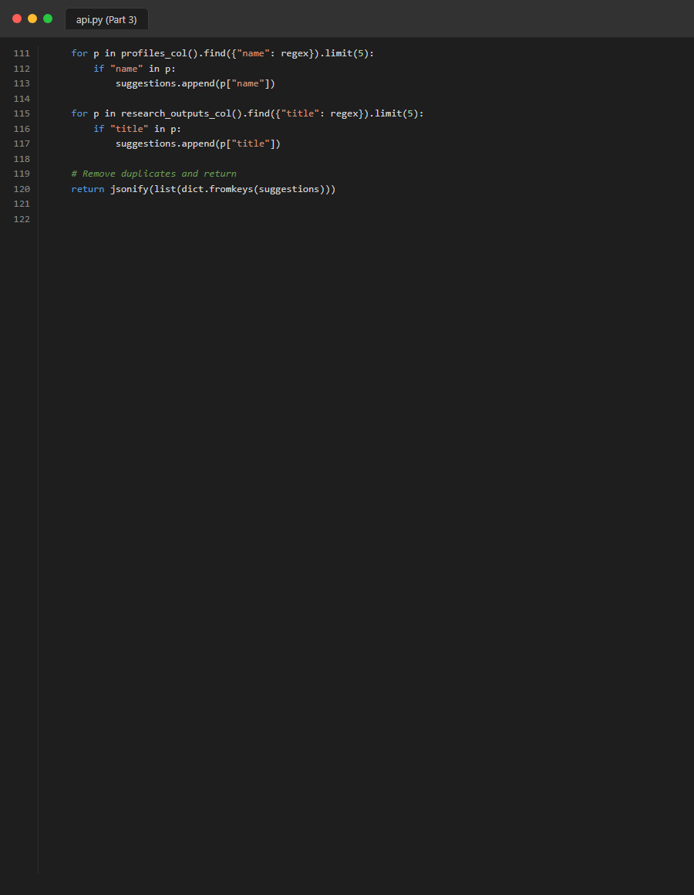
Figure 68. Source Code: task1_routes_api_part3

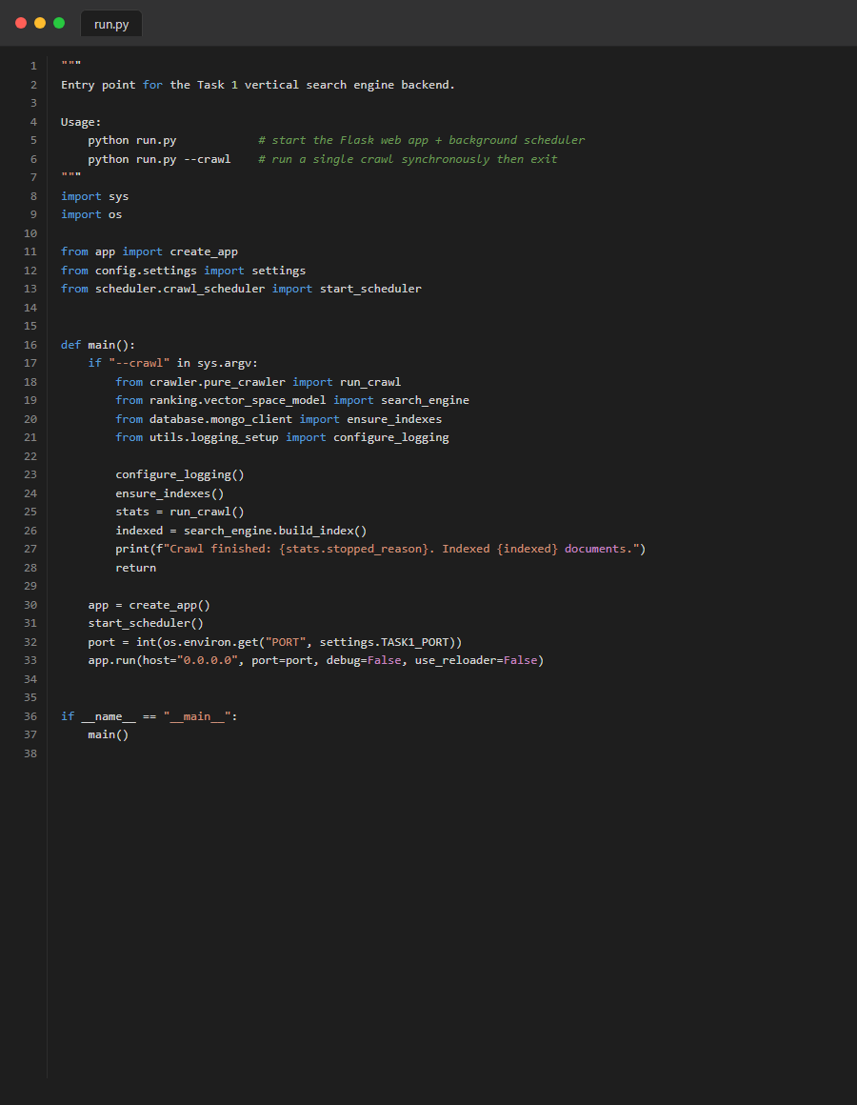
Figure 69. Source Code: task1_run

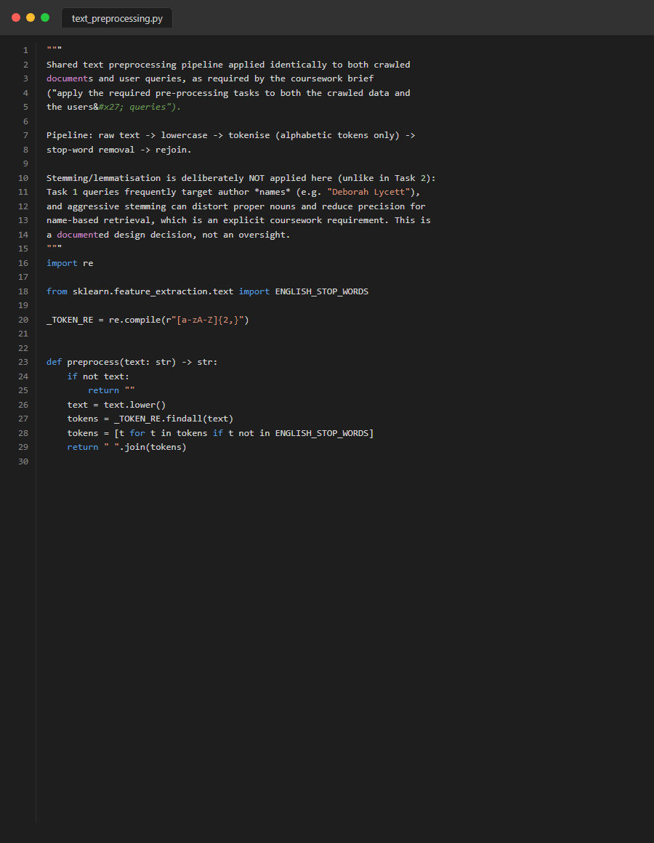
Figure 70. Source Code: task1_utils_preprocessing
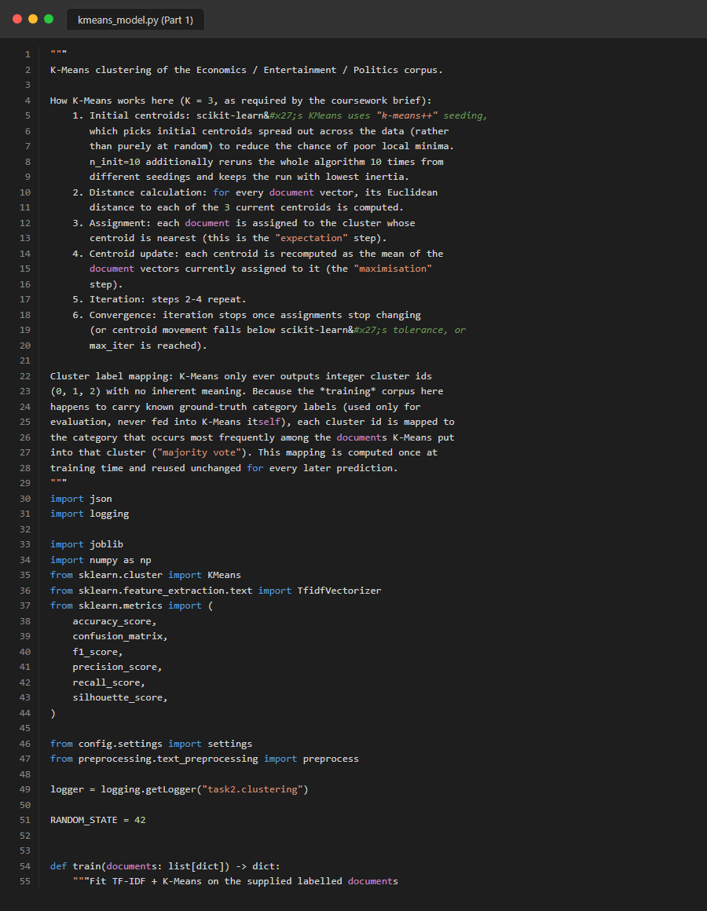
Figure 71. Source Code: task2_clustering_kmeans_part1
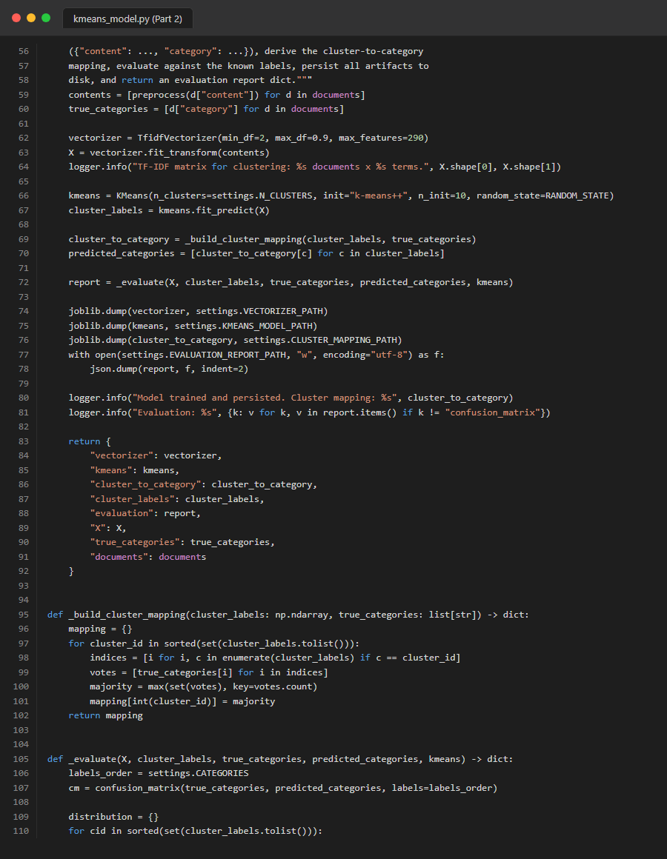
Figure 72. Source Code: task2_clustering_kmeans_part2
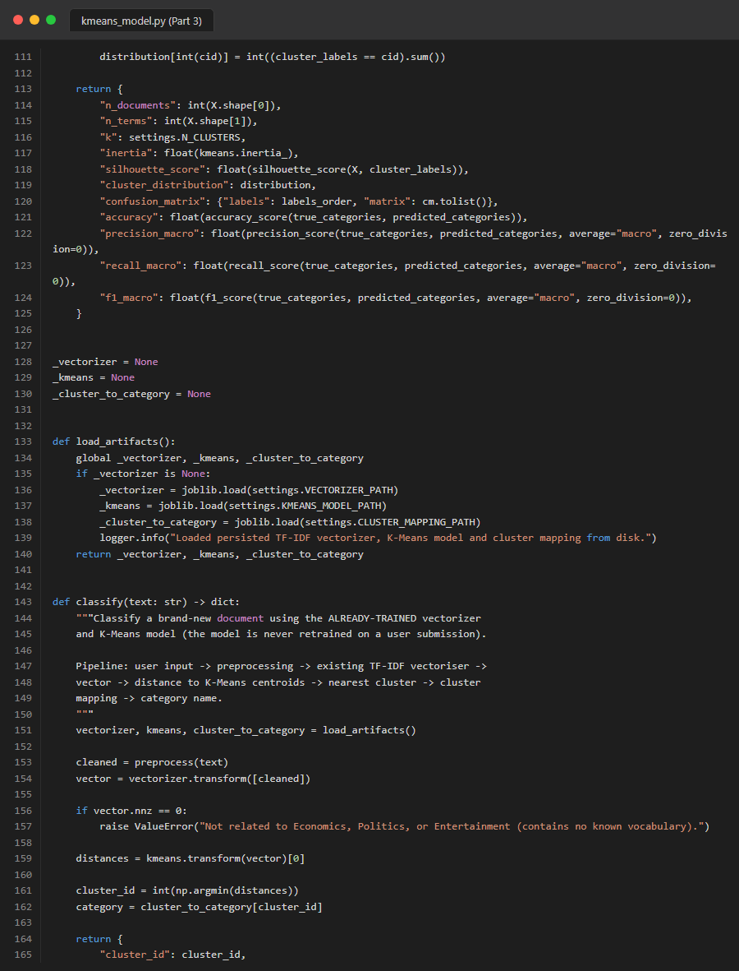
Figure 73. Source Code: task2_clustering_kmeans_part3
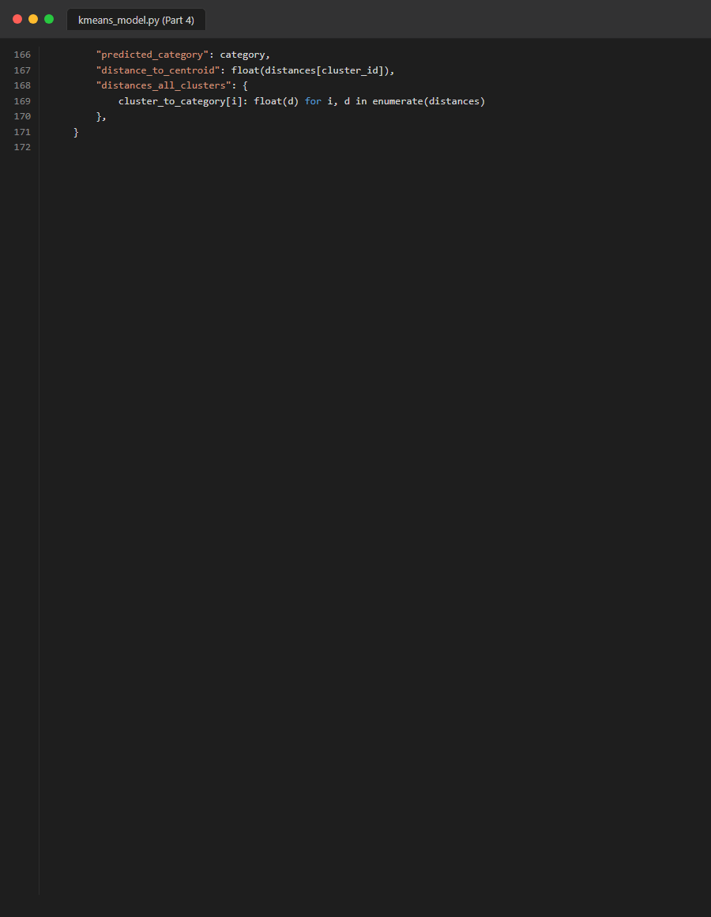
Figure 74. Source Code: task2_clustering_kmeans_part4

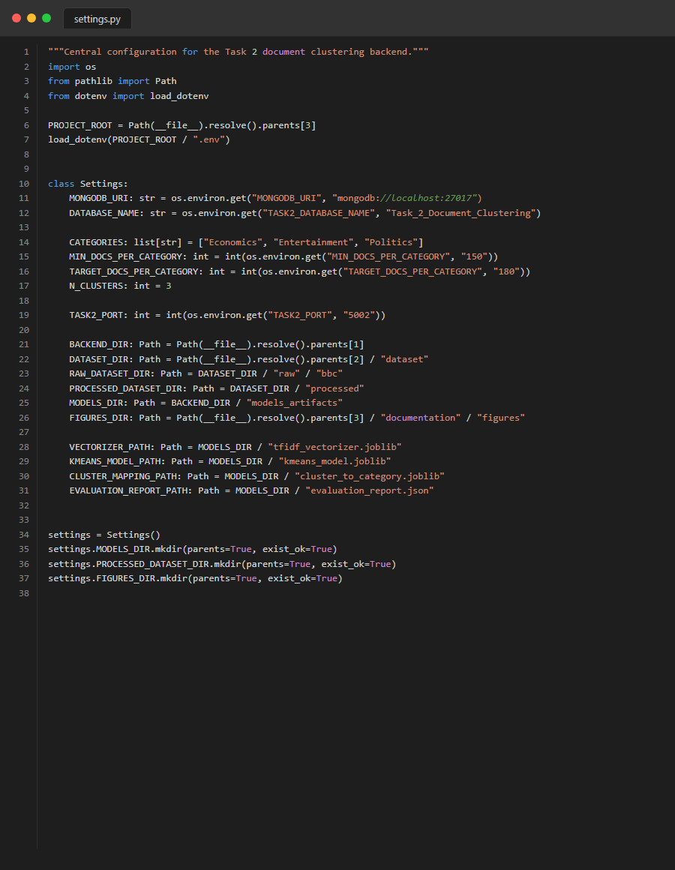
Figure 75. Source Code: task2_config_settings
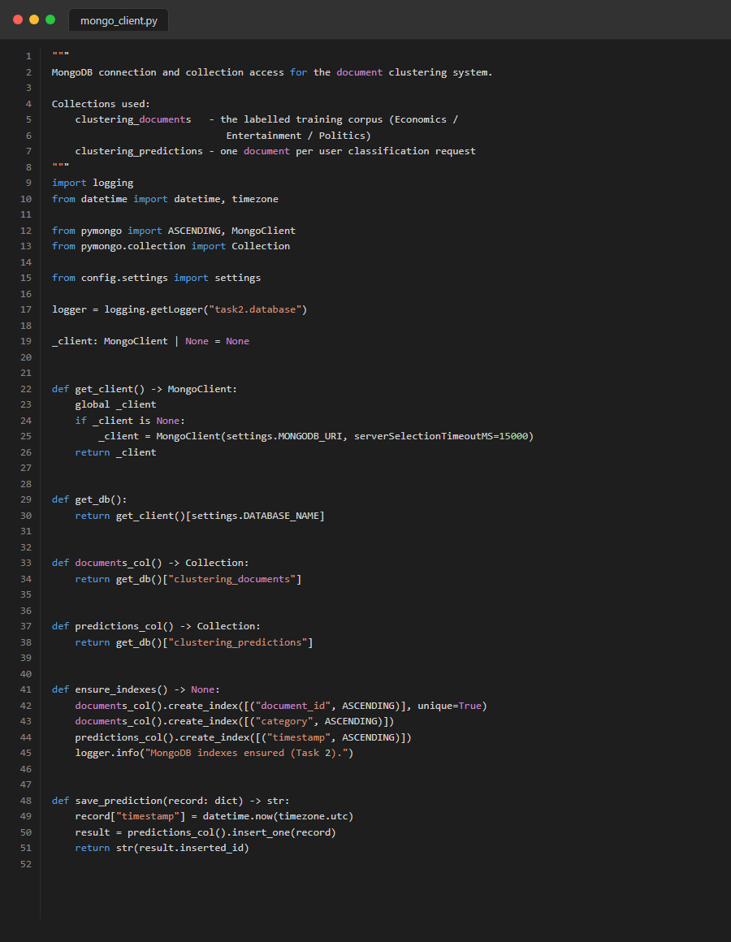
Figure 76. Source Code: task2_database_mongo
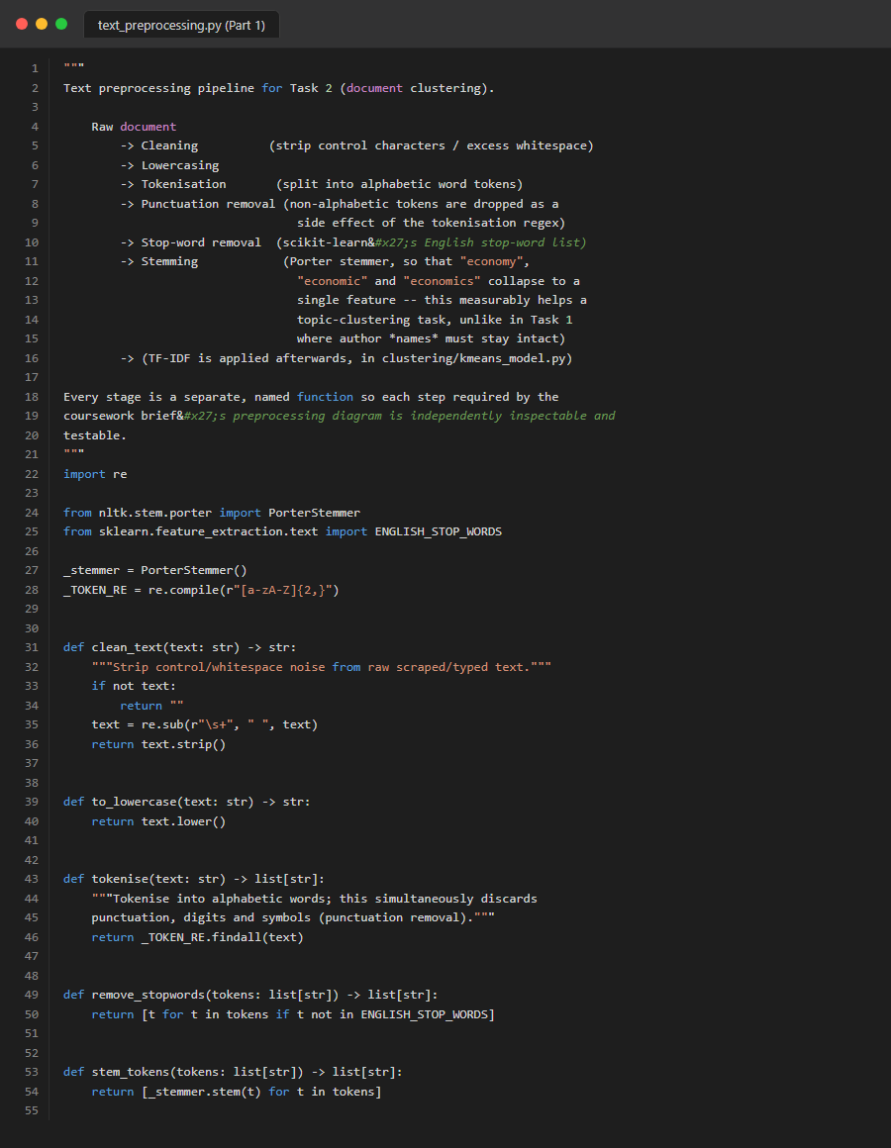
Figure 77. Source Code: task2_preprocessing_part1


Figure 78. Source Code: task2_preprocessing_part2
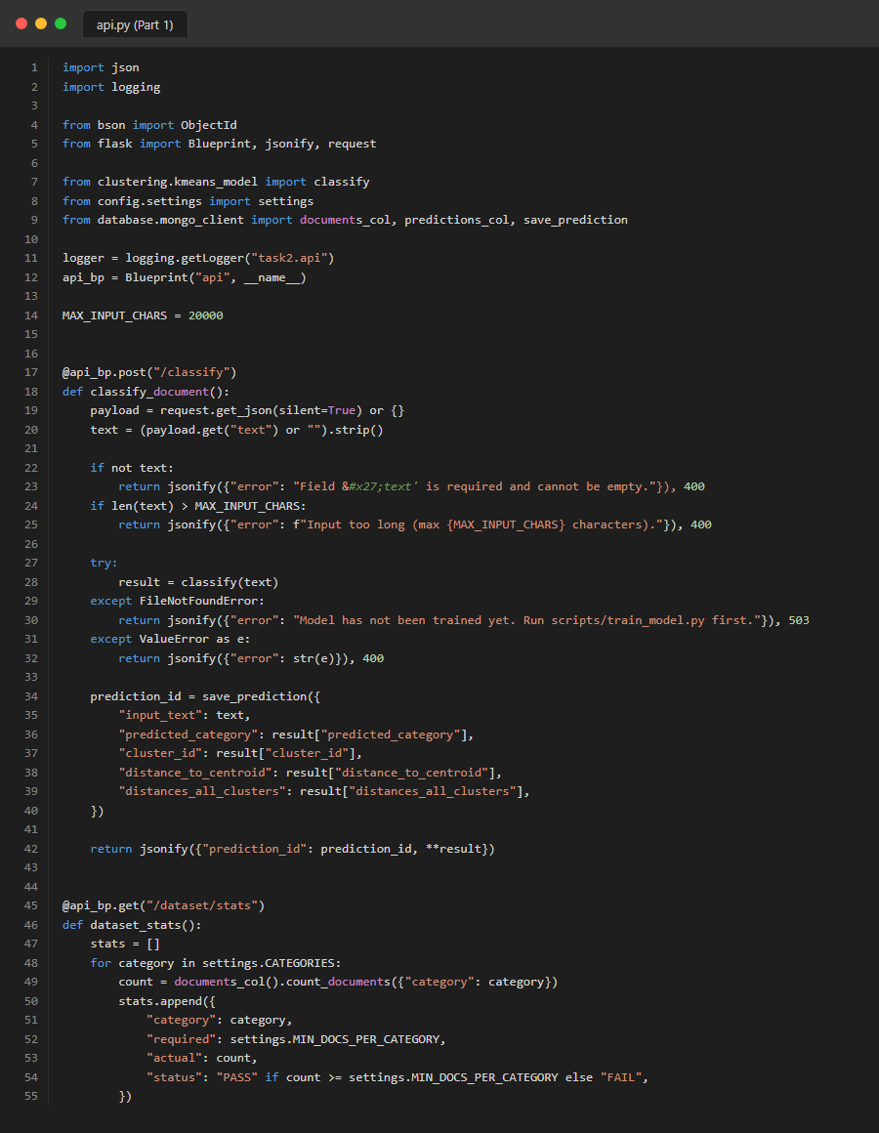
Figure 79. Source Code: task2_routes_api_part1
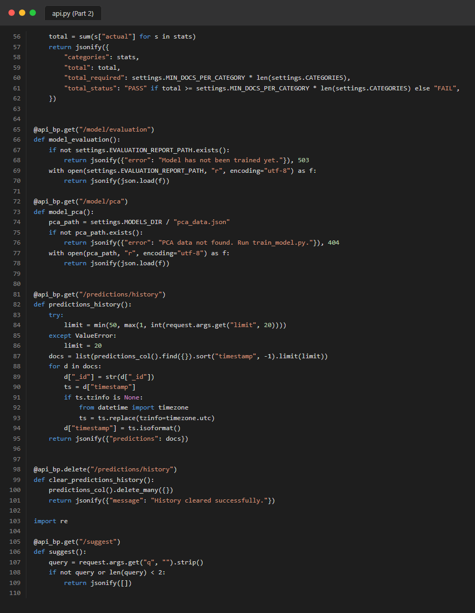
Figure 80. Source Code: task2_routes_api_part2

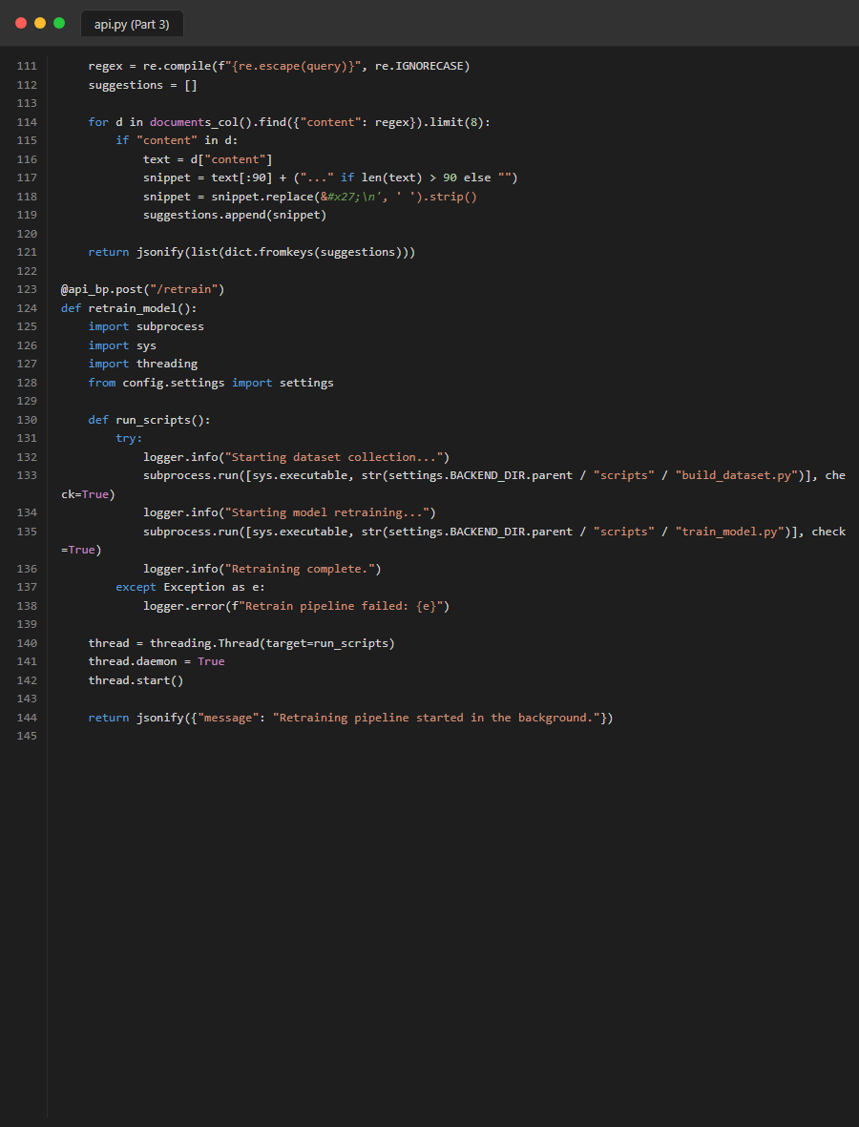
Figure 81. Source Code: task2_routes_api_part3

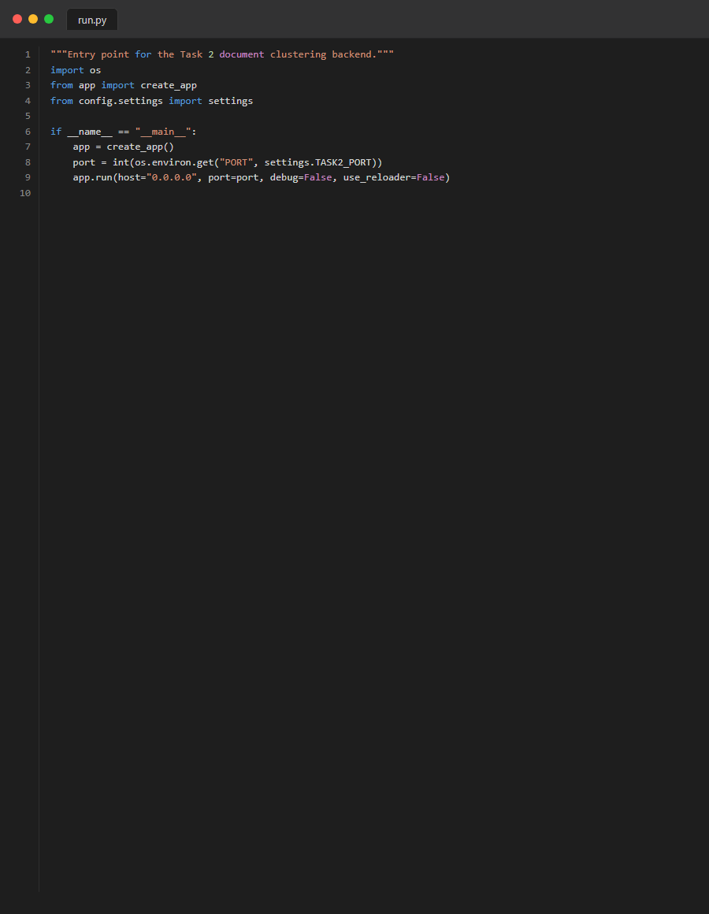
Figure 82. Source Code: task2_run
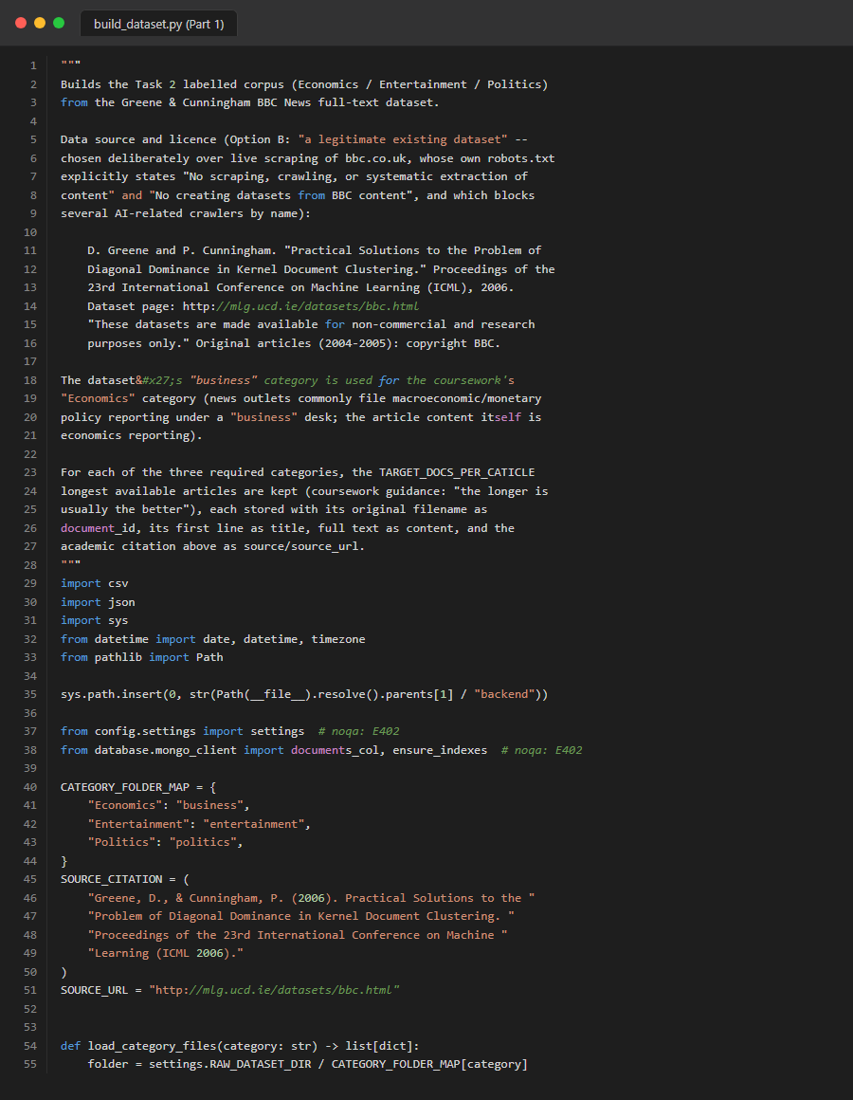
Figure 83. Source Code: task2_scripts_build_dataset_part1
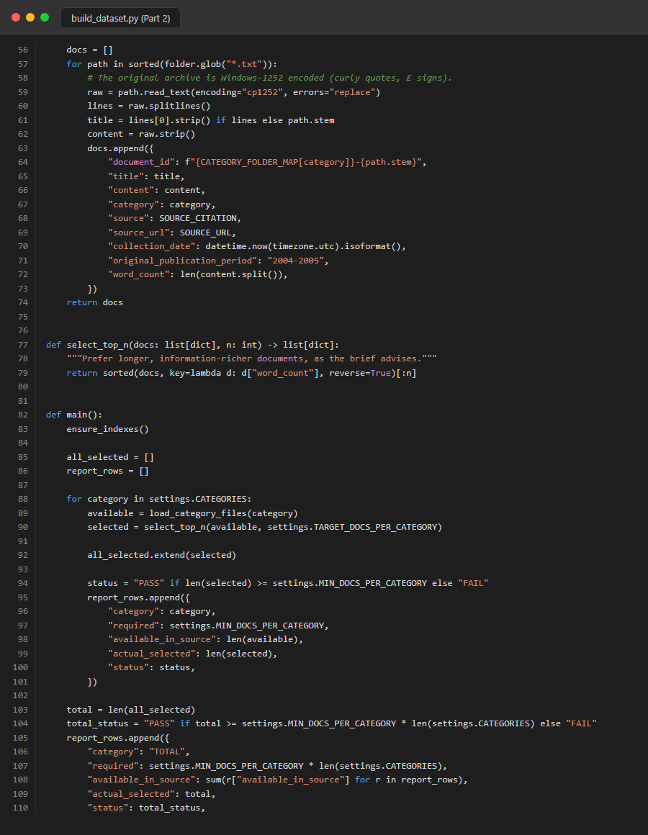
Figure 84. Source Code: task2_scripts_build_dataset_part2
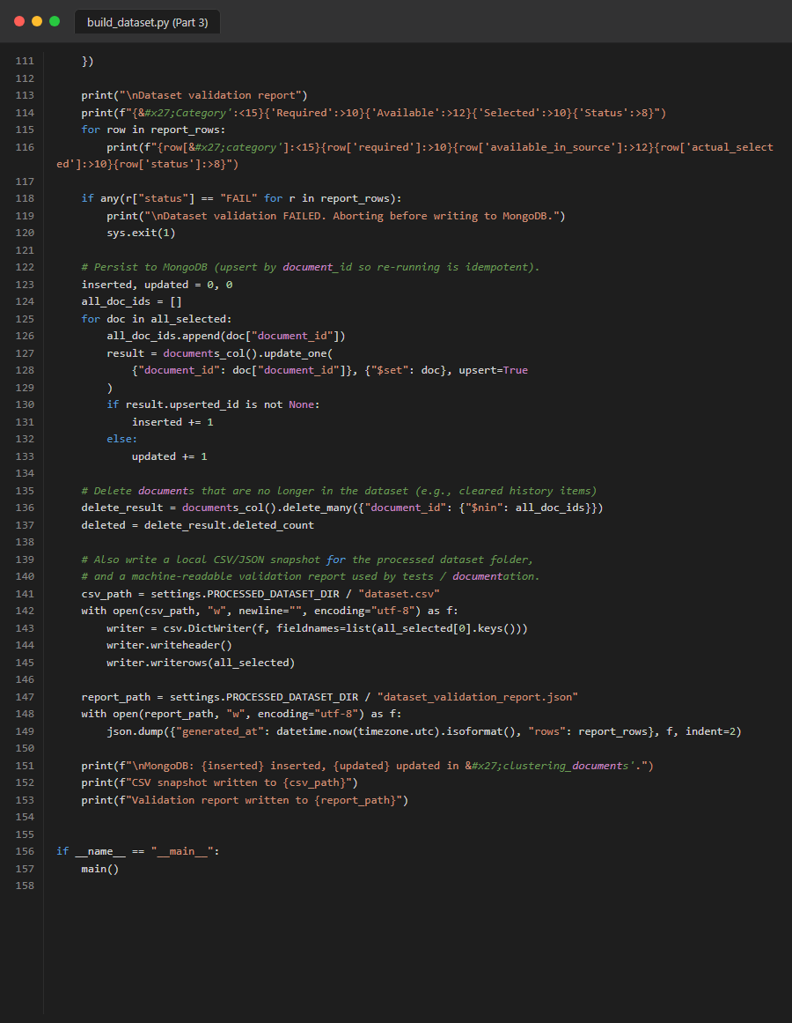
Figure 85. Source Code: task2_scripts_build_dataset_part3
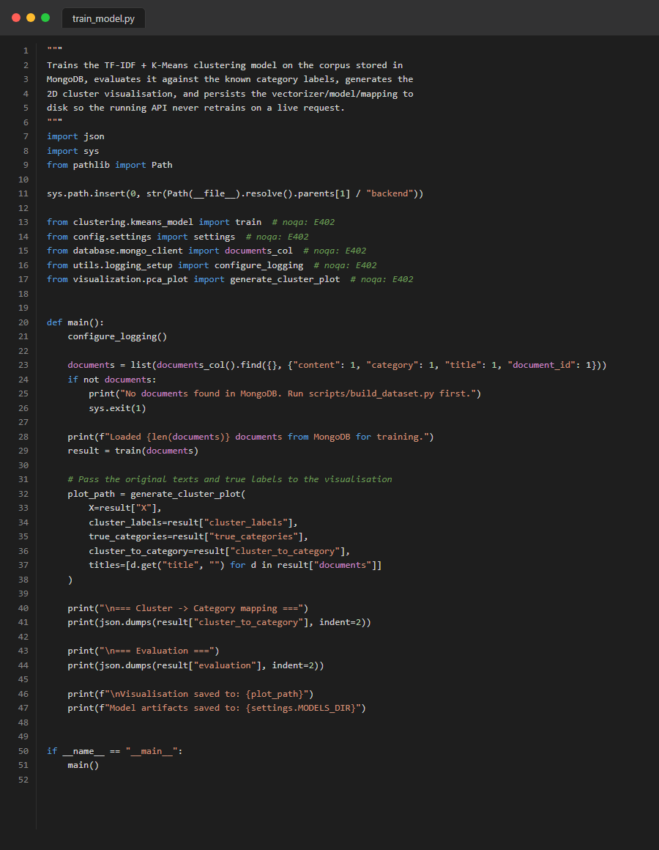
Figure 86. Source Code: task2_scripts_train_model
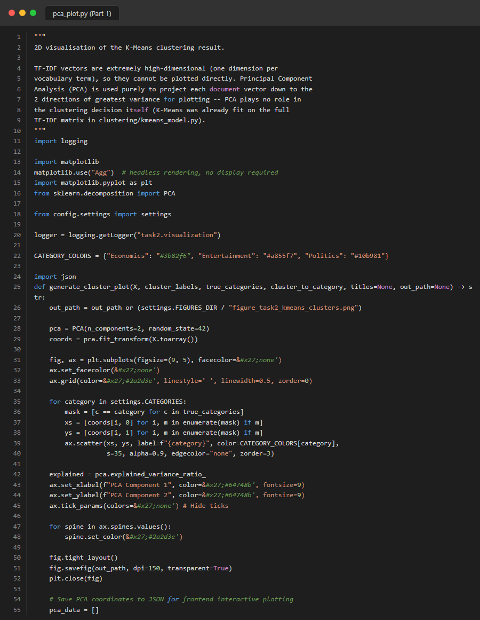
Figure 87. Source Code: task2_visualization_pca_part1

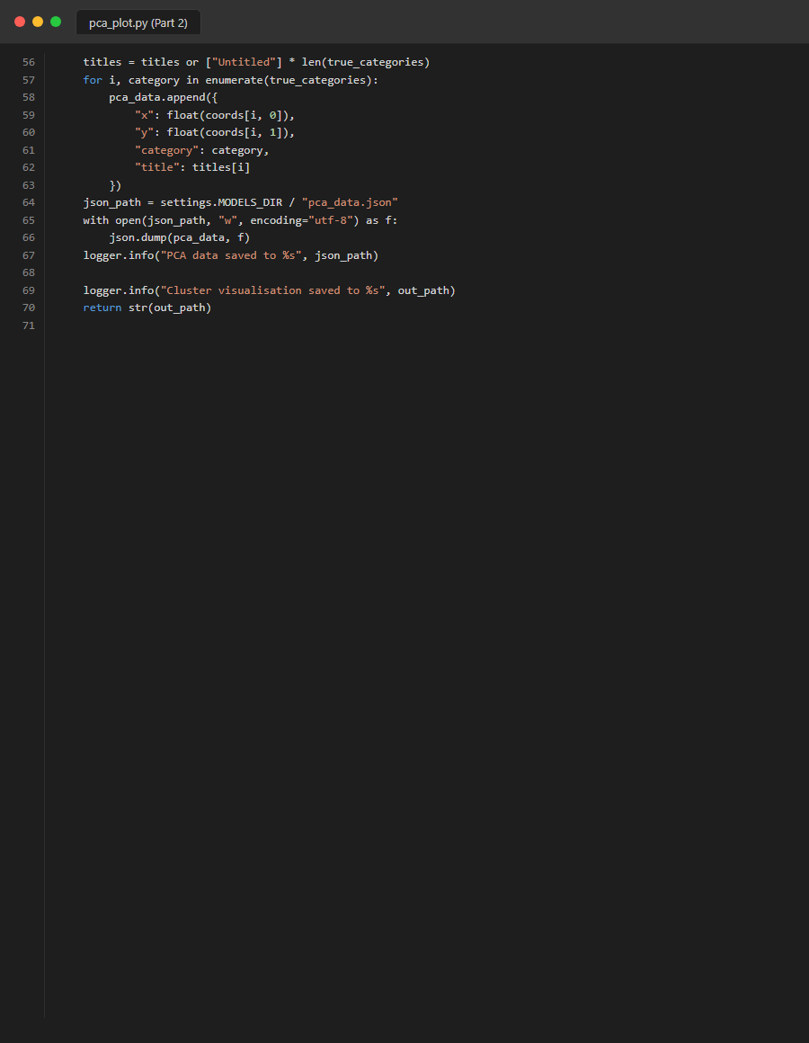
Figure 88. Source Code: task2_visualization_pca_part2

Appendix D: Pytest Evidence
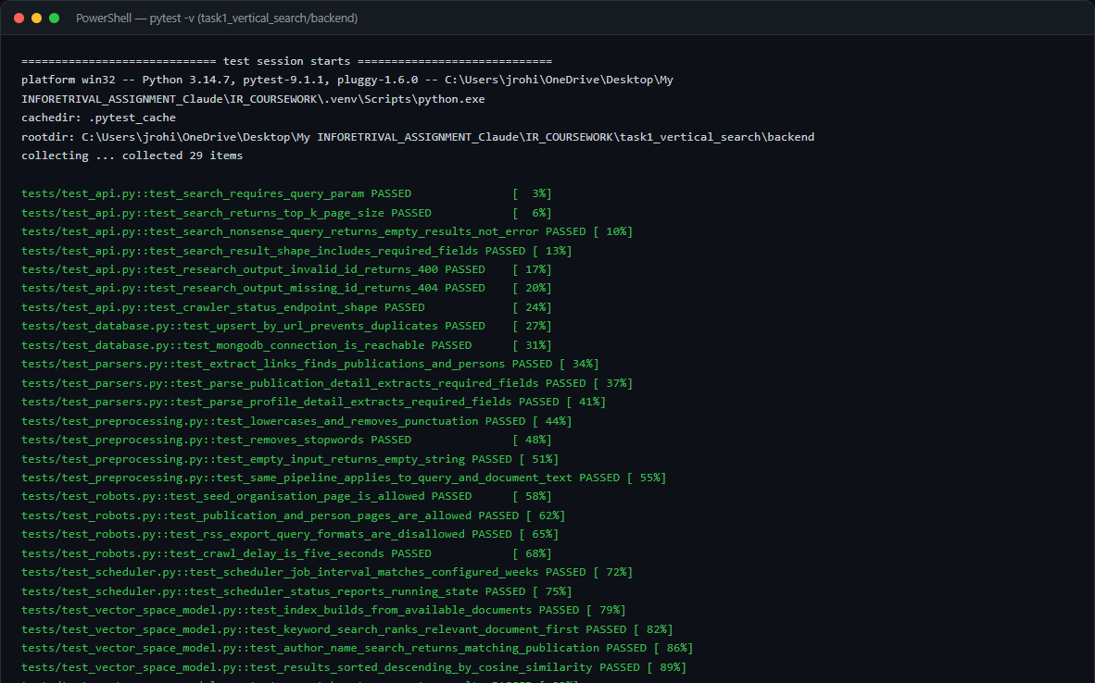
Figure 89. Full Pytest execution for Task 1.
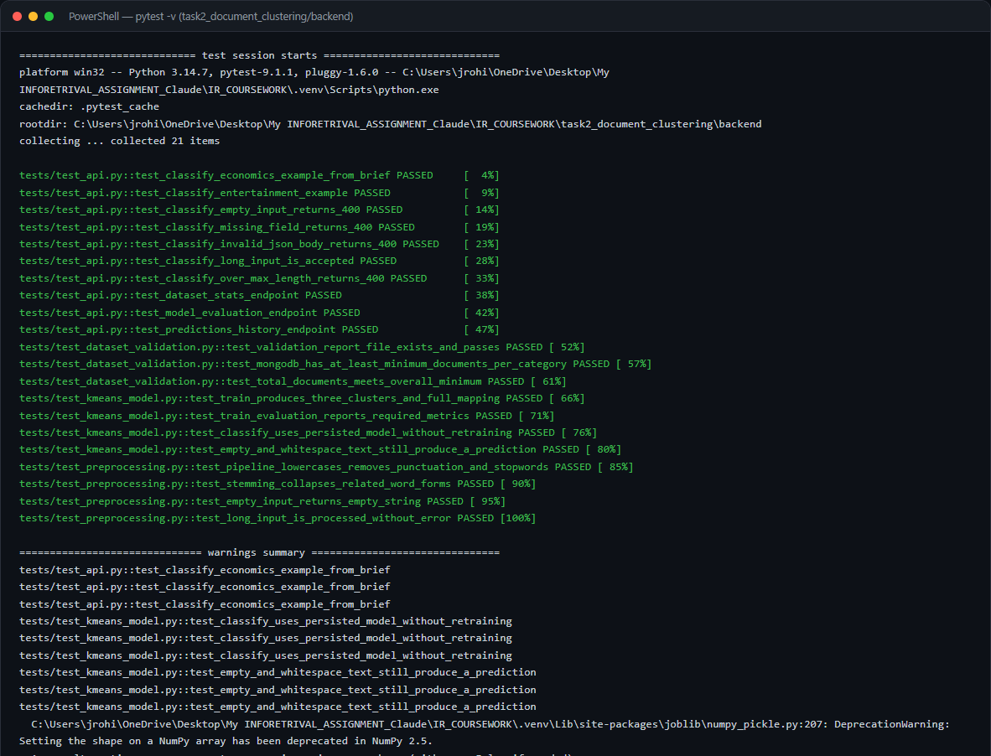
Figure 90. Full Pytest execution for Task 2.

Appendix E: Additional Application Screenshots
The following screenshots represent additional UI views, visualizations, and MongoDB states captured during the system's live operation.
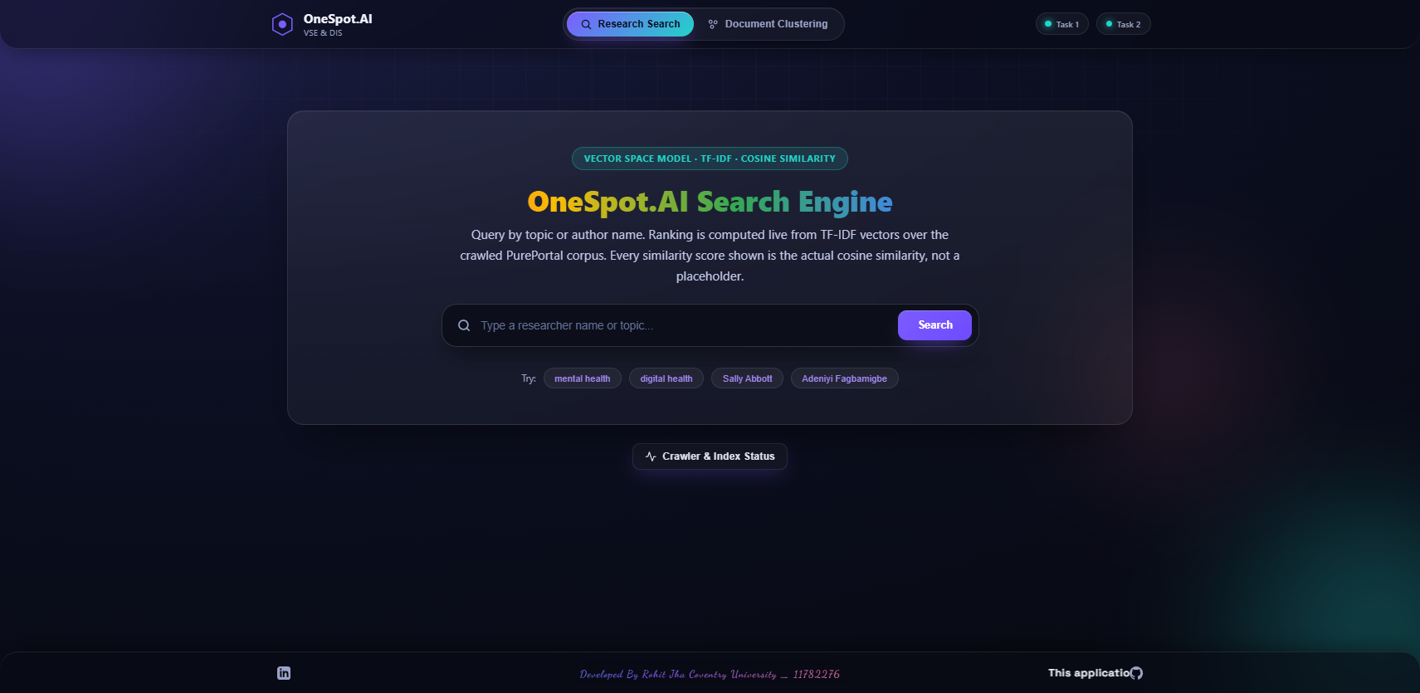
Figure 91. Additional System Screenshot: 01_unified_search_home
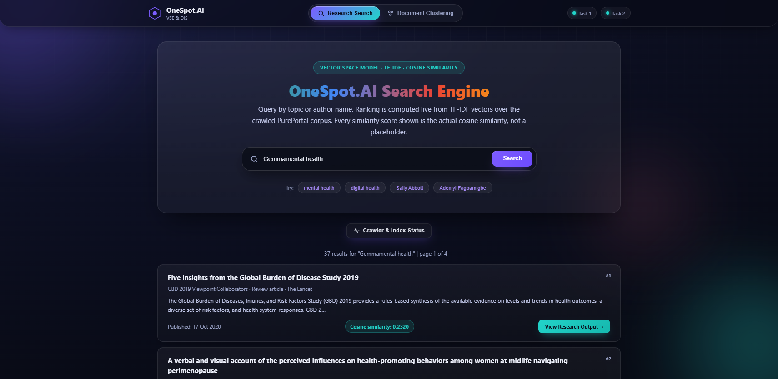
Figure 92. Additional System Screenshot: 02_unified_search_results

Figure 93. Additional System Screenshot: 03_task1_search_digital_health

Figure 94. Additional System Screenshot: 03_unified_search_pagination
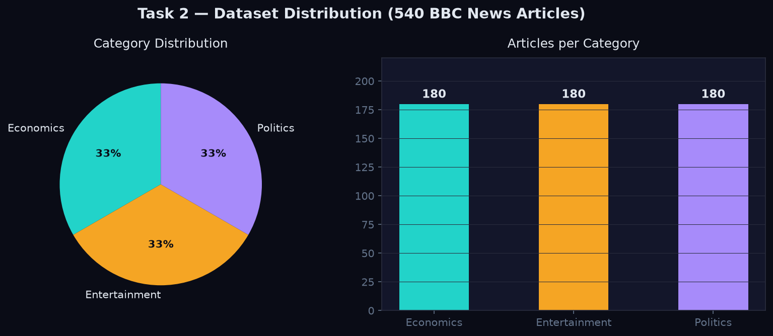
Figure 95. Additional System Screenshot: 04_task2_dataset_stats
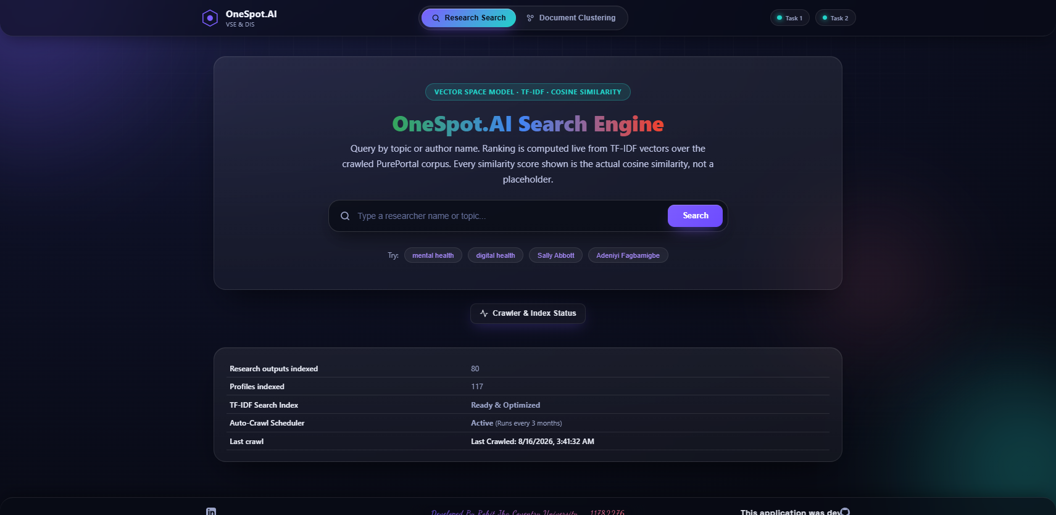
Figure 96. Additional System Screenshot: 04_unified_crawler_status
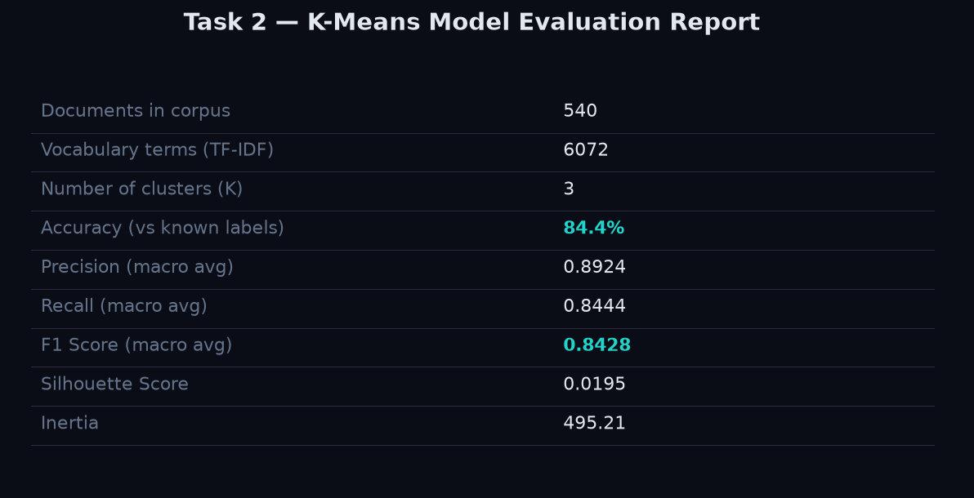
Figure 97. Additional System Screenshot: 05_task2_model_evaluation
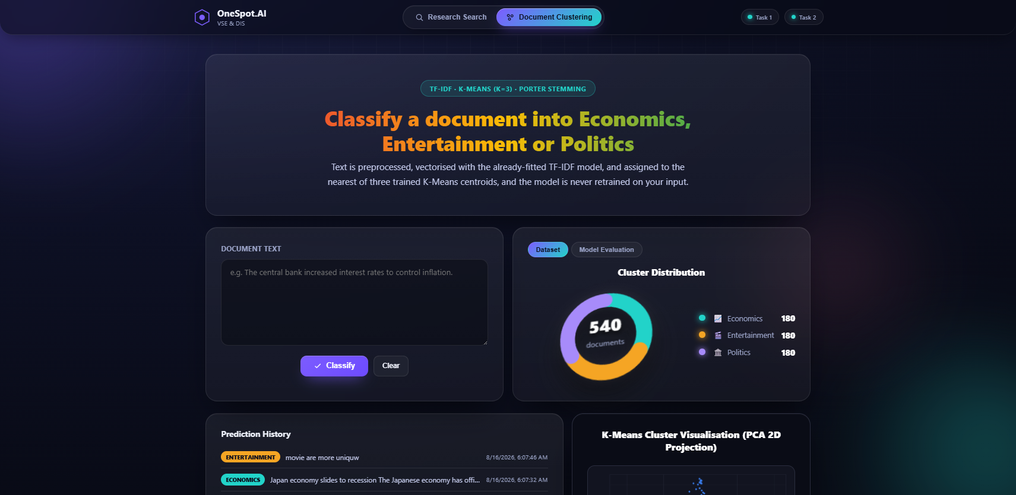
Figure 98. Additional System Screenshot: 05_unified_cluster_home
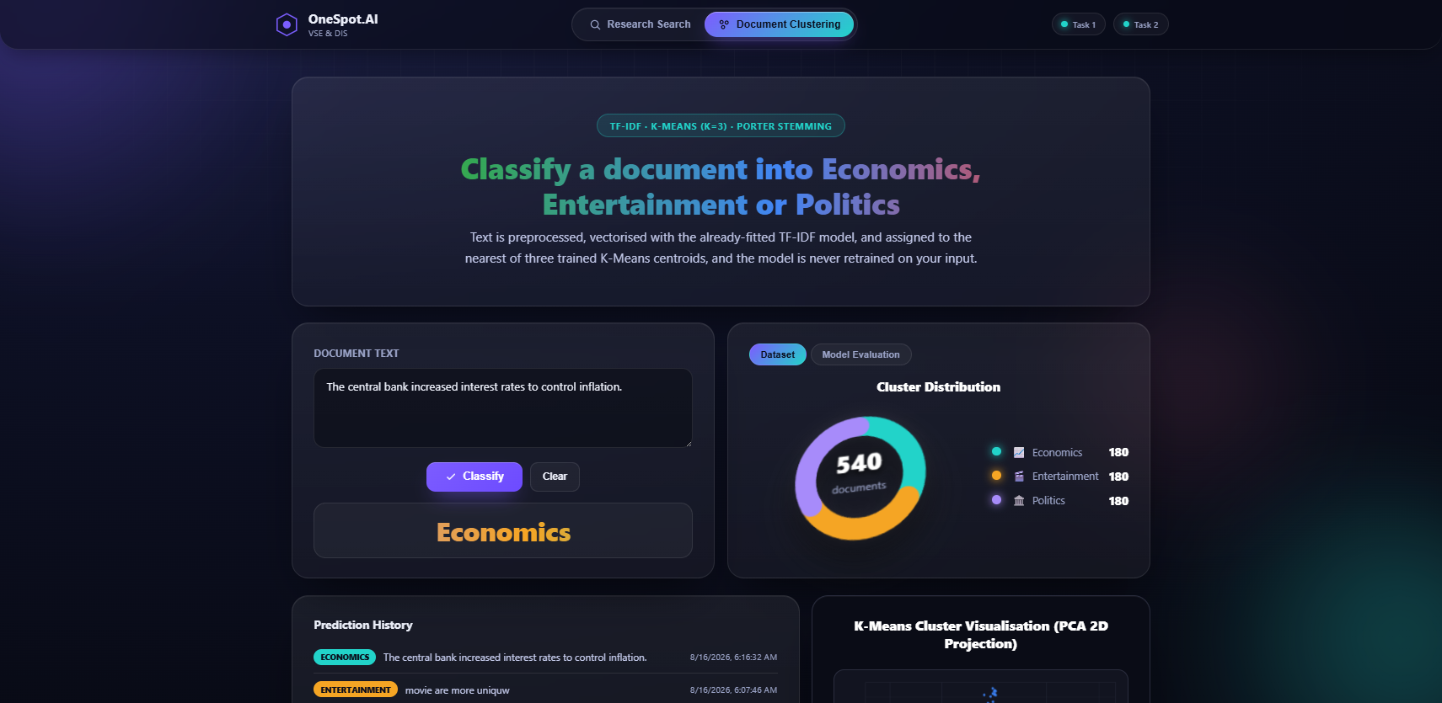
Figure 99. Additional System Screenshot: 06_unified_cluster_result

Figure 100. Additional System Screenshot: 08_unified_model_evaluation
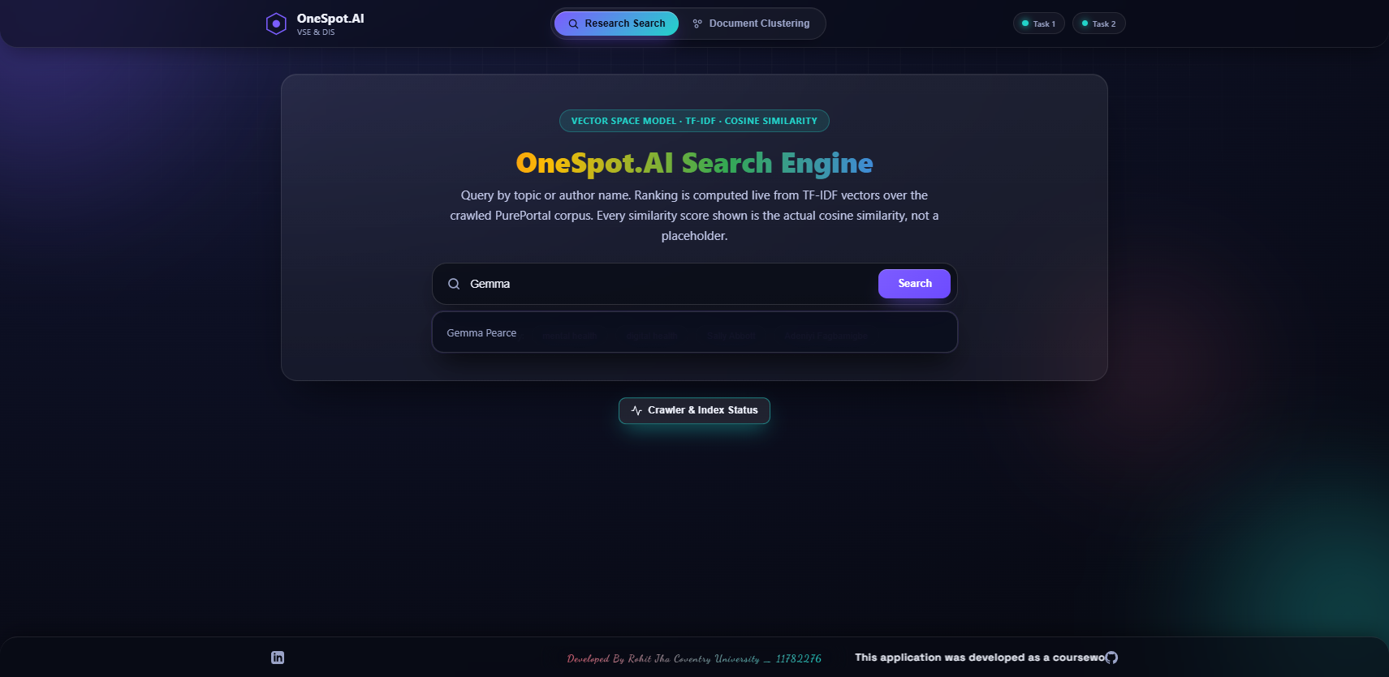
Figure 101. Additional System Screenshot: 08_unified_search_suggestions
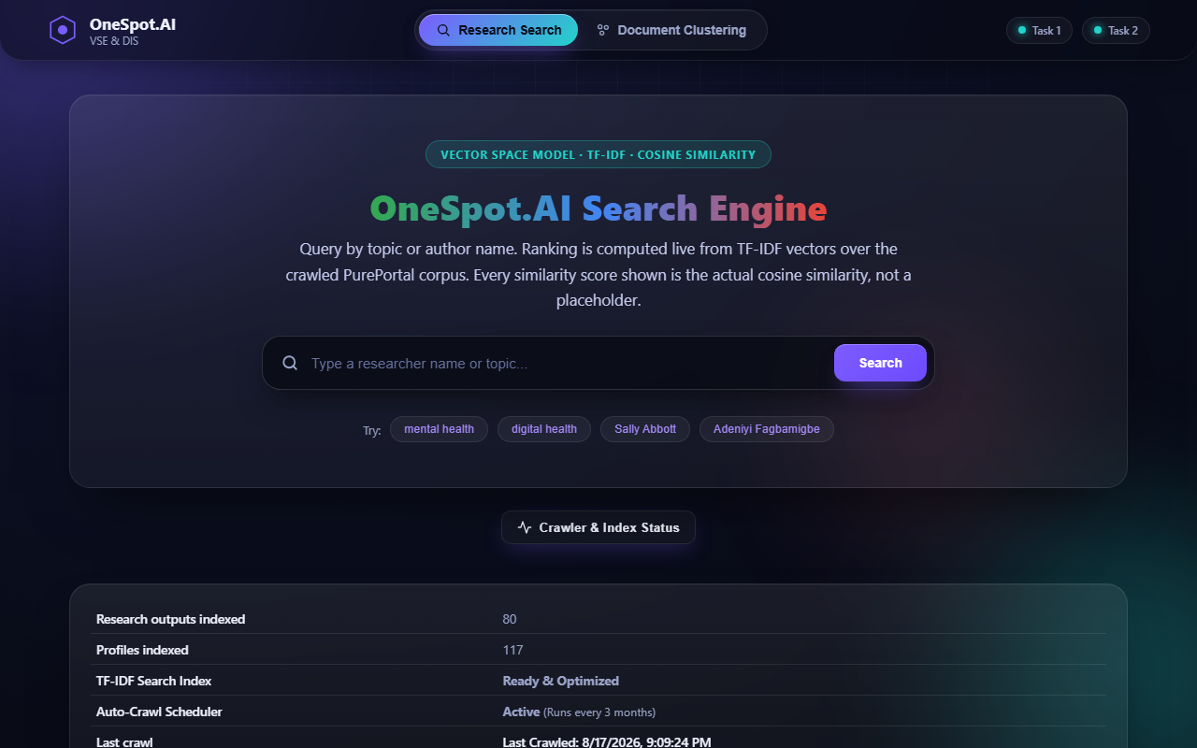
Figure 102. Additional System Screenshot: new_02_crawler_status

